**1.** Install a DNS server as part of the Nano Server image building process.

**2.** Create a Nano Server image and install the DNS Server Package *Microsoft-NanoServer-DNS-Package* after the Nano Server Generation 2 Hyper-V virtual machine is created.

The deployment of a DNS server onto a Windows Server 2016 Nano Server is available only with file-based DNS; *AD-integrated DNS server is not supported*.

To add functionality or roles to a Windows Server 2016 Nano Server, you need packages.

You can dynamically list available packages using the **Get-NanoServerPackage** cmdlet.

**New-NanoServerImage** -BasePath C:\nanotemp -TargetPath C:\Nano\ NanoDNS.vhd -OEMD*r*ivers -Packages Microsoft-NanoServer-DNS-Package -Computer Name NanoDNS -DomainName pearson.com -Language en-us

**New-NanoServerImage** -DeploymentType Host -Edition Standard -MediaPath \\Path\To\Media\en_us -basePath .\Base -targetPath .\NanoVM.vhd -InterfaceNameorIndex Ethernet -IPv4Address 192.168.1.200 -IPv4SubnetMask 255.255.255.0 -IPv4Gateway 192.168.1.1 -IPv4Dns 192.168.1.100

**Enable-WindowsOptionalFeature** -Online -FeatureName DNS-Server-Full-Role; **Import-Module** DNSServer

Deploying DNS Nano Server to Bare Metal Host

**Step 1.** Mount the Windows Server 2016 ISO. Note the drive in which it is mounted.

**Step 2.** Copy NanoServerImageGenerator.psm1 and ConvertWindowsImage.ps1 from the \NanoServer folder in the Windows Server 2016 ISO to a folder on your local hard drive.

**Step 3.** Import the NanoServerImageGenerator script with the following PowerShell command:

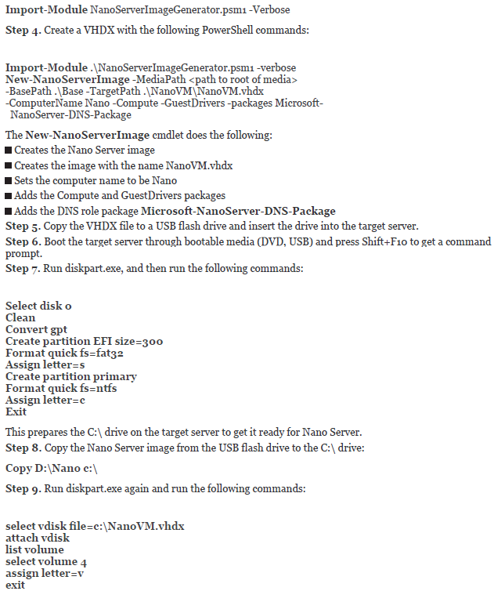

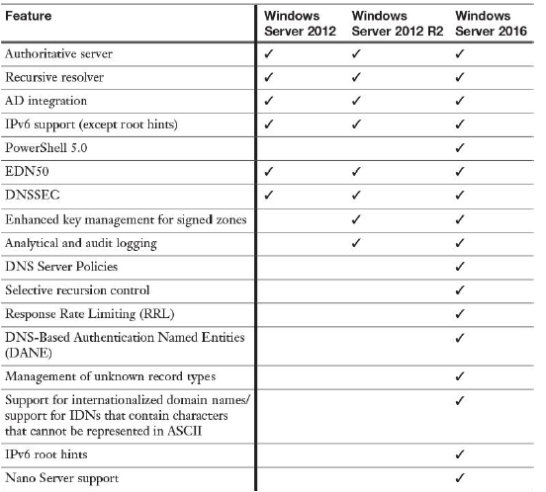

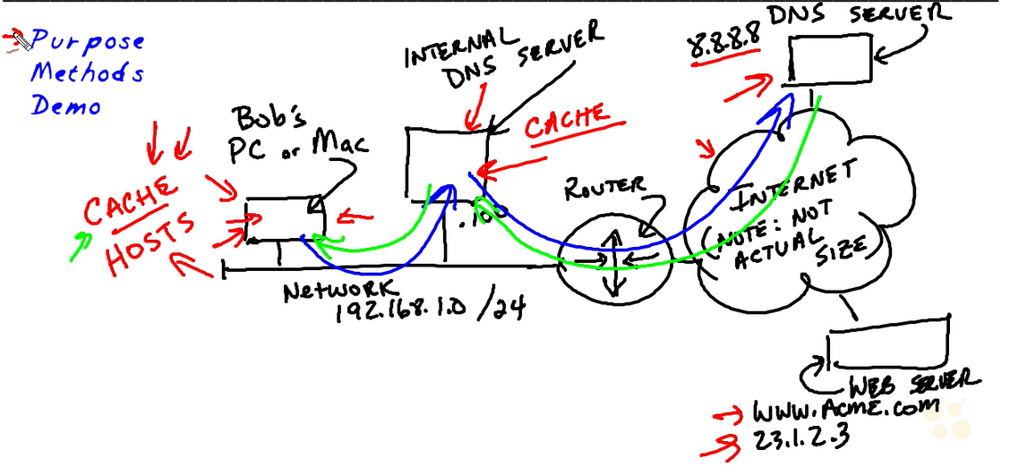

Local host address>> 127.0.0.1

Clientside

Ipconfig/displaydns (powershell) Get-DnsClientCache

Ipconfig/flushdns or (powershell) Clear-DnsClientCache

Nslookup “address” >> ilk address cevabın hangi dns den geldiği, ikinci adres sorgulanan adresin ipsi

Resolve-DnsName “address”

Serverside

Show-dnsservercache

Clear-dnsservercache

Resolve-DnsName “address”



Dns cache on client

C:\Windows\System32\drivers\etc

Modifying dns cache (sunucu üzerinde)

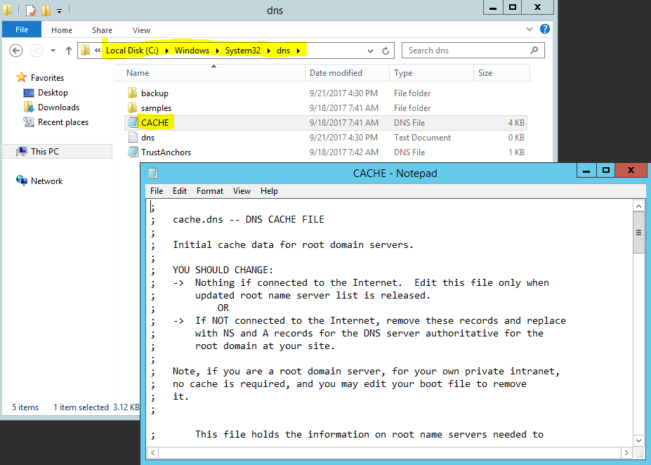

Configuring forwarder

When you designate a network DNS server as a forwarder, other DNS servers in the network forward the queries that they cannot resolve locally to that server

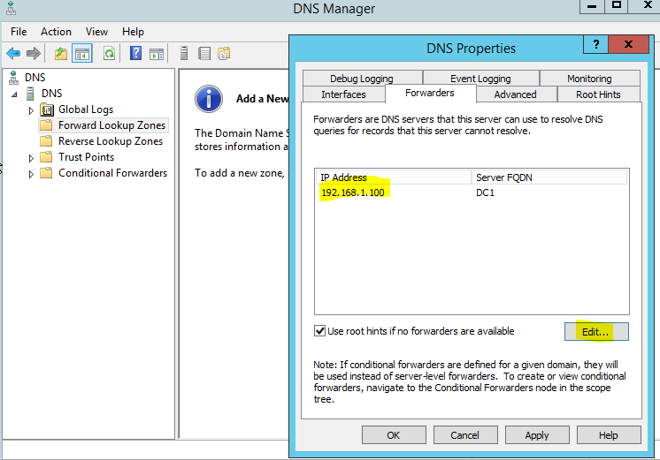

Sunucuya cache’inde olmayan bir istek geldiğinde forwarda sorar ve bilgiyi client’a gönderir bu işlemden sonra sunucu cache ine o adresi ekler.

powershell

**Add**-**DnsServerForwarder** -IPAddress 192.168.1.201 -PassThru

Conditional Forwarding

**Add-DnsServerConditionalForwarderZone** -Name "pearson.com" -ReplicationScope "Forest" -MasterServers 172.23.90.124 -PassThru

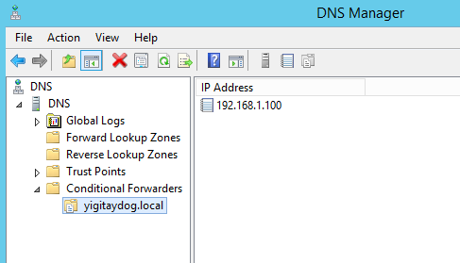

If dns server takes request for anything about yigitaydog.local, it uses forwarder address

Eğer DNS sunucuda forwarder yapılandırılması yoksa ve üzerinde cache yoksa

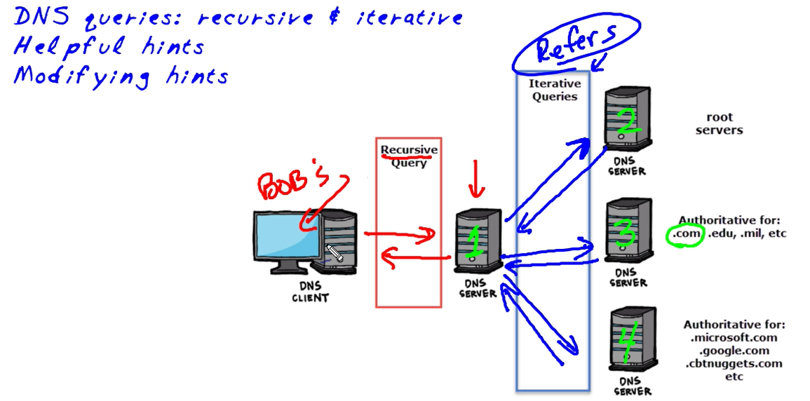

1-2 arasındaki iletişim

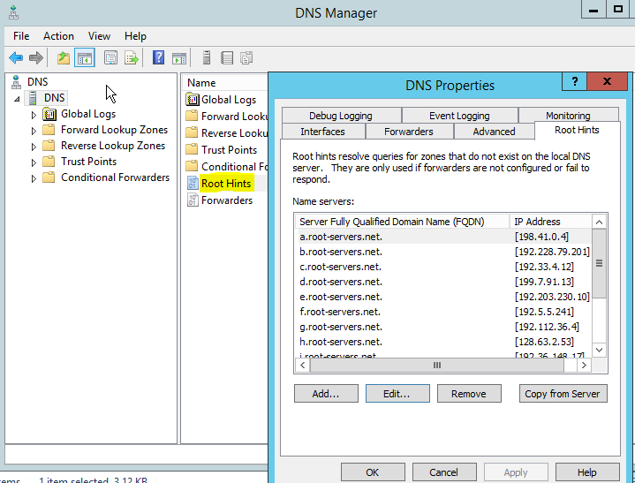

Ilk başta root hint’lerin iplerini çözümleyebilmek için forwarder olması lazım

Powershell ile eklemek

Add-DnsServerRootHint “name” “ipaddress”

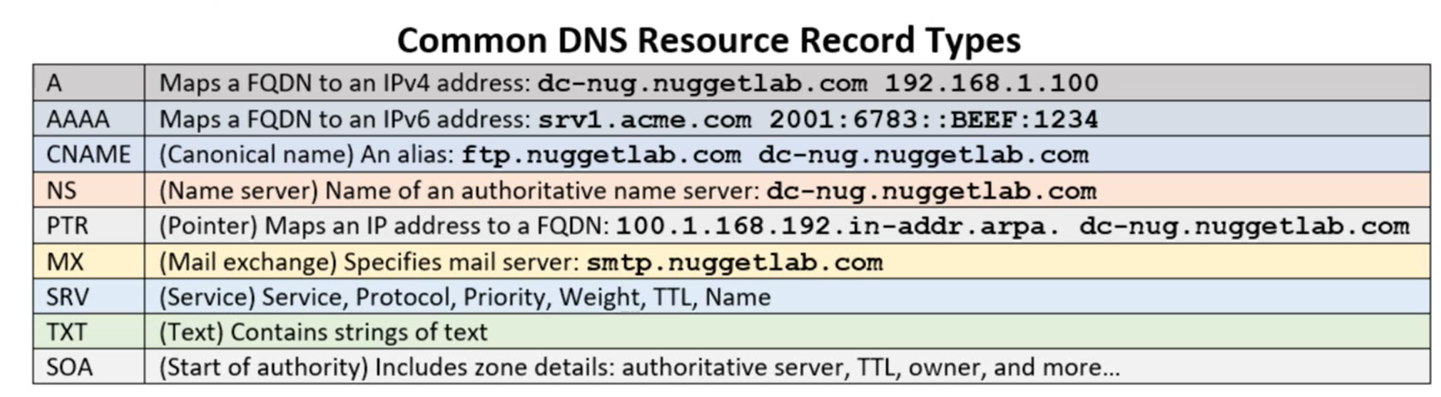

SRV>> Which host running web service

NS>> zone’dan sorumlu sunucu

Powershell’de record’lar oluşturmak:

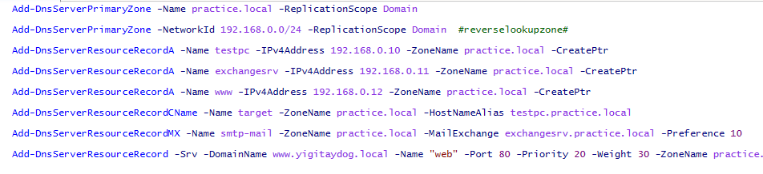

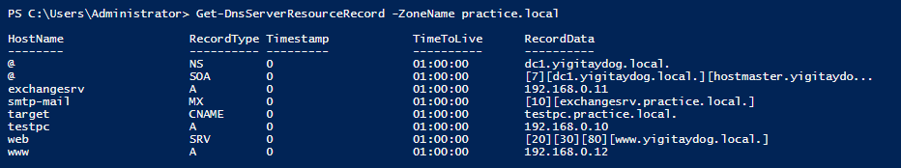

Priority lower is better

Weight kullanılma yükü

TTL of SOA Record

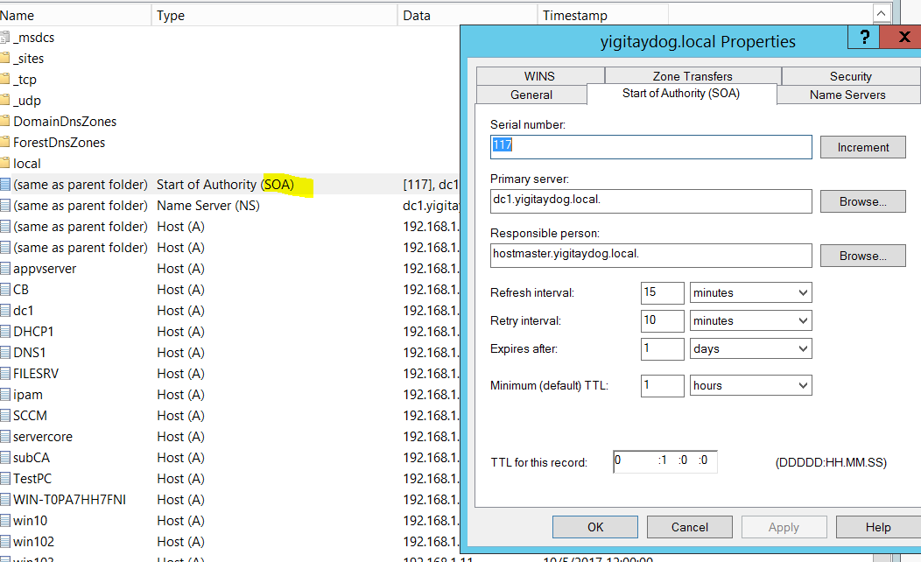

**SOA TTL** - The interval at which the SOA record itself is refreshed.

**Refresh TTL**- The interval at which slave servers (secondary DNS) are set to refresh the master zone file from the master server.

**Retry TTL -**The rate at which a slave server will retry to refresh the master zone file if the initial refresh failed.

**Expiry TTL**- If Refresh and Retry fail repeatedly, this is the time period after which the master should be considered gone and no longer authoritative for the given zone.

**NX TTL**- In the event that requesting the domain results in a non-existent query (NXDOMAIN), this is the amount of time that is respected by the recursor to return the NXDOMAIN response.

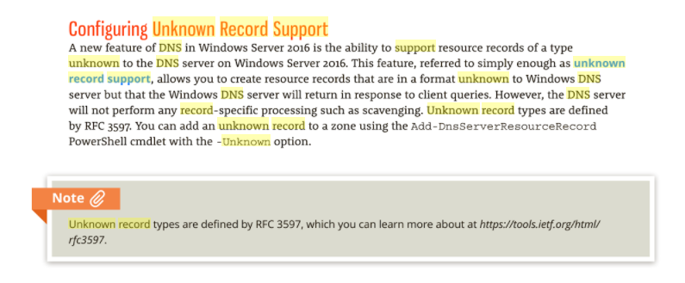

Recordlara bakmak için:

Nslookup –type=A “FQDN”

Nslookup –type=PTR “ipaddress”

Zone: collection of records, kept in files in DNS server or in AD integrated zone info (is available for all DCs for read and write, secured dynamic updates enable-DNS Clients can register and dynamically update their resource records with DNS server whenever changes occur-

Every zone has SOA record

Primary Zone>> read &write of records

p.s 

ReplicationScope Domain> AD integrated zone

Secondary Zone> read only

Stub zone>> dynamically update name server for other domain (conditional forwarding ile aynı)

Forward Lookup zone> name to ip

Reverse lookup zone> ip to name

Secondary zone’a primary zone’dan bilgileri aktarmak

(DC olmayan dns sunucu üzerinde)

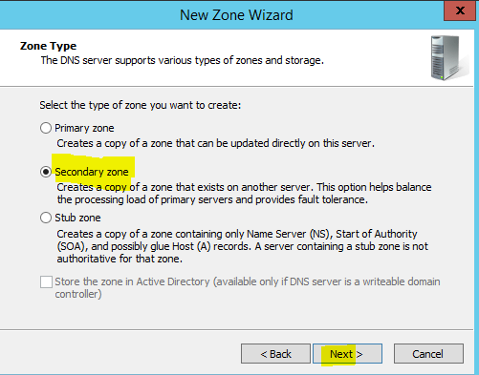

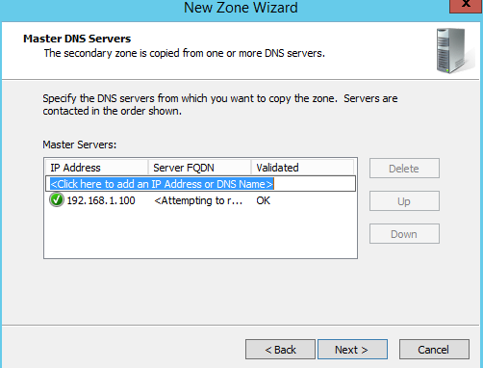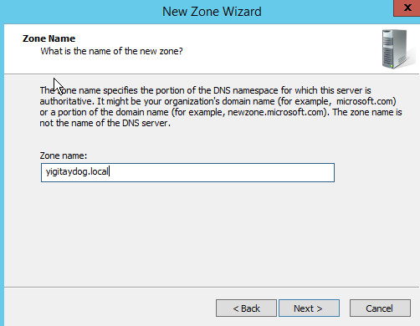(dc olan dns sunucu üzerinde)

Ikinci dns sunucunun kayıtlı olduğu görülür

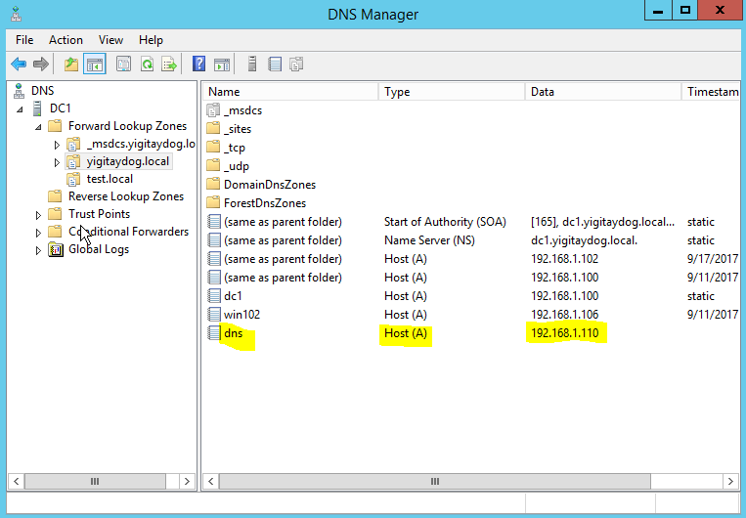

Zone transferine izin verilir

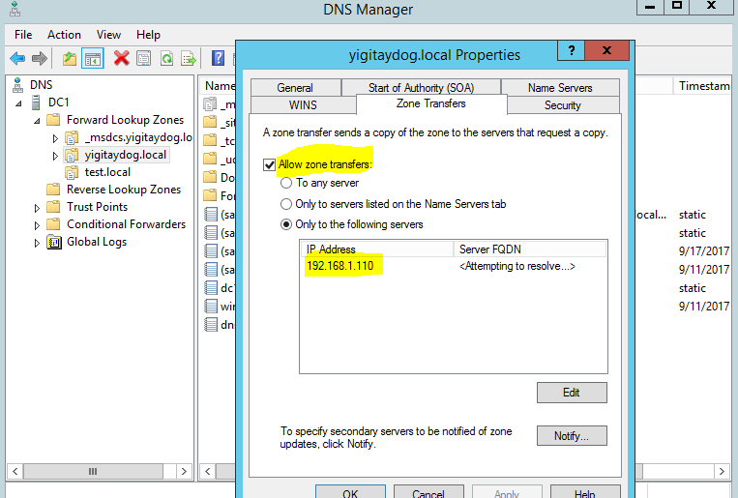

(DC olmayan dns suncu üzerinde)

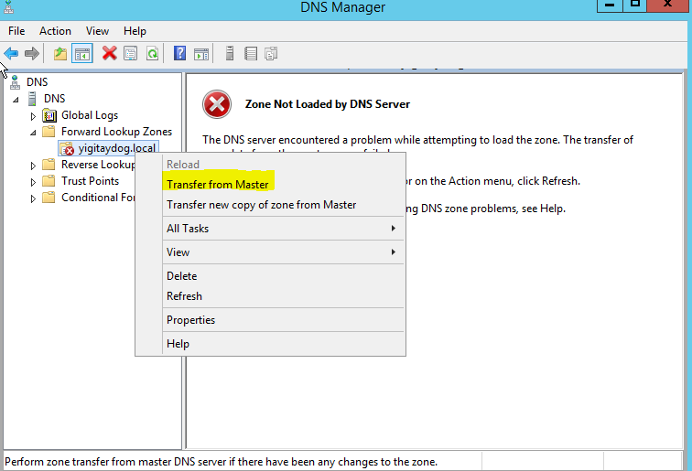

(DC olan sunucu üzerinde>> ikinci sunucu name server olarak eklenir)

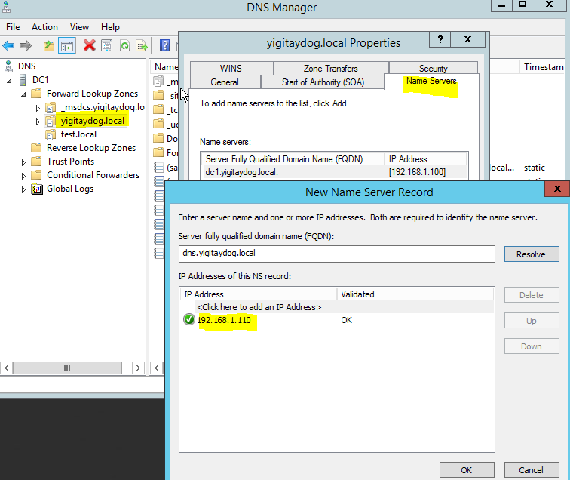

**Start-DnsServerZoneTransfer** -Name "pearson.com"

Types of Zone Transfers

The three types of zone transfer are as follows:

**Full zone transfer:** A full zone transfer occurs when you copy the entire zone from one DNS server to another. A full zone transfer is known as an all-zone transfer (AXFR).

**Incremental zone transfer:** An incremental zone transfer occurs when an update to the DNS server takes place and only the resource records that were changed are replicated to the other server. This is known as an incremental zone transfer (IXFR).

Belli bir sunucuya zone transfere izin vermek



10.0.0.50 dışındakilere zone transfer olmaz

**REVERSE LOOKUP ZONES**

Bu işlem yapılmazsa

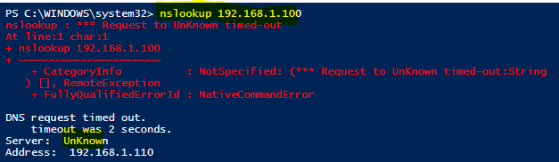

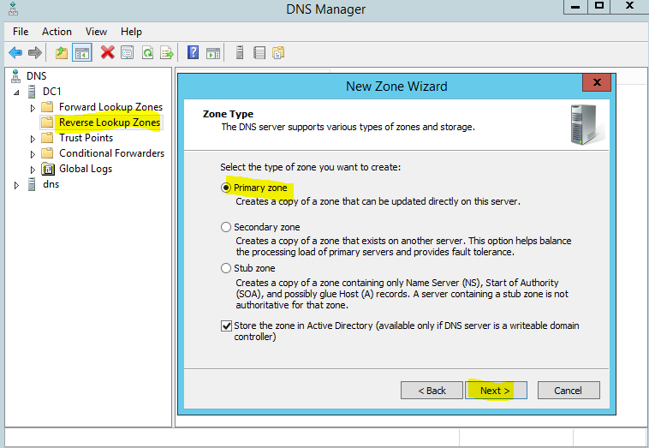

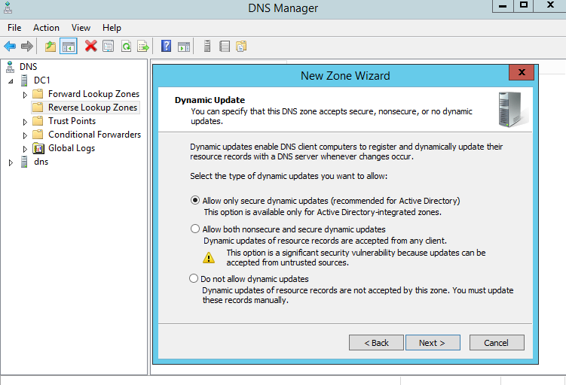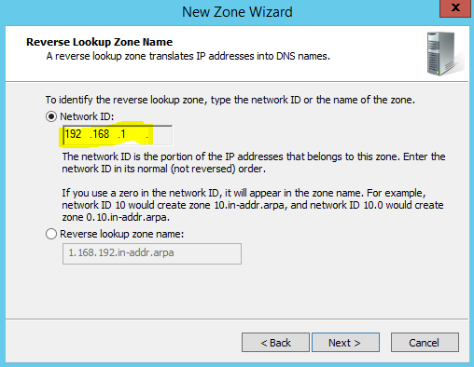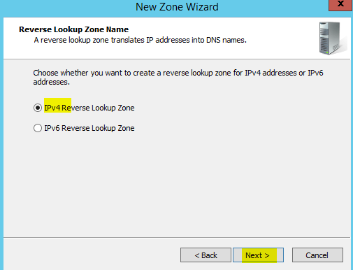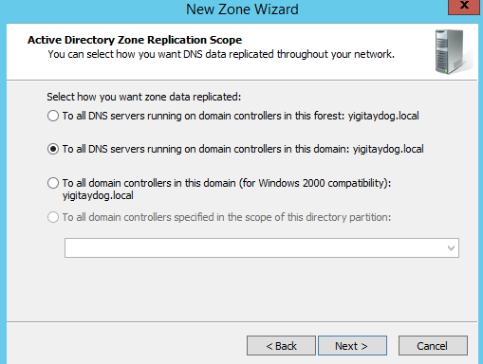

PTR kayıtlarının oluşturulması:

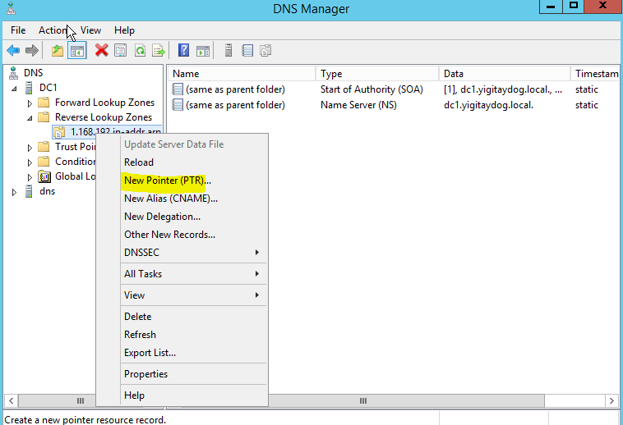

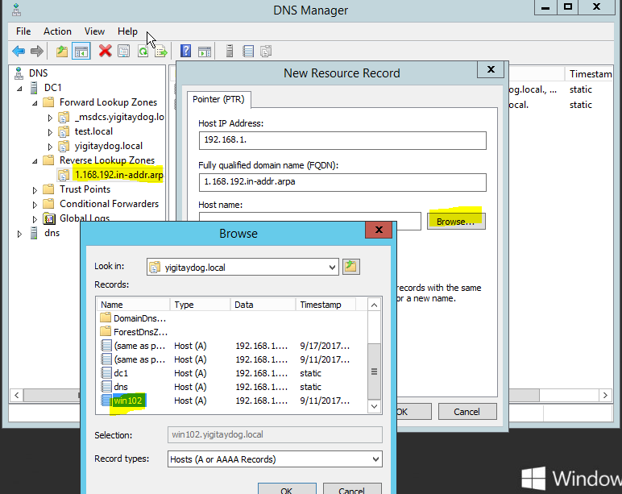

Bu işlemden sonra ip’den bilgisayar ismine geçilir

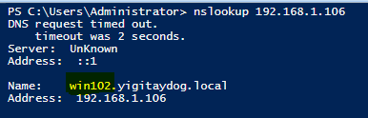

Bundan sonra yeni A-record’lar oluşturulurken otomatik olarak PTR’ları oluşturulur

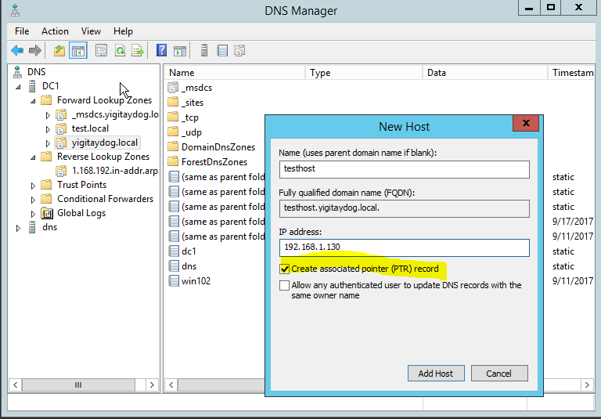

**GlobalNames zone**

 to use short, single-label names to represent longer FQDNs



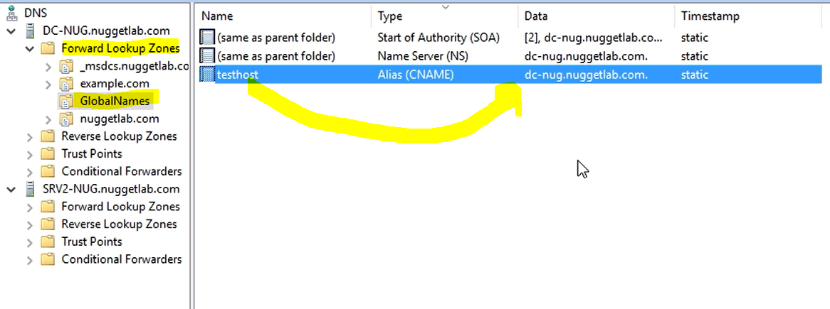

The DNS server service in Windows Server 2016 provides the GlobalNames zone, which you can use to contain single-label names that are unique across an entire forest

no longer need NetBIOS-based WINS to provide support for single-label names.

**DNS ROUND ROBIN**

load-balance requests among multiple web servers

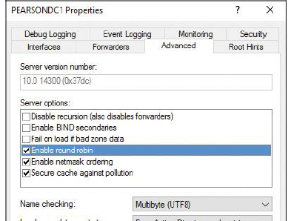

Application Delivery Control>> Load Balancing



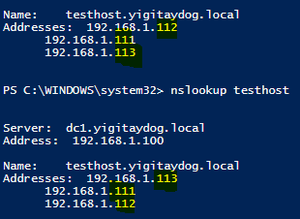

**DNS DELEGATION**

**Add-DnsServerZoneDelegation** -Name "pearson.com" -ChildZoneName "EU" -NameServer "DNSEU1.EU.pearson.com" -IPAddress 172.16.0.20 -PassThru -Verbose

İkinci dns sunucu üzerinde

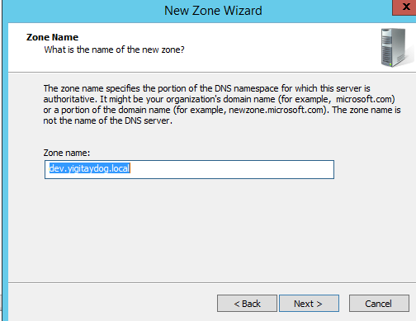

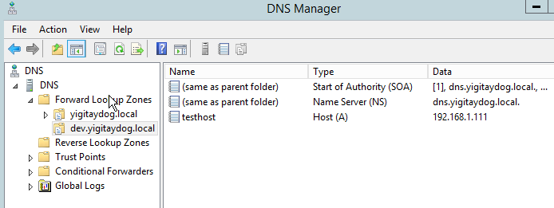

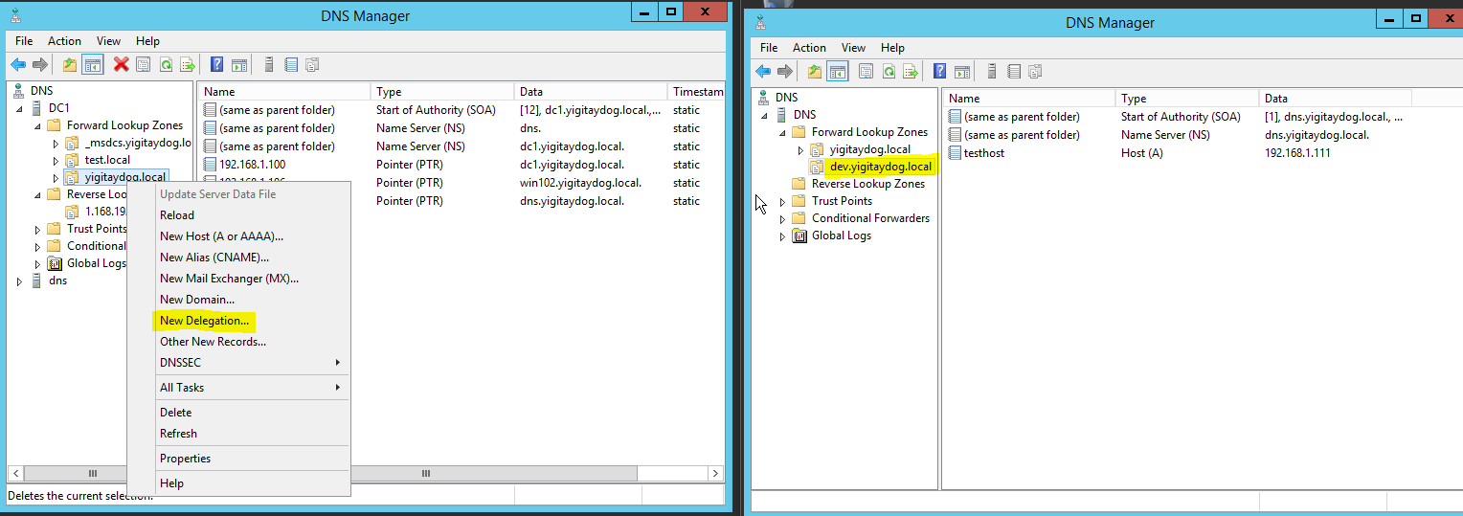Dns sunucu olarak ikincil dns sunucuyu gösteren istemcide testhost.dev.yigitaydog.local bulunamaz

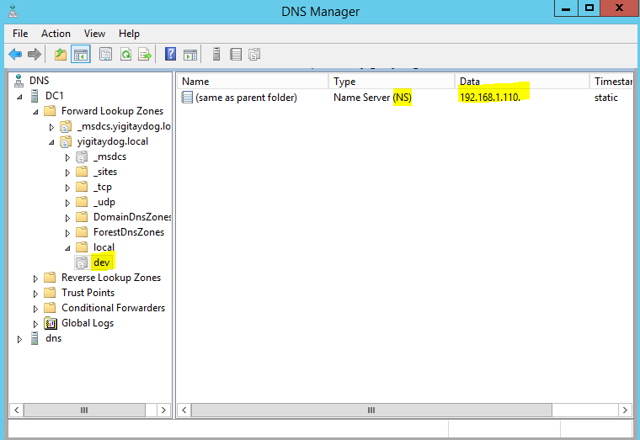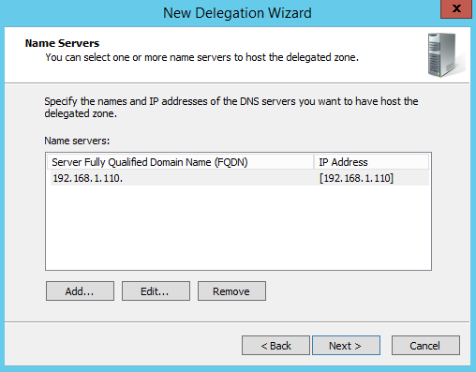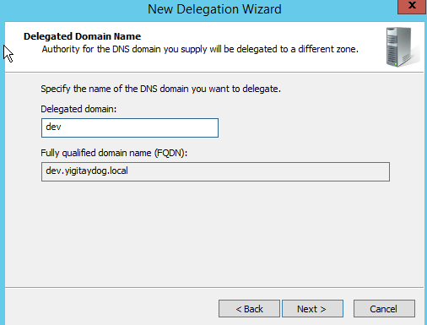

Delegasyondan sonra birincil sunucu üzerindeki kayıtlar gözükmez fakat ikincil sunucuya gidip bilgileri alır

Bu işlem sonucu istemcide testhost.dev.yigitaydog.local bulunabilir

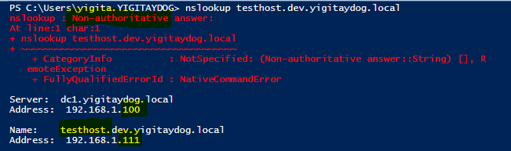

**STUB ZONES**

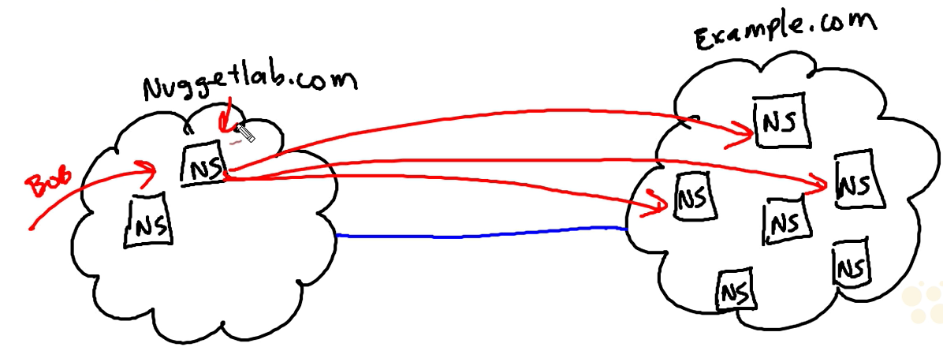

İkincil dns sunucusu üzerinde example.local primary zone’u oluşturulur ve birincil sunucu name server olarak gösterilir

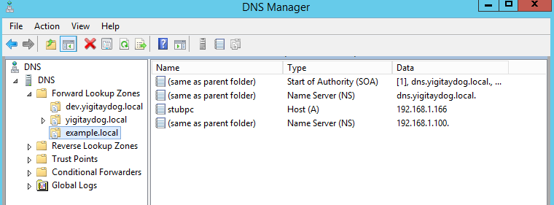

Brincil sunucu üzerinde stub zone oluşturulur

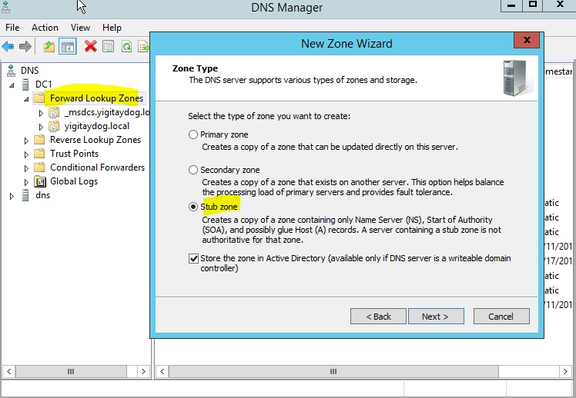

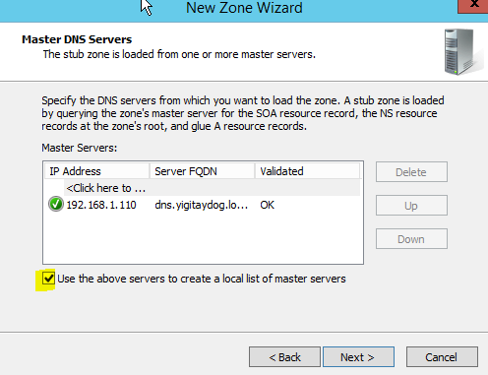

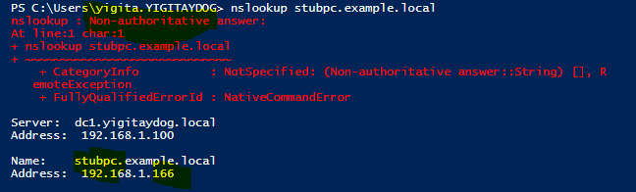

**DYNAMIC UPDATE**

When an administrator executes the PowerShell cmdlet **Register-DNSClient** or runs **ipconfig /registerdns** at a command prompt, the dynamic update process runs.

Enabling taking recursive queries one way and don’t from other way

Iterative query’leri sadece belirli bir ip interface’e göre scope ile sınırlamak

tamamen sınırlamak için:

**dnscmd** <servername> /config /NoRecursion 1

**Set-DnsServerRecursion** -Enable 0

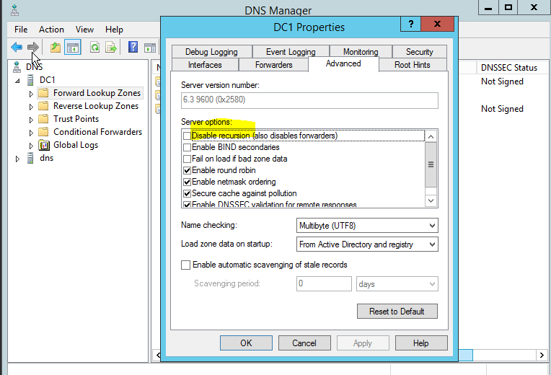



Belirli bir İP arayüzü ve scope’a göre kısıtlamak:

Add-DnsServerRecursionScope -Name "InternalClients" -EnableRecursion $True

Add-DnsServerQueryResolutionPolicy -Name "RecursionControlPolicy" -Action ALLOW -ApplyOnRecursion -RecursionScope "InternalClients" -ServerInterfaceIP  "EQ,10.0.0.39"

**DNS SECURITY (DNSSEC)**

AD integrated yapılarda

Dns info come from trusted dns server (with certificate)

Dns server uses private key (zone signing key) and client uses public key (from trust anchor)

Name Resoltion Policy Table force clients

DNSSEC enables a DNS zone and all records in the zone to be signed cryptographically so that client computers can validate the DNS response. DNS is often subject to various attacks, such as spoofing and cache tampering. DNSSEC helps protect against these threats and provides a more secure DNS infrastructure.

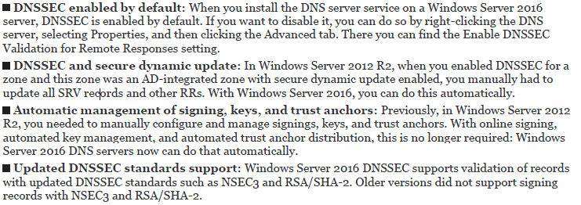

Zone Signing

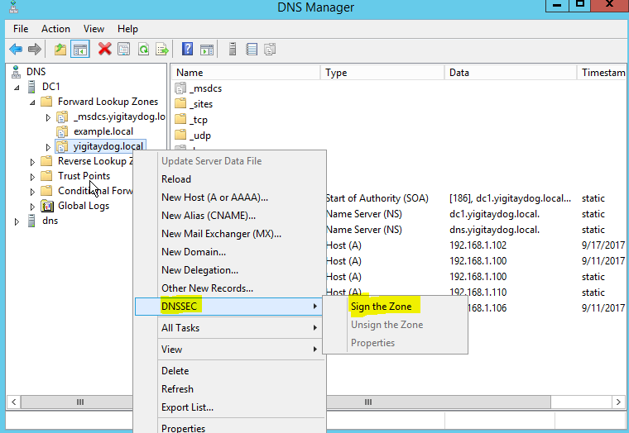

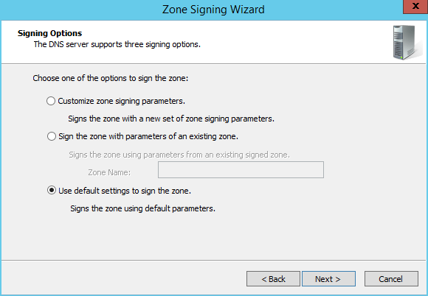

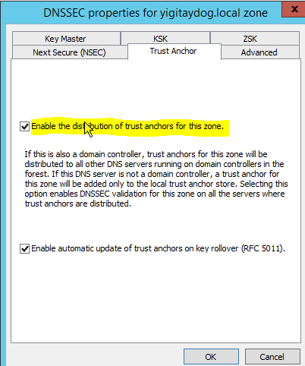

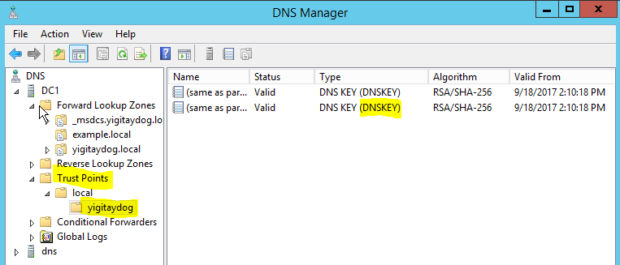

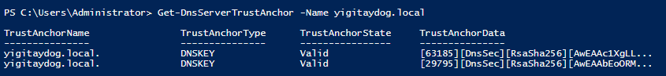



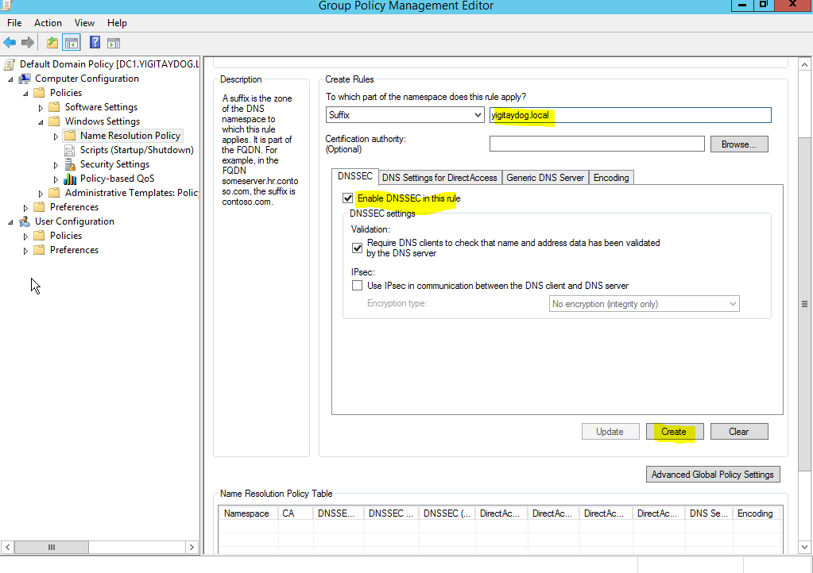

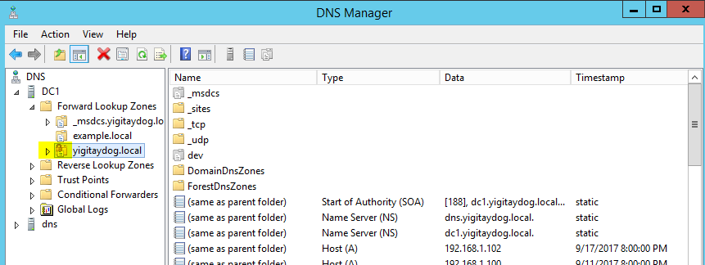

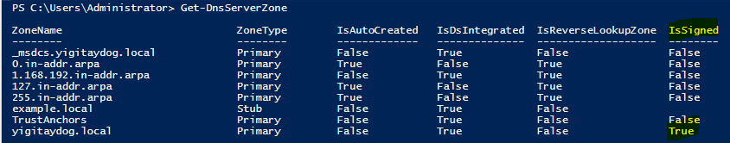

Client’ın aldığı name resolution policy’I bulmak> Get-ClientNrptPolicy

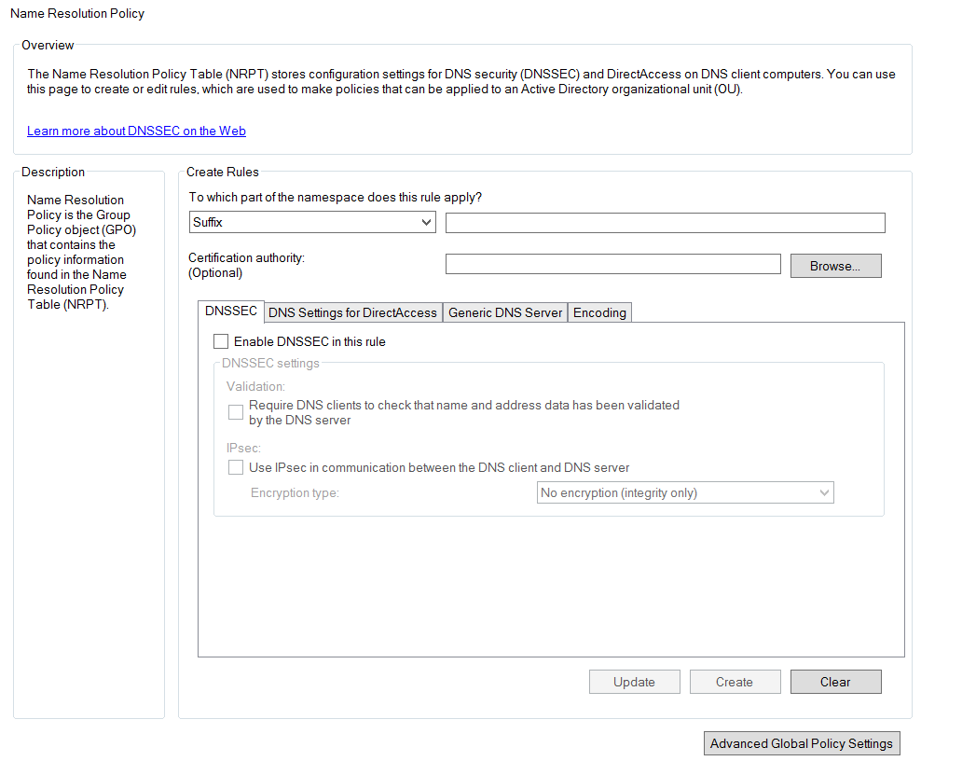

Bundan sonraki sorgular sign halde gelecektir

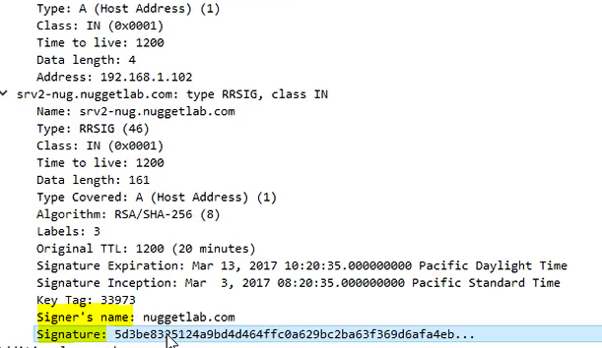

**CACHE LOCKING**

To prevent DNS client caches from being overwritten, use the DNS Cache Locking feature. With this feature enabled, the cached records cannot be overwritten for the duration of the Time To Live (TTL) value. Cache locking provides improved security against cache poisoning attacks, which occur when an attacker’s DNS server provides false name resolution.

Cache locking percentage > ttl değerinin ne kadar kullanılacağını belirler

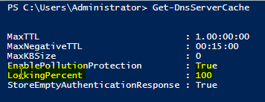

Değiştirmek için:

Set-DnsServerCache –LockingPercent 90

Socket pool:

The DNS socket pool feature enables a DNS server to use source port randomization when it issues DNS queries. DNS socket pool is enabled by default in Windows Server 2016.

the DNS server uses a random port number that it selects from the DNS socket pool.

from 0 to 10,000. The larger the value, the greater the protection you have against DNS spoofing attacks.

Değer olarak 0-10.000 verebiliyoruz ve yine istersek bazı portların kullanılmasını da taleb edebiliyoruz (DNS socket pool exclusion list)

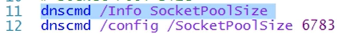

dnscmd /Config /SocketPoolExcludedPortRanges <excluded port ranges>

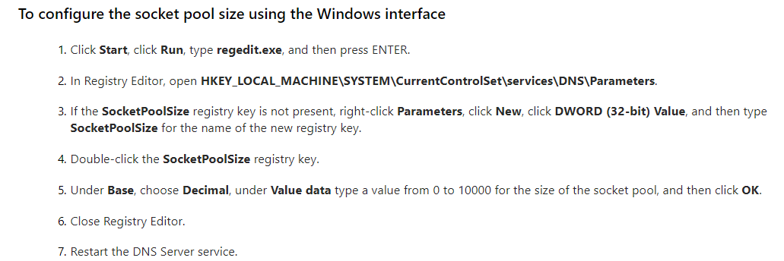

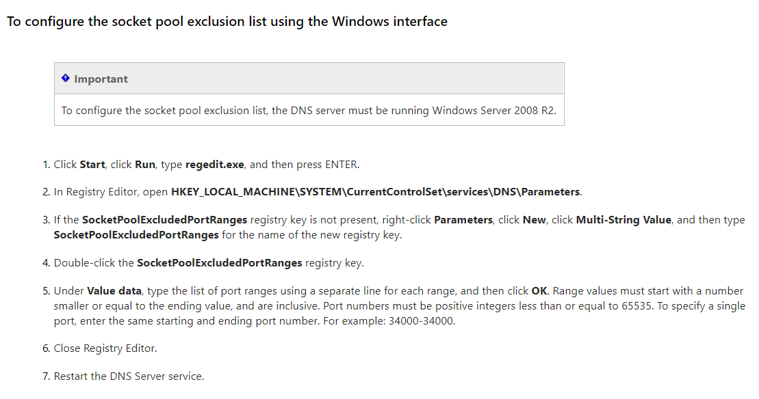

**DNS Response Rate Limiting (RRL)**

Dos attack with lots of queries

Response bilgilerini çekmek

Get-DnsServerResponseRateLimiting

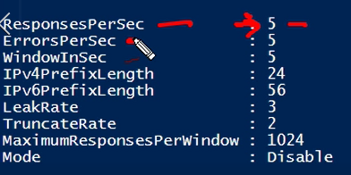

Error per sec>> max number of times that server can send error response to single client within 1second interval

Bu ayarlarda değişiklik yapmak istersek:



(bu komutlar server2012r2 de yok)

**DNS POLICIES**

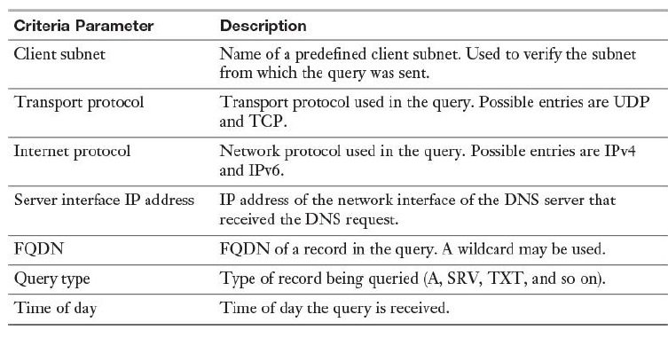

Mevcut dns policy’leri görmek:

Get-DnsServerQueryResolutionPolicy

Action: allow, deny, ignore

Örnek:

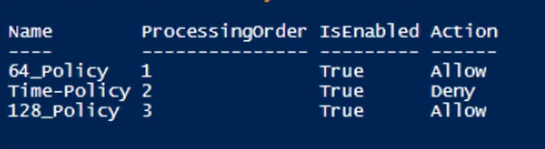

Processing order’I düşük olana göre politika uygulanır

**DNS Policy Based Load Balancing based on server interface ip**

Criteria ipv4 or ipv6,interface ip,type of record, time based

Entire server or zone based policy (server based policy has higher priority)

“weight based”

Procedure: Create zone,create scope, give weights to scopes

1.Loadbalance.local isimli bir primary zone oluşturulur

2. Zone scope’ları oluşturulup isim verilir



3.Aynı isimli A record’ları oluşturulur



4. Policy oluşturup, ağırlıkları scope’lara dağıtmak (%90,%10) 

**DNS Policy Based Load Balancing based on client subnet**

Farklı subnetlere göre aynı hostname’i farklı ip’ye çözer

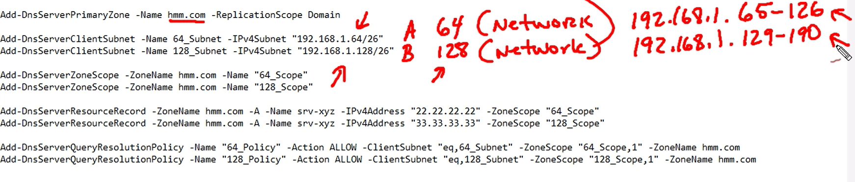

**DNS Policy Based Load Balancing based on time**



**DNS SETTINGS AND TROUBLESHOOTING**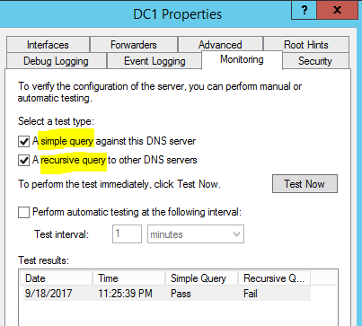

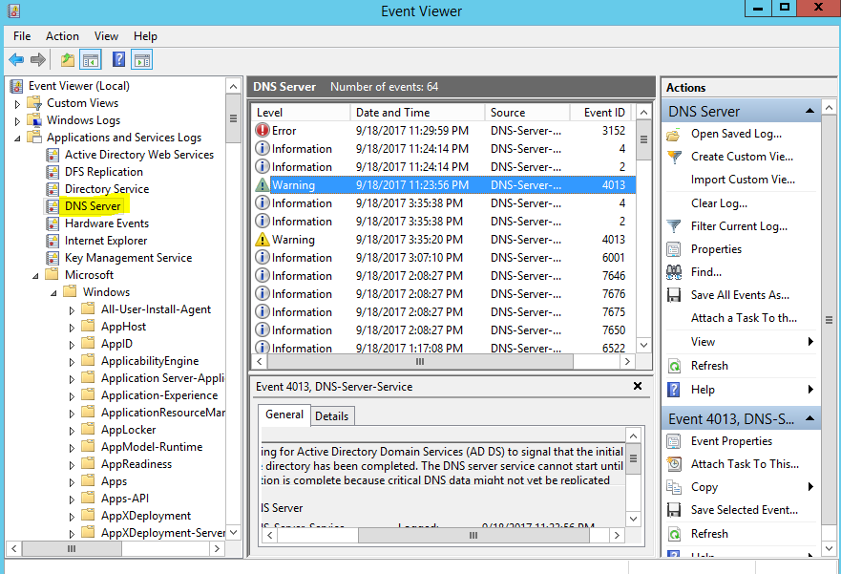

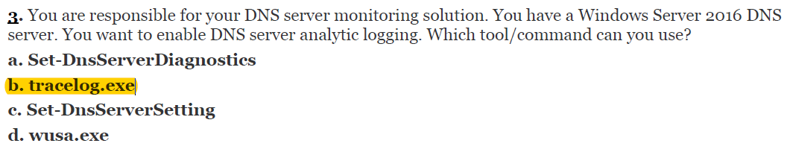

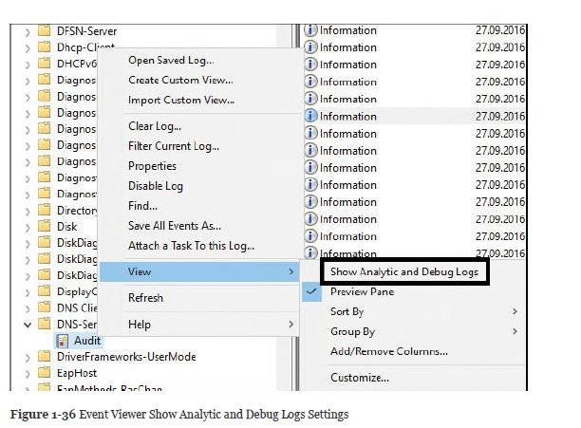

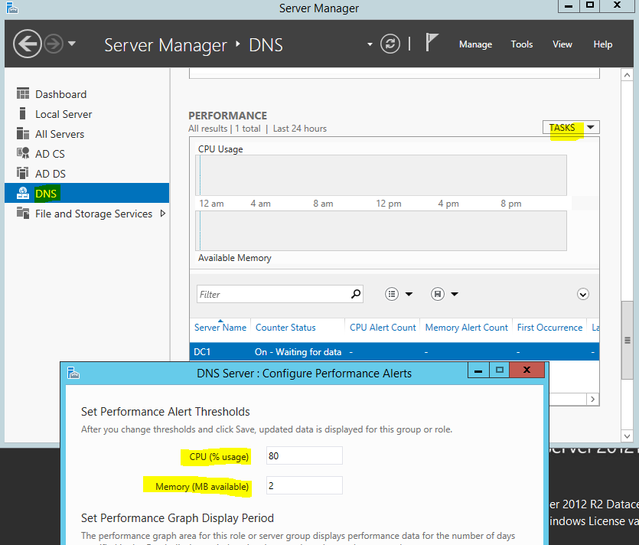

**DNS SCAVENGING**

Dynamic updates fill dns records, clean-up records if they are not updated for specific time period

Zone seviyesindeki ayar

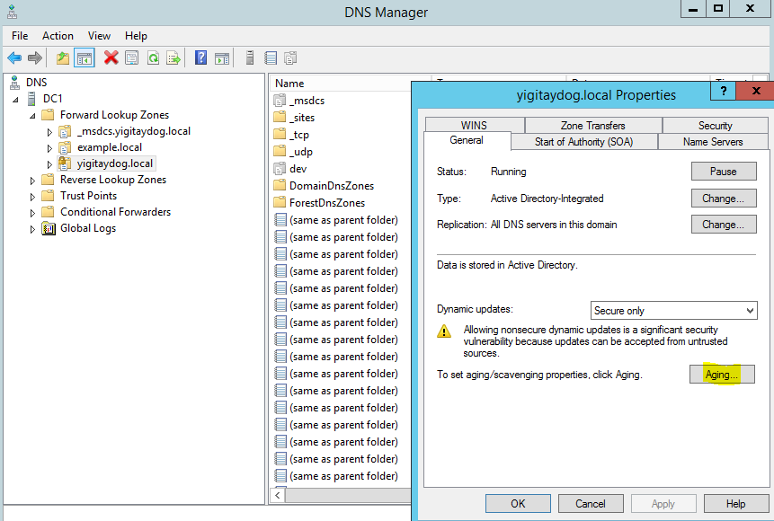

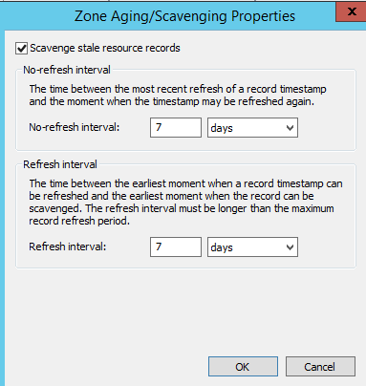

No refresh interval>> bu süre içerisinde client record’lar dinamik olarak sunucuda güncellemez

Refresh interval> no refresh interval sonrası, dinamik güncelleme gönderir. Eger bu refresh süresi boyunca kayıt güncellenmezse client’ın record’u silinir

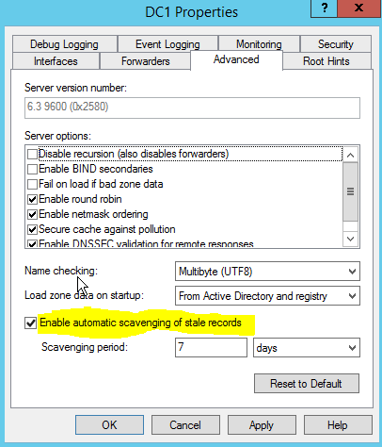



Static records that are manually entered have a time stamp value of 0. They are not removed through the aging and scavenging process, so you must remove them manually from the zone.!!

Add-DnsServerResourceRecordA –AgeRecord ile >> time stamp konulabilir

-TimeToLive >>ile TTL değeri ayarlanabilir

**DNS BASED AUTHENTICATION OF NAMED ENTITIES (DANE)**

DANE is a set of mechanisms and techniques that allow Internet applications to establish cryptographically secured communications by using information made available in DNS. By binding the key information to a domain name and protecting that binding with DNSSEC, applications can easily discover authenticated keys for services.

[**www.huque.com/bin/gen_tlsa**](http://www.huque.com/bin/gen_tlsa)

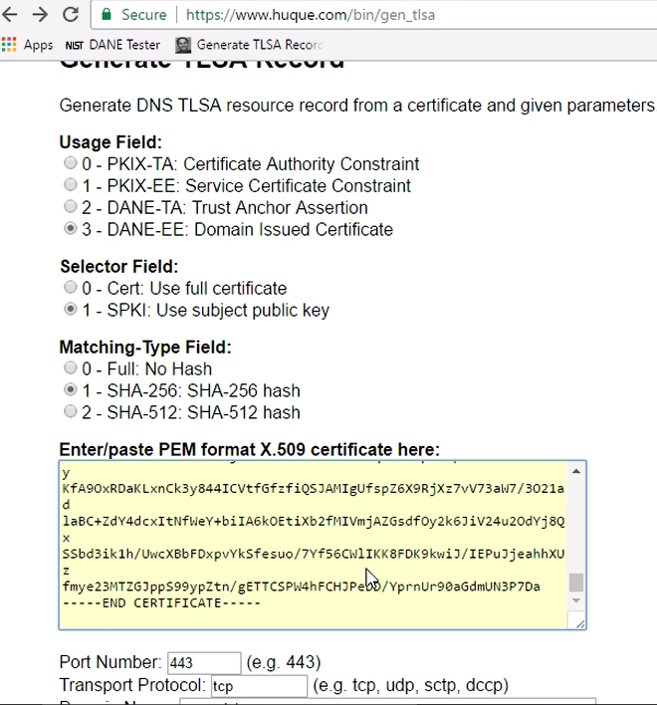

Sertifika browserdaki trusted auth den imort edilip, txt ile açılır

Add-DnsServerResourceRecord with parameters

-CertificateAssociationData

-Certficate Usage DomainIssuedCertificate

-MatchingType

-Selector SubjectPublicKeyInfo

-TLSA

-ZoneName

-Name _443.tcp.hostname

**DNS STATISTICS**

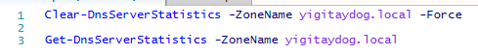

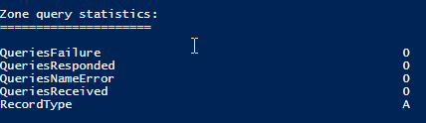İstatistiklerde record type’a göre

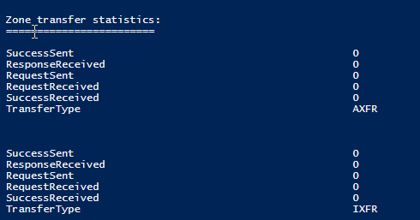

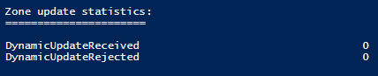

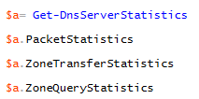

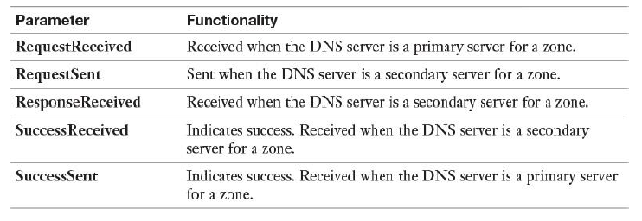

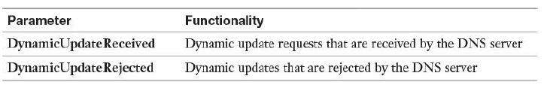

DNS ADMIN GRUPLARI > Domain admins, Enterprise Admins, Dns Admins

Sunucu yada zone seviyesinde güvenlik yapılandırılması

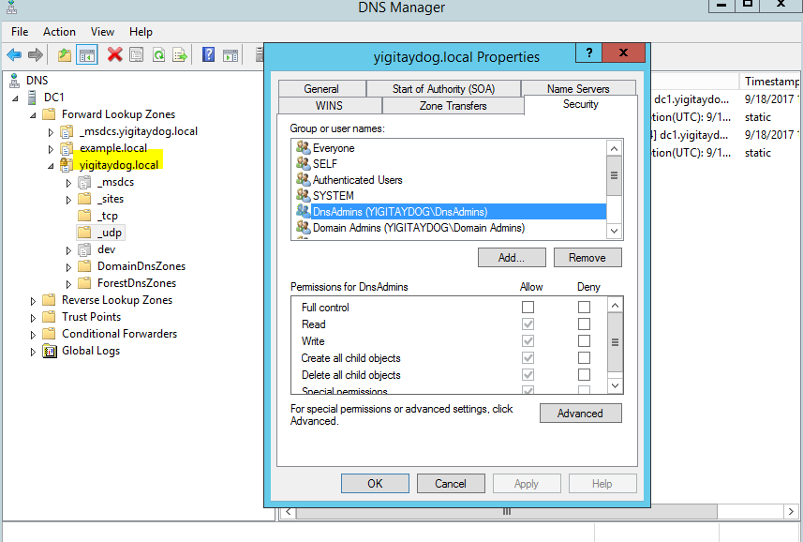

Members of the DNS Admins group get the following permissions:

View and modify all DNS data

Perform DNS settings and configurations

**DNS Logging**

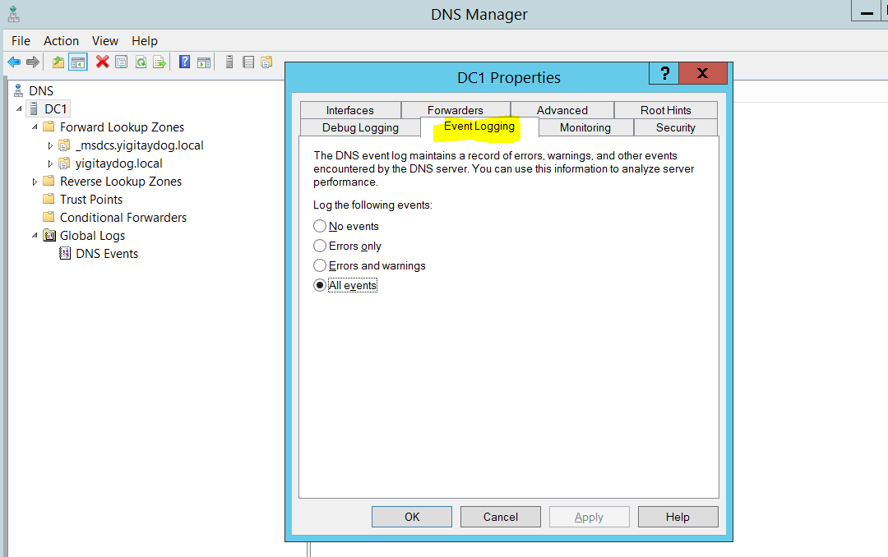

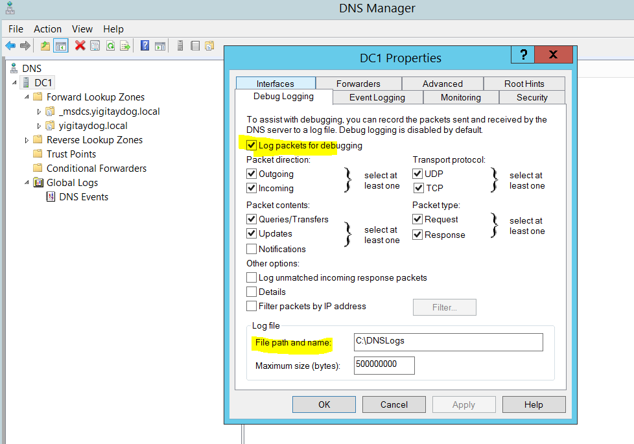7

The DNS server log records common events such as these:

* DNS service starting and stopping
* Background loading and zone signing events
* Changes to DNS configuration settings
* Various warnings and error events
* Debug logging must be explicitly enabled and can be used for the following logging options:
* Direction and contents of packets
* Transport protocol
* Request type
* Filtering based on IP address
* Name and location of the log file, which is located in the %windir%\ System32\DNS directory
* Log file maximum size limit
* Debug logging is resource intensive.

**ZoneScopes**

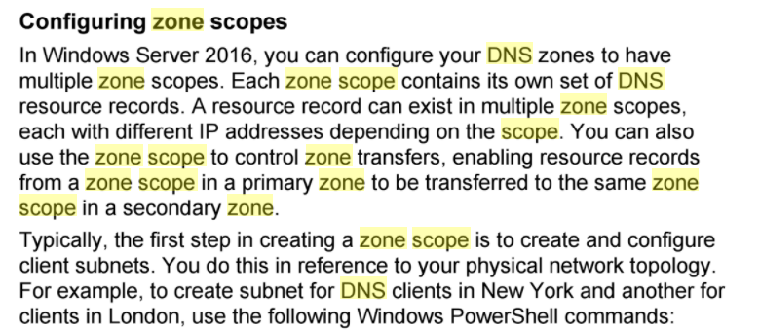

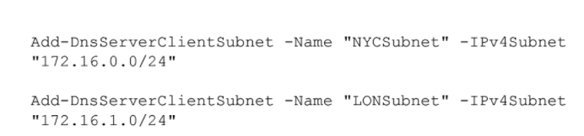

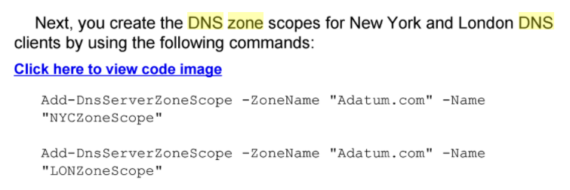

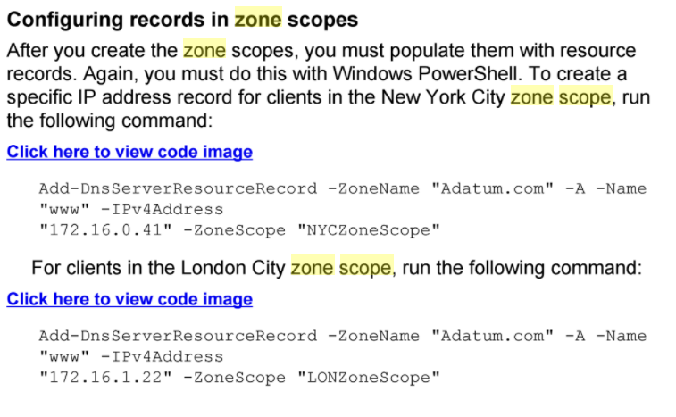

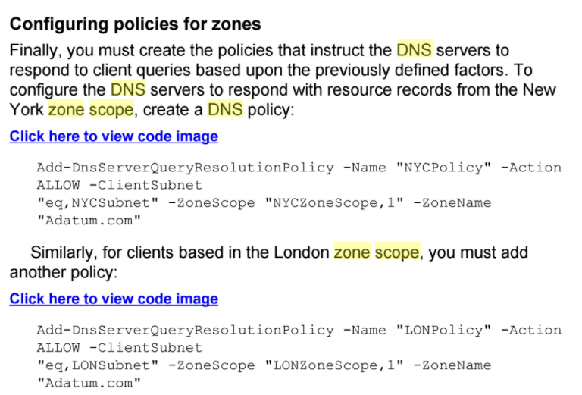

**DNS BACKUP**

Active Directory–integrated zone, your DNS zone data is stored in the AD database (ntds.dit file)

**Export-DnsServerZone** -Name pearson.com -Filename pearson



DNS zone is a primary zone and is not stored in the AD DS, the file is stored as a DNS file in the %SystemRoot%\System32\Dns folder

You can back up a primary zone simply by copying the individual zone file (zonename.dns), which is located in the %windir%\System32\DNS directory.

**ROOT HINTS**

If you want to disable all iterative queries, clear the **Use Root Hints If No Forwarders Are Available** check box on the Forwarders tab. If you configure the server to use only a forwarder and you disable root hints, it attempts to send a recursive query to its forwarding server; if the forwarding server does not answer this query, the first server responds that the host could not be found.

**Get-DnsServerRootHint**

DNS server in Windows Server 2016 supports the native IPv6 root hints

**msdcs Zone**

The _msdcs subdomain of the forest’s root domain automatically is created with the setup of the forest root domain controller with DNS server. The _msdcs zone is an Active Directory–integrated zone and its replication scope is set to all DNS servers in the forest. This means that all content in this zone will be replicated to all DNS servers, and all DNS servers in the forest are authoritative for that zone. Normally, some CNAME records are registered in this zone. For each domain controller in the forest, there must be a CNAME record with the GUID number of the domain controller. The DCs automatically register their records in that zone. AD uses these records to increase AD replication performance. All writeable domain controllers must register a record in this zone for proper AD replication.

store a DNS zone in a custom Active Directory partition.

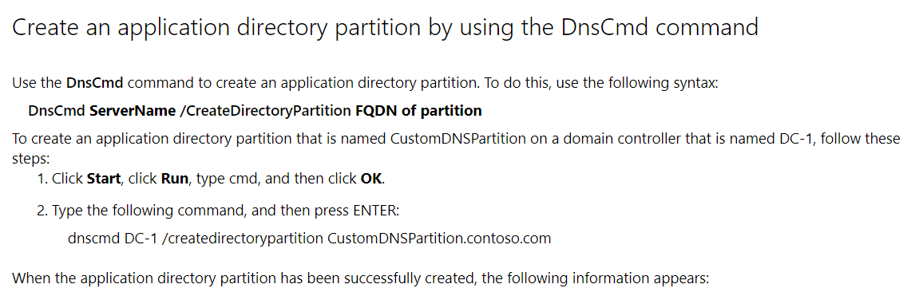

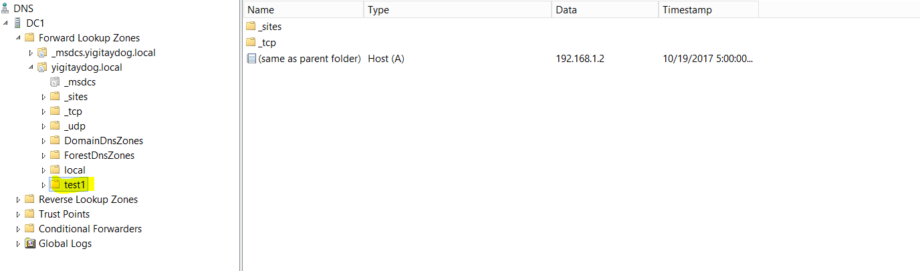

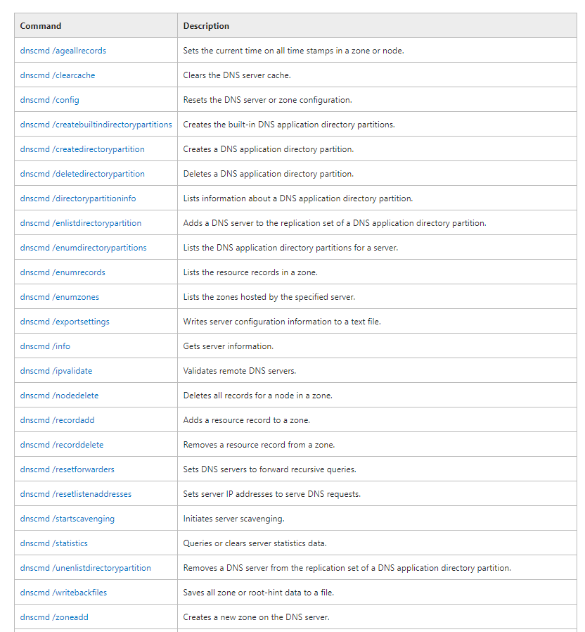

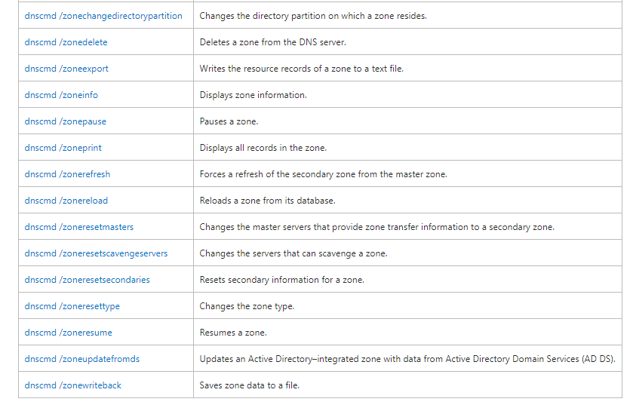

**DHCP**

A DHCP server cannot be installed on a Windows Server 2016 Nano Server: no Nano Server package is available for a DHCP server!!!

You must use an Enterprise Administrator account to authorize the DHCP server!!

Authorization>> Add-DhcpServerInDC –DNSName $Env:computername

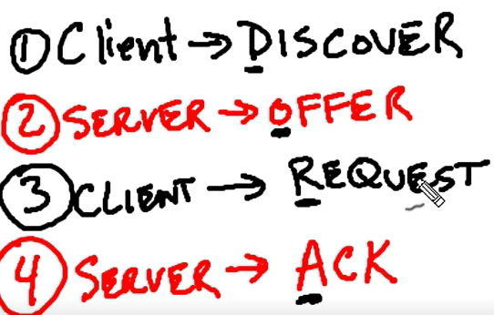

DORA

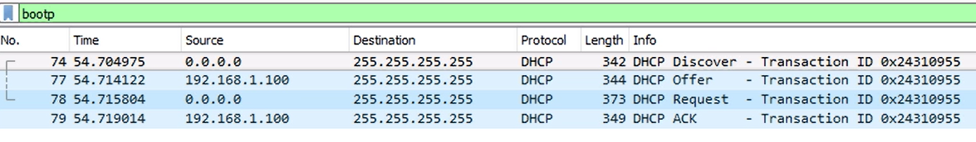

Post installation

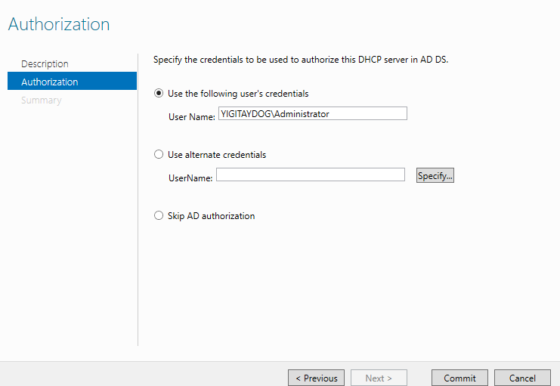

Creating Scopes

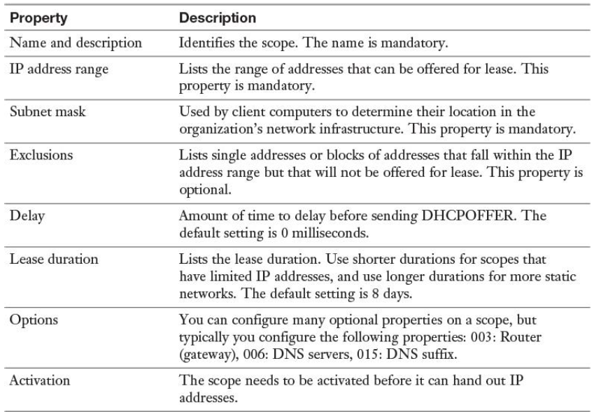







**Add-DhcpServerv4Lease** -IPAddress 10.10.10.11 -ScopeId 10.10.10.0 -ClientId F0-DE-F1-7A-00-5E -LeaseExpiryTime "2012-01-28 01:38:13Z" -HostName MyComputer.contoso.com

(adds an IPv4 address lease for the IPv4 address)

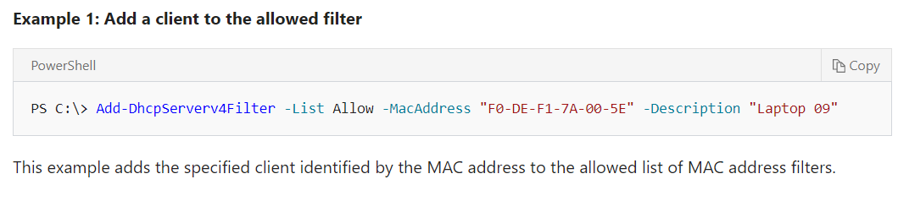

**Add-DhcpServerv4Reservation** -ScopeId 10.10.10.0 -IPAddress 10.10.10.8 -ClientId "F0-DE-F1-7A-00-5E" -Description "Reservation for Printer"

(reserves the specified IPv4 address in the scope for a client)

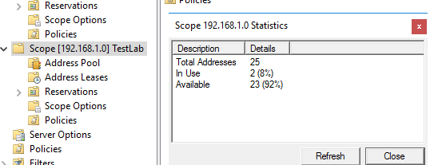

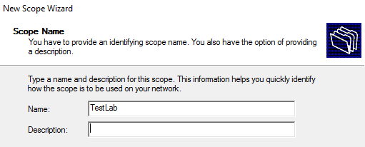

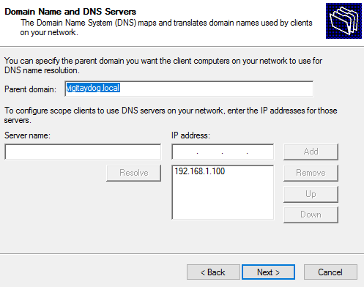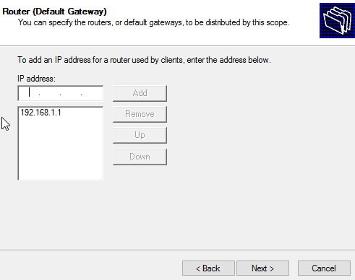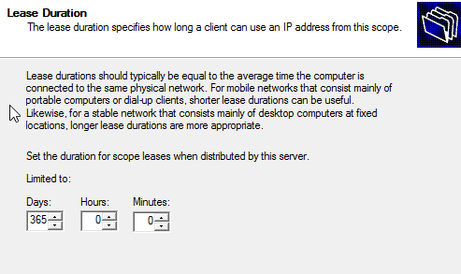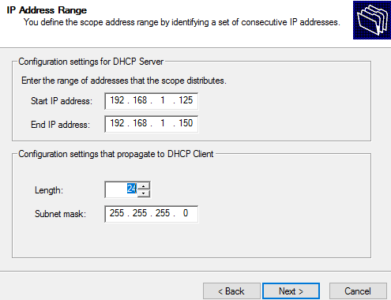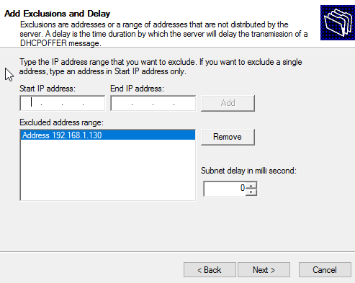Subnet delay client’a dhcp offer’ın ne kadar geç verileceği

Bu işlem sonrasında client

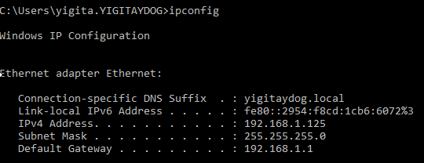

*Workgroup’ta çalışan bilgisayar da otomatik olarak ip alır*

Ağdaki bilgisayarların ip ve mac’ları

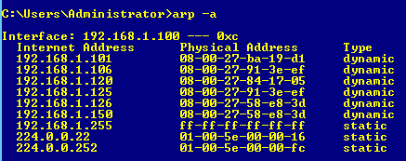

**Scope’u deaktive etmek**

Set-DhcpServerv4Scope -computername DHCP1 -ScopeID 172.16.0.0 -State InActive

**DHCP server statistics**

Get-DhcpServerv4Statistics -computername DHCP1

**Reservations**

Sıfırdan reservation vermek

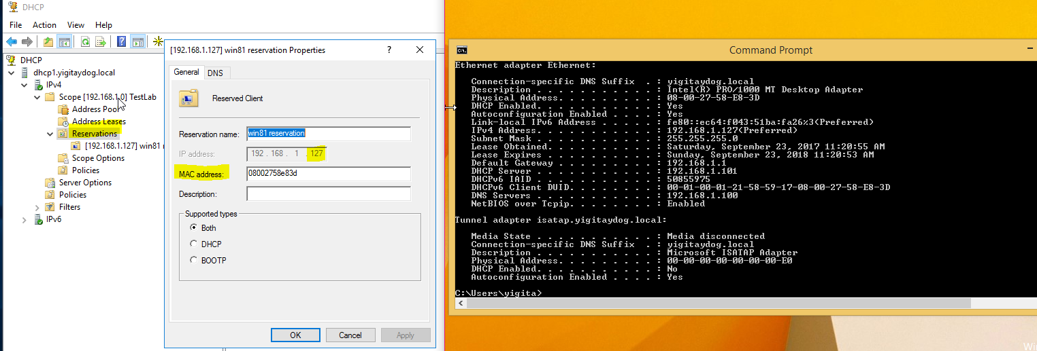

Mevcut ip almış cihaza reservation vermek

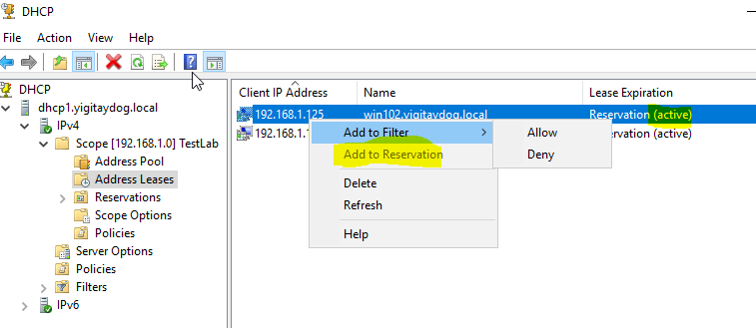

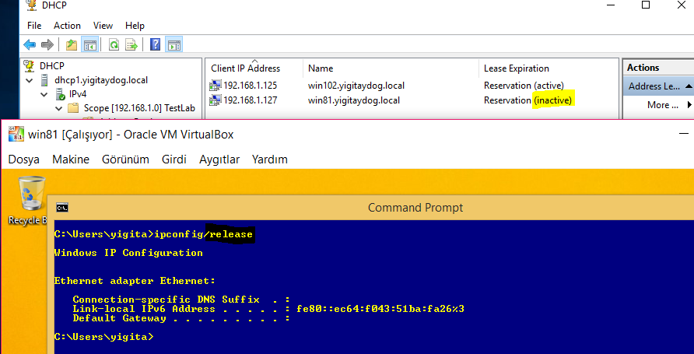

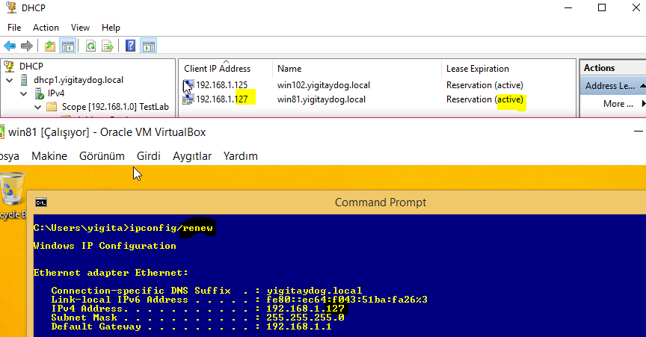

**Reservation’ları csv üzerinden toplu olarak yapmak**

ScopeID,IPAddress,Name,ClientID,Description 172.16.0.81, Client1, b1-ac-5a-f1-9e-6f,Reservation Client1 172.16.0.82, Client2, f1-bc-7a-f1-9a-1a,Reservation Client2 172.16.0.83, Client3, D1-a9-5b-e1-2a-6f,Reservation Client3

Save this file as C:\reservations.csv and run the following PowerShell command to create the DHCP reservations:

Import-Csv -Path C:\reservations.csv | Add-DhcpServerv4Reservation -computername DHCP1

**DHCP OPTIONS**

Server level>scope level>reservation level

>> Inheritance

<< who wins in conflict

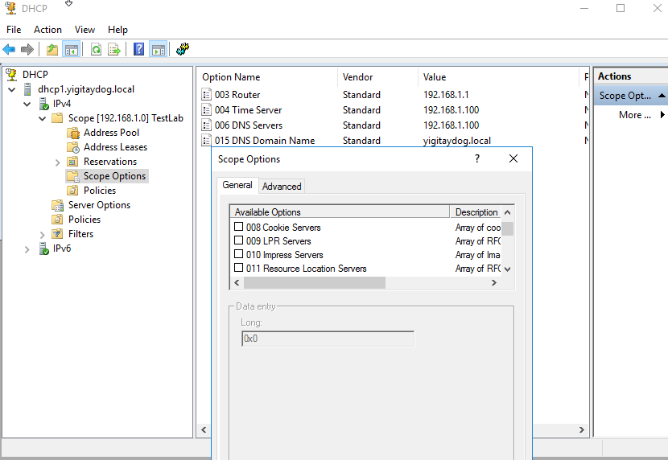

**Scope level**

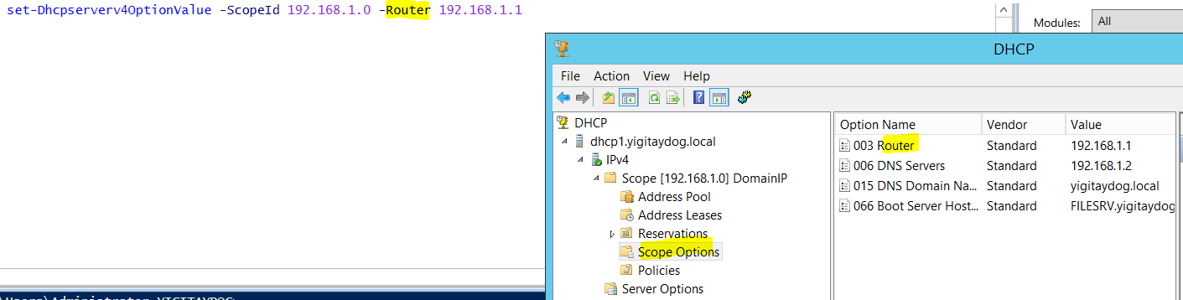

**Server level**

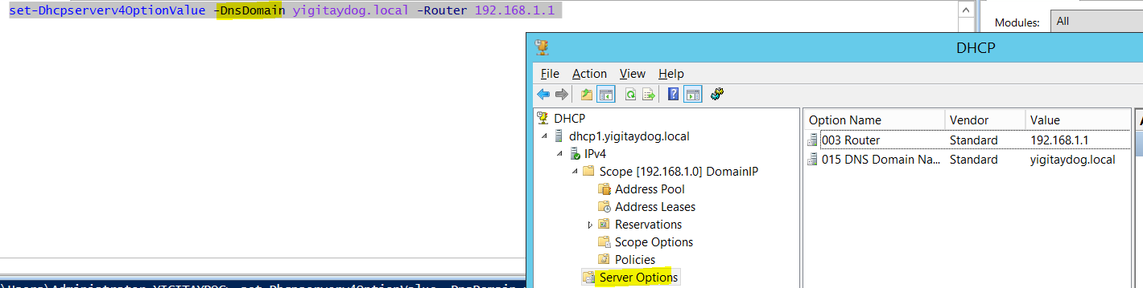

**ReservationLevel**

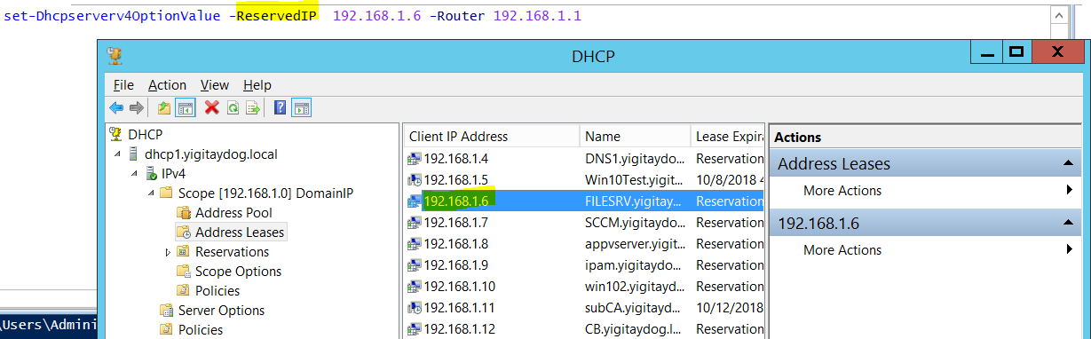

**DNS options**

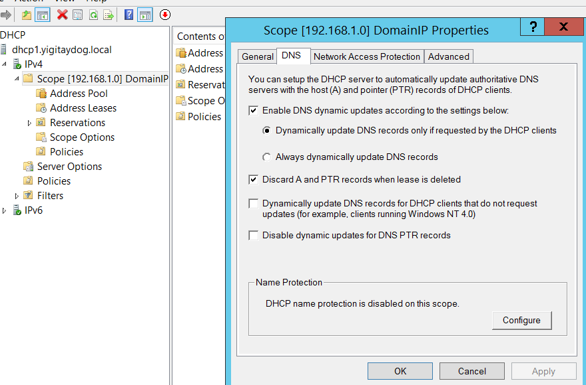

Name protection

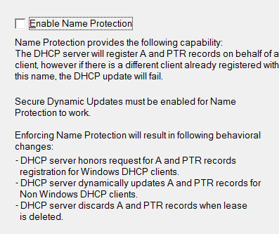

**Set**-**DhcpServerv4DnsSetting** -ComputerName "dhcpserver.pearson.com" -ScopeId 10.10.10.0 -DynamicUpdates "OnClientRequest" -NameProtection $True

**DHCP server binding settings**

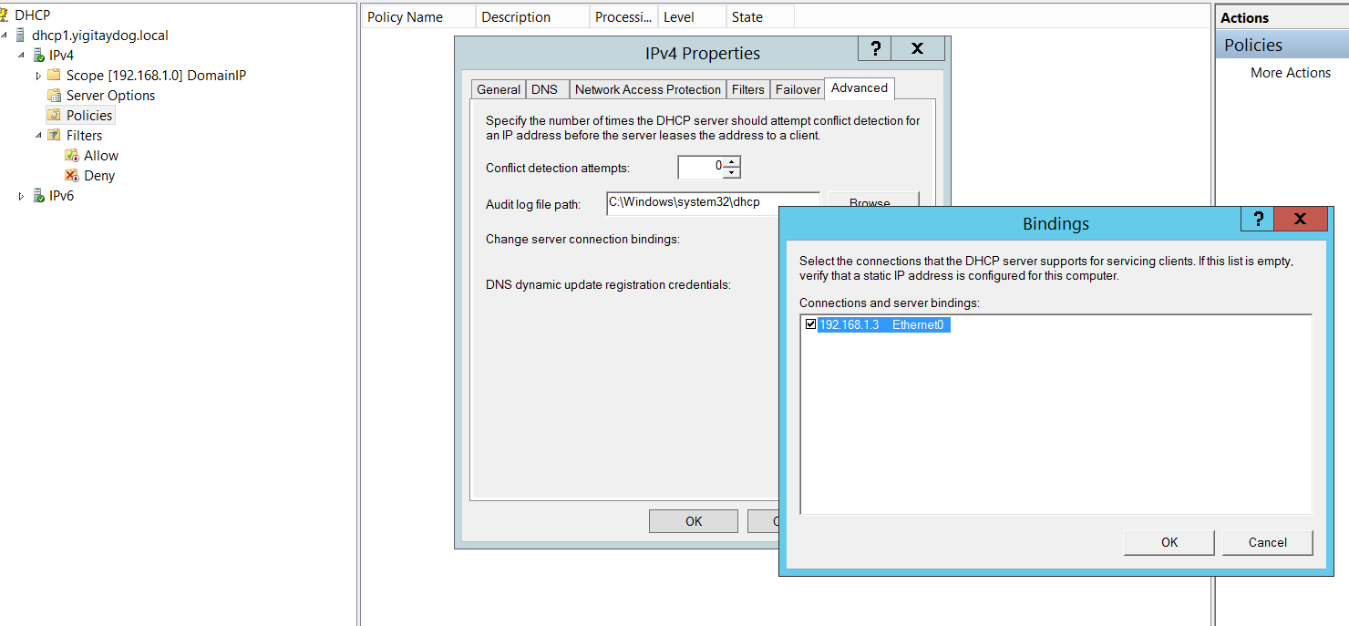

**RELAYING**

DHCP servers and clients can communicate only within their IP subnet. As a consequence, many networks have a DHCP server in each subnet.

The DHCP server sends DHCP offer and acknowledge packets back to the relay agent by using unicast broadcasts. The relay agent then broadcasts these packets on the local subnet.

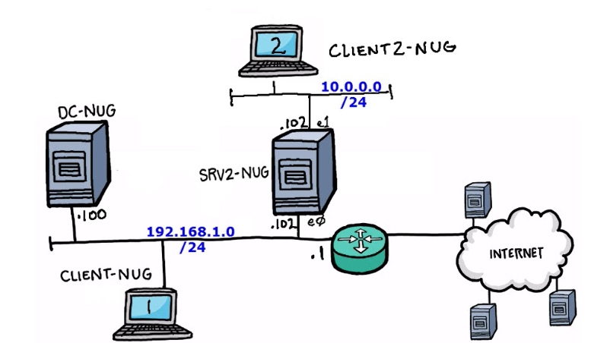

Client2 is not in domain

1. DC-NUG üzerinde scope oluşturulur

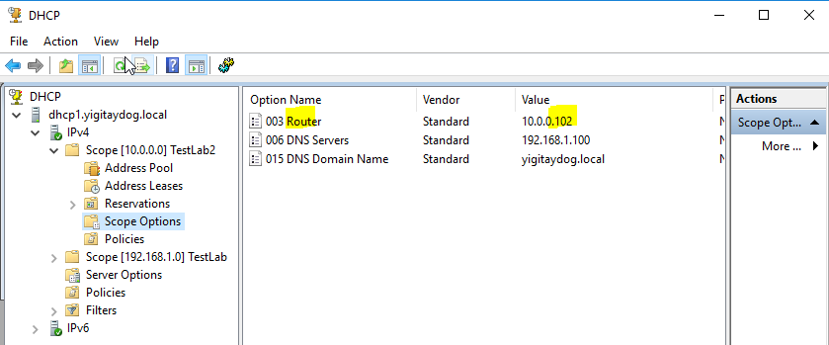

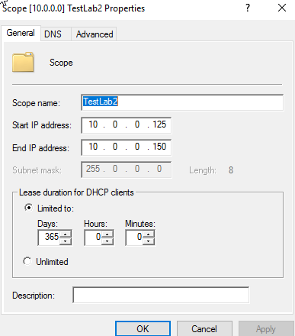

1. SRV2 üzerine “Remote Access” rolü kurulur “routing” ve “direct access ve vpn”role servisi kurulur

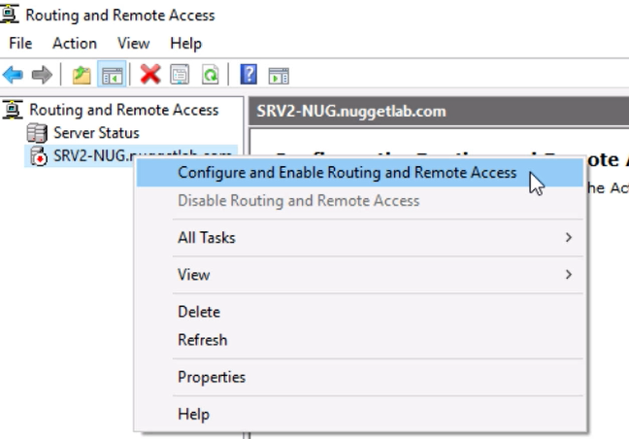

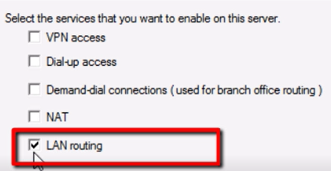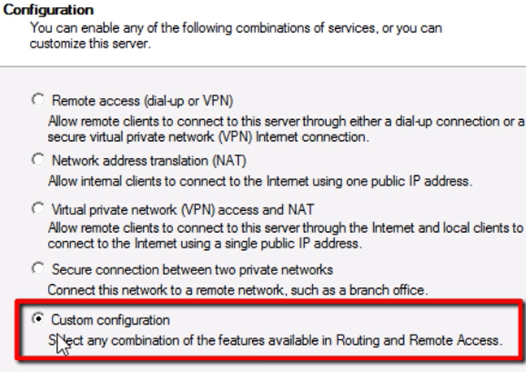

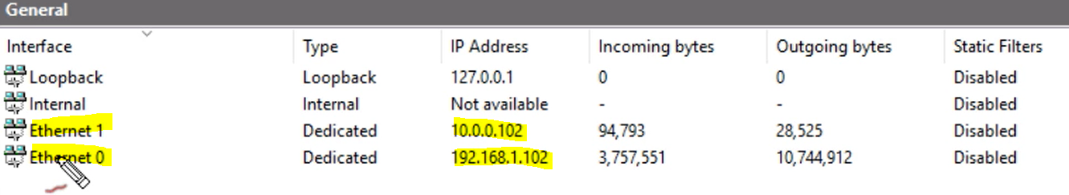

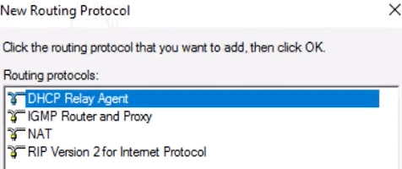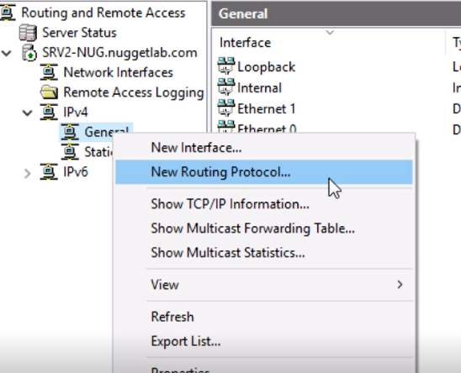

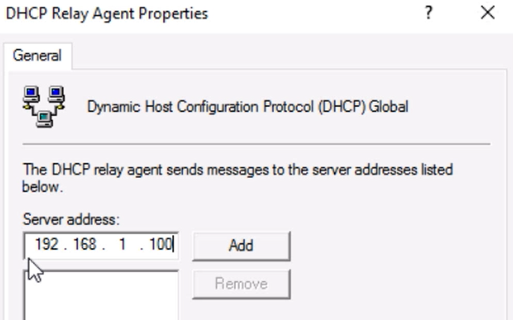

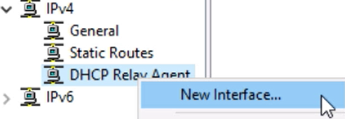

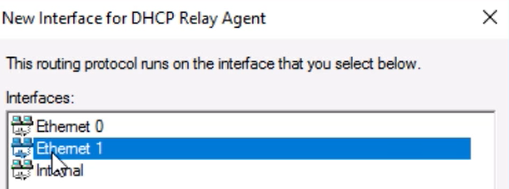

Ethernet1 üzerinde dhcp isteklerini alır

**DNS DYNAMIC UPDATE VIA DHCP ON BEHALF OF CLIENT**

Domain’e üye olan ama record’unu dns’e kaydedemeyen Client’lar DHCP’den ip aldığında kendi kaydını dhcp, dsn e kaydettirebilir. AD integrated zone’lar için geçerlidir.

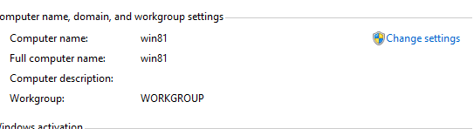

Not member of domain

A record’u DNS üzerinde yok

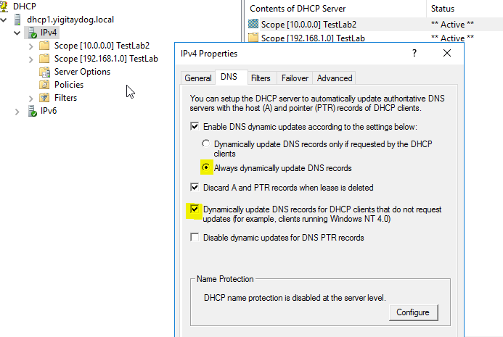

**DHCP PXE SUPPORT**

**Genel konfigurasyon**

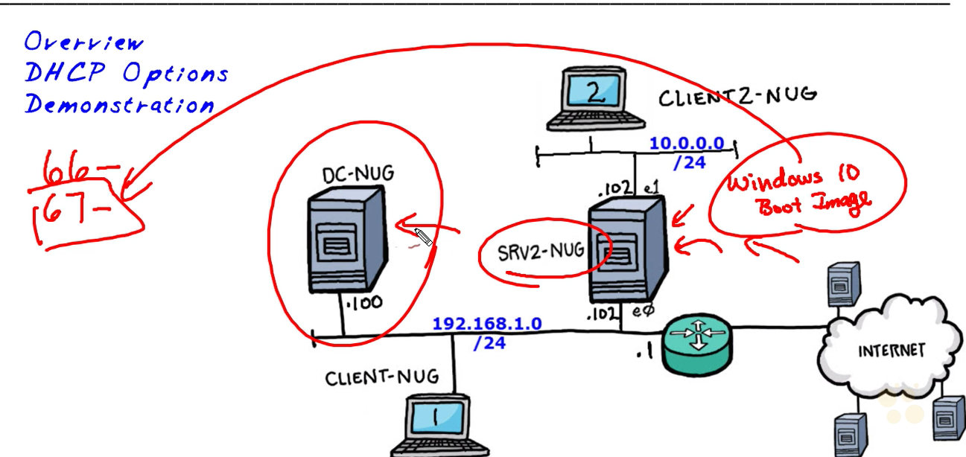

Srv2 üzerinde WDS rolü kurulur

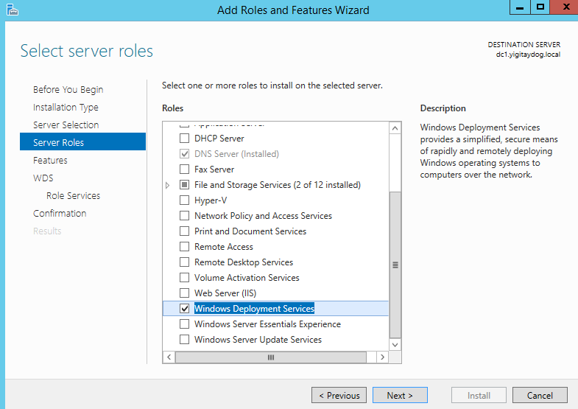

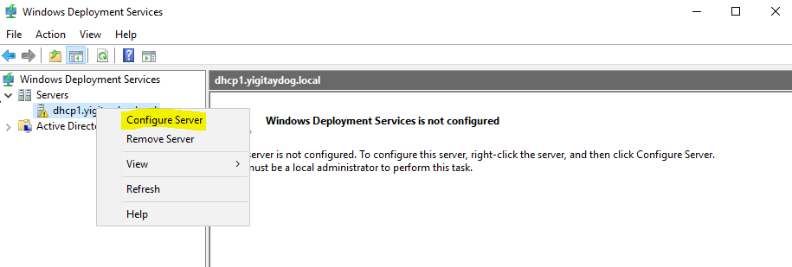

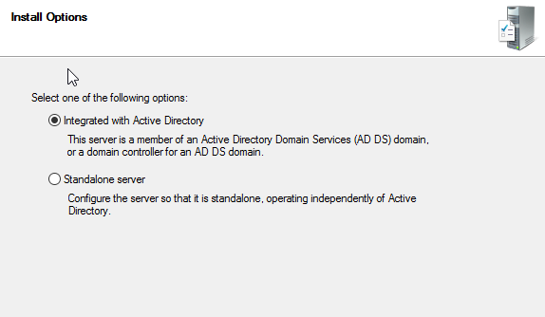

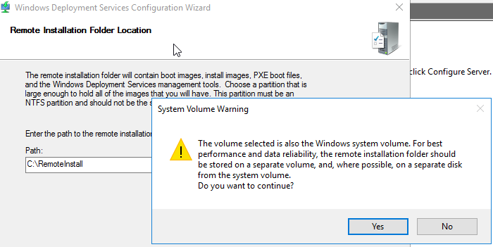

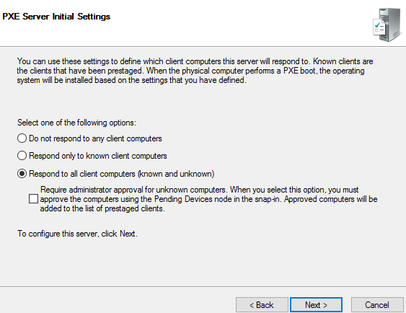

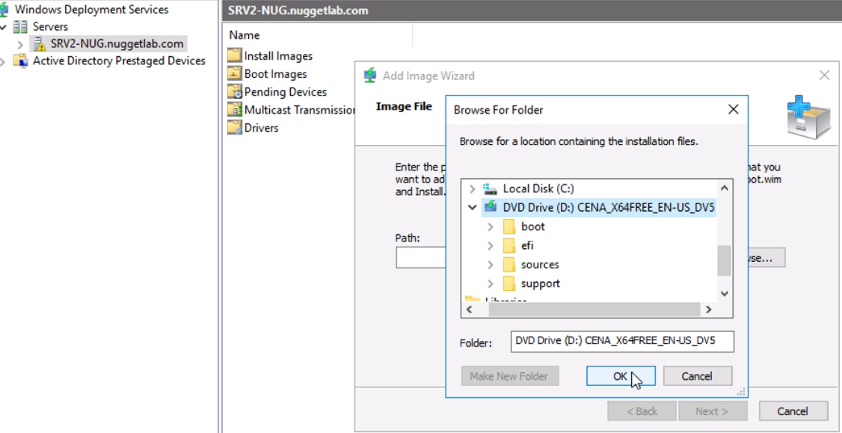

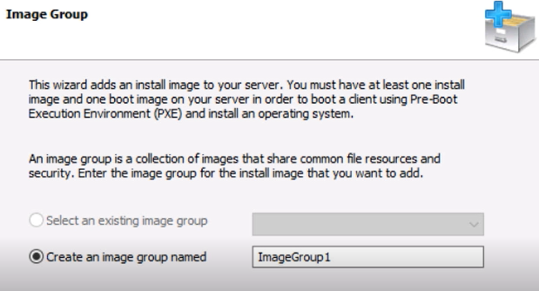

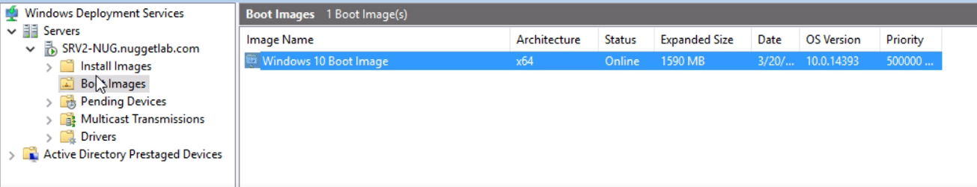

DC-nug dhcp server ve üzerinde scop ayarlarına 066 boot server host name ve 067 botfile name ekleme

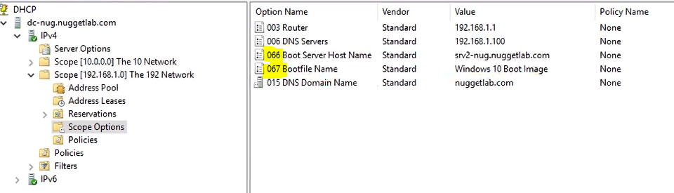

Client Settings

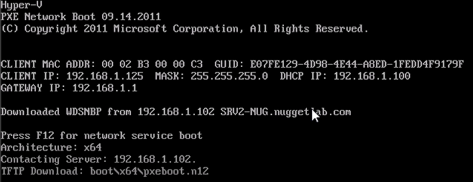

Connects to wds and download files

**SUPERSCOPE**

use a superscope to allow clients to receive an IP address from multiple logical subnets even when the clients are located on the same physical subnet.

add a new subnet to the DHCP server. This scope will lease addresses to clients in the same physical network, but the clients will be in a separate network logically. This process is known as *multinetting*. After you add a new subnet, you must configure routers to recognize the new subnet

Include 2 or more scopes

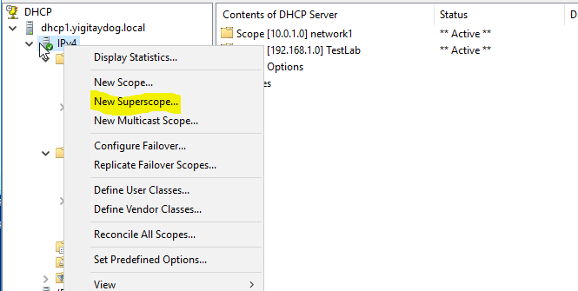



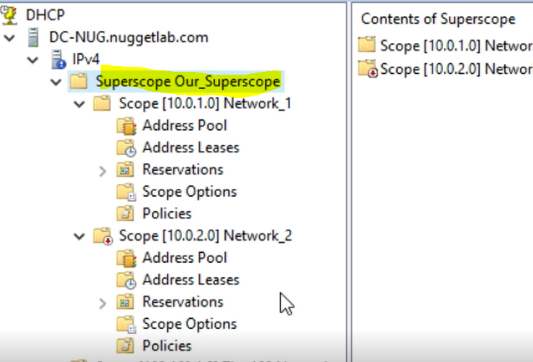

Multicast scopes

multicast addresses from the class D IP address range of 224.0.0.0 to 239.255.255.255

Multicast scopes allow applications to reserve a multicast IP address for data and content delivery.

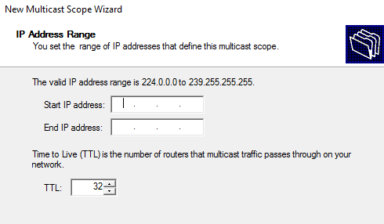

Multiple logical networks on same broadcast domain



**DHCP POLICIES**server level or scope level

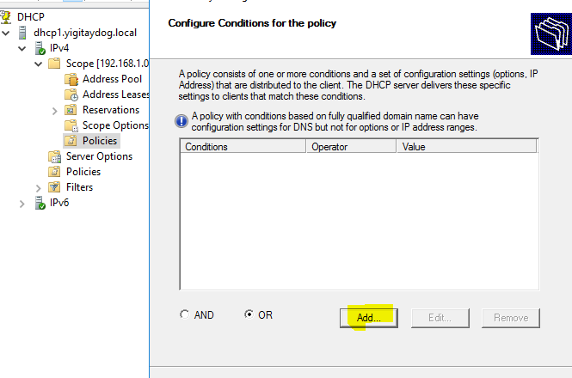

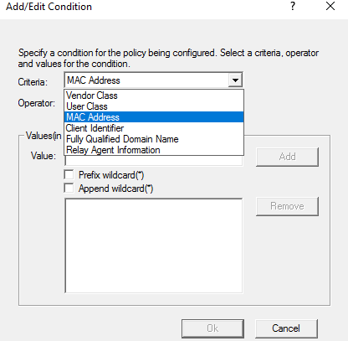

Kosullara göre ip aralığından ip verilebilir ya da scope ayarlarından verilebilir (verilmezse halihazırdaki scope ayarları kullanılır)

User Classes

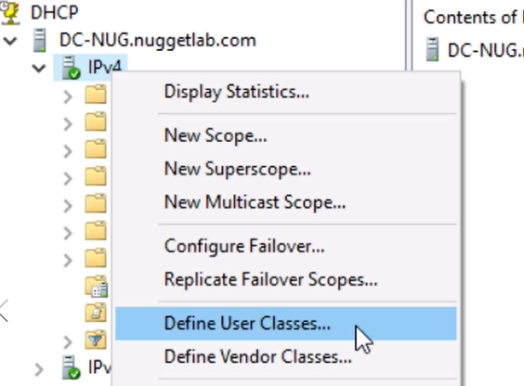

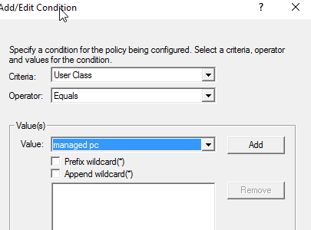



Policy ye göre ayar eklenebilir (örn.dns server,router etc.)

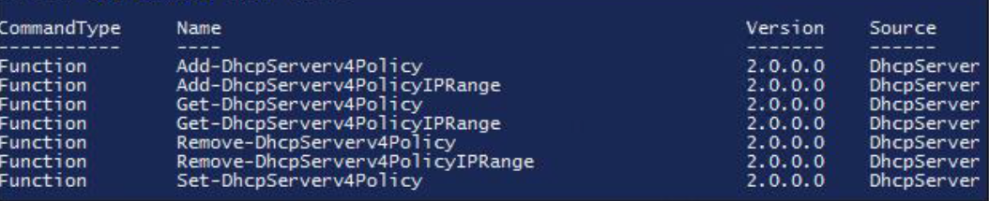

**BACK-UP DHCP**

The DHCP database is automatically backed up every 60 minutes

The following items are backed up:

All scopes

Reservations

Leases

All options, including server options, scope options, reservation options, and class options

All registry keys and other configuration settings that are set in DHCP server properties.

Database files

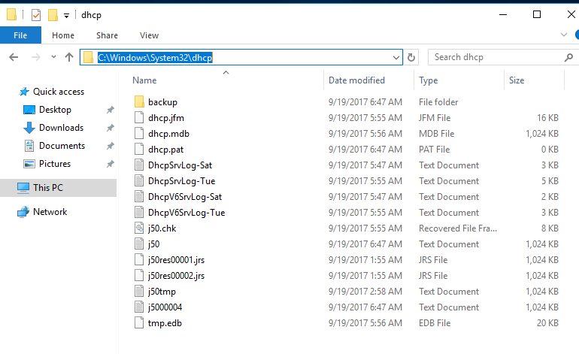

Backup-DhcpServer –Path “ “ >> to backup all dhcp data(leases,reservations)

Restore-DhcpServer

Back-up alınan konumdan restore ile database geri getirilir

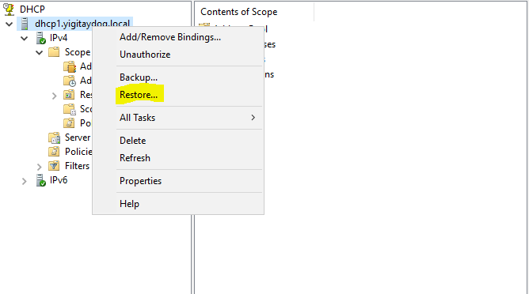

**Moving DHCP Database**

**Step 1.** Back up the DHCP database on the old server.

**Step 2.** Stop the old DHCP Server service.

**Step 3.** Copy the DHCP database to the new server and, if necessary, install the DHCP server role.

**Step 4.** Restore the database.

**Step 5.** Start the DHCP Server service.

**Migrating DHCP Server**

**Step 1.** Install the DHCP server role on the computer that will be the new DHCP server.

**Step 2.** Stop the DHCP service on the current DHCP server.

**Step 3.** Export the DHCP data from the current server.

**Step 4.** Copy the DHCP data to the new server (or make it available on the network).

**Step 5.** Import the DHCP data to the new server.

3- **Export-DhcpServer** -ComputerName D1 -Leases -File C:\d1.xml >>exports only configuration

5- **Import-DhcpServer** -ComputerName D2 -Leases -File C:\export\d1.xml -BackupPath C:\dhcp\

**SPLIT SCOPES**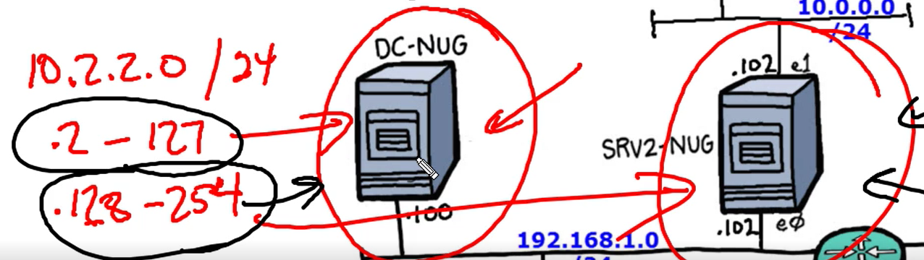

Scope’daki ip aralıkları 2sunucuya dağıtılır

İkincil sunucu srv2 de scope oluşturulur (10.2.2.0)

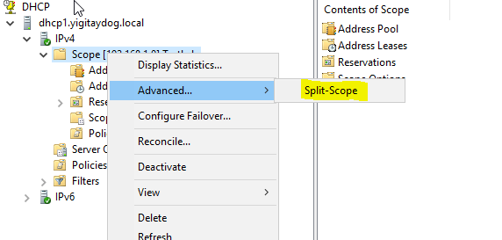

Aynı scope içerisindeki ip’leri iki sunucu üzerinden dağıtır

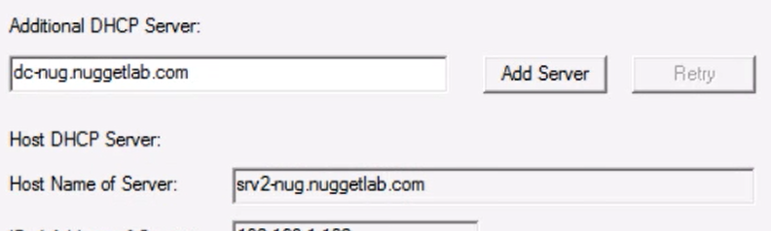

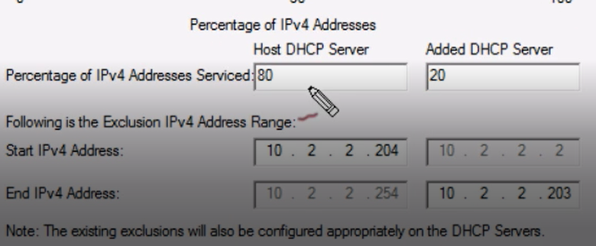

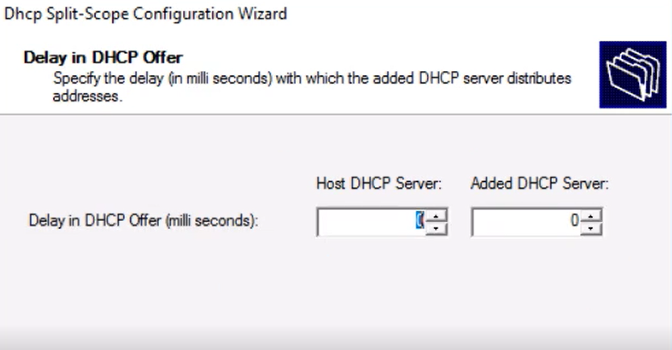

Önce cevap vermesi istenen dhcp’nin delay I düşüktür

En sonunda split edilmiş scope’lar aktifleştirilir

Split scope yapısında iki sunucu arasında replikasyon olmaz

**DHCP FAILOVER**

You cannot configure DHCP failover for more than two DHCP servers. In addition, DHCP failover cannot be used with IPv6 scopes and subnets.

Replication between 2dhcp servers

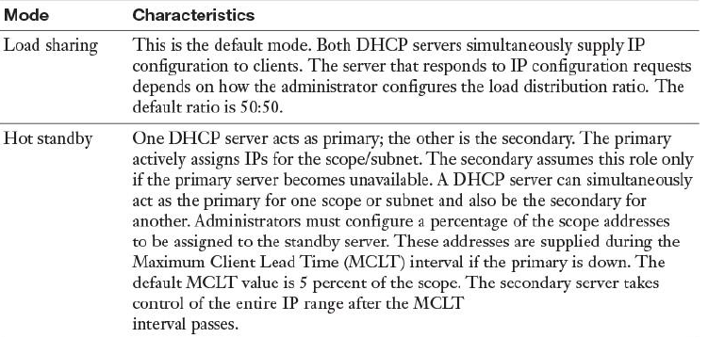

Load sharing or hot standby

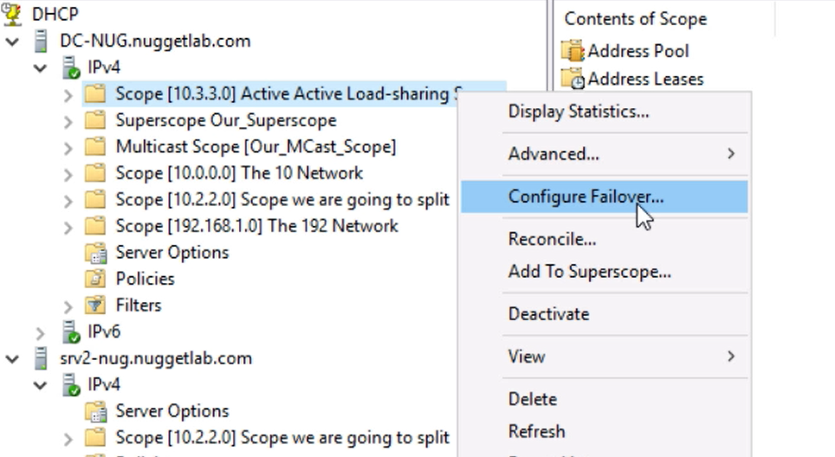

Choose partner server

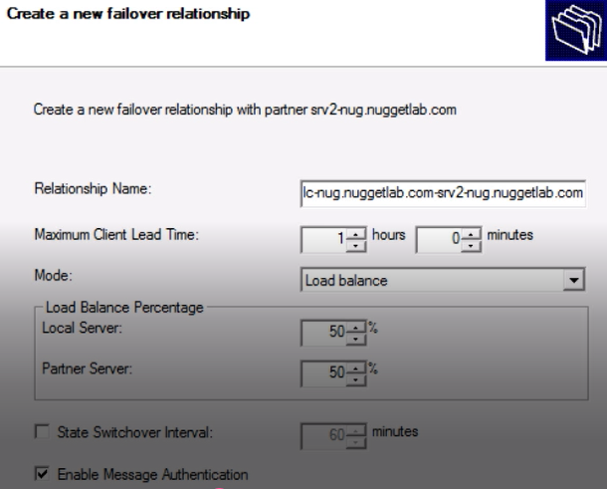

State switchover interval: eğer sunuculardan birine erişilemezse, bu interval sonrasında sunucu down dusunulur ve onun yükü diğer sunucuya gider

Failover tanımlandıktan sonra



Sonraki kurulumlarda seçilebilir

**Scope Replication**

Invoke-DhcpServerv4FailoverReplication

AutoStateTransition: in hot standby

Set-Dhcpserver4failover –AutoStateTransition $true

**DHCP MAC ADDRESS FILTERING**

Not hand out ip address for some specific MACs

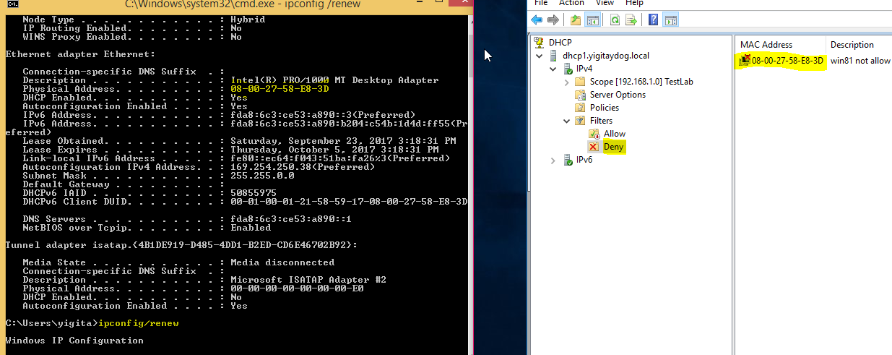

**CONFLICT DETECTION**

Ip vermeden once o ip’nin verilip verilmediğini deneme sayısı

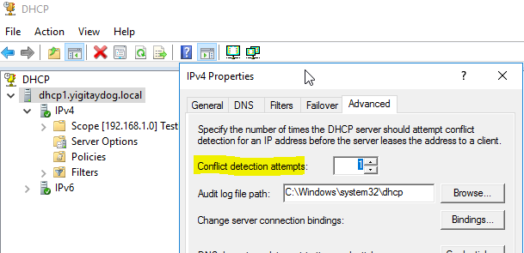



Repair-DhcpServerv4IPRecord>> Dhcp database’inde belli scope için registry ve database uyumsuzlugunu control eder

**TROUBLESHOOTING**

**Step 1.** Open the DHCP Manager.

**Step 2.** In the console tree, click the DHCP server you want to configure.

**Step 3.** On the **Action** menu, click **Properties**.

**Step 4.** On the **General** tab, select **Enable DHCP Audit Logging** and then click **OK**.

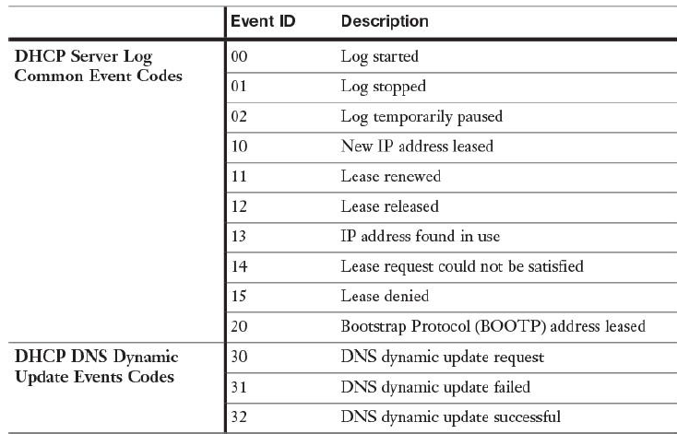

Configure IPv4 addresses and options

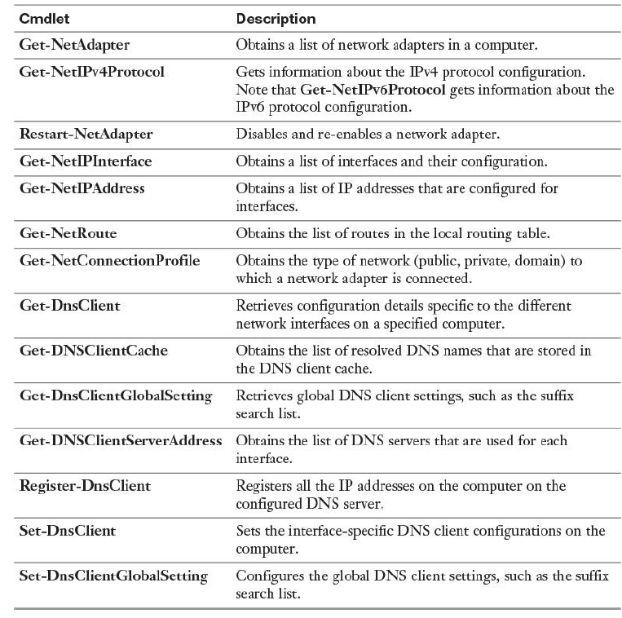

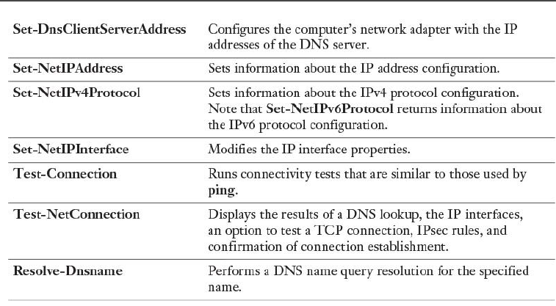

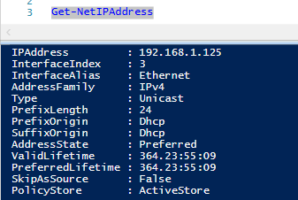

**New-NetIPAddress** -InterfaceAlias "Ethernet" -IPAddress 172.16.0.10 -PrefixLength 24 -DefaultGateway 172.16.0.1

**Set-DNSSclientServerAddress** -InterfaceAlias "Ethernet" -ServerAddresses 172.16.0.10, 172.16.0.11

**Set-NetIPInterface** -InterfaceAlias "Ethernet" -Dhcp Enabled **Restart-NetAdapter** -Name "Ethernet"

Network Adapter’lerini listelemek

Get-NetIpConfiguration >>>>>>>>>> adapter settings

Test-NetConnection >>>>>>>>>>>>>>>ping

* IPv4 Adreslerini powershell üzerinden vermek

New-NetIPAddress –InterfaceAlias “Ethernet” –IPv4Address “192.168.0.1” –PrefixLength 24 -DefaultGateway 192.168.0.254

Set-DnsClientServerAddress -InterfaceAlias Ethernet -ServerAddresses 10.0.1.10

Get-NetRoute –AddressFamily IPv4

Finding Routing Table

Get-NetRoute –AddressFamily IPv4

Private Address Ranges ipv4 (not routable over internet)

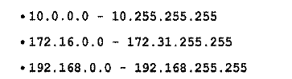



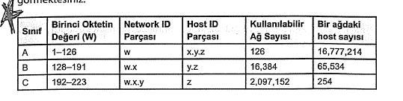

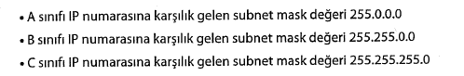

Default subnet masks

A>8

B>16

C>24

Subnets

192.168.1.0/24

192.168.2.0/24

192.168.3.0/24

Statik ip verilmediyse

DHCP server bul(1dakika) yoksa

Alternate configuration’a git

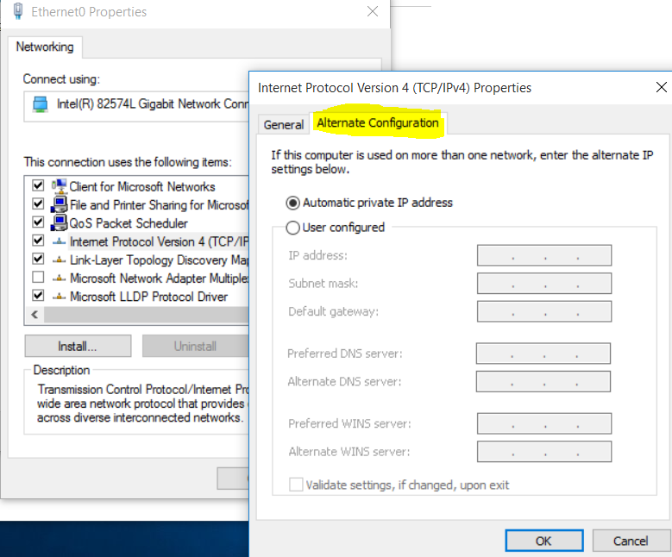

Automatic private IP address varsa

APIPA 169.254.x.x ‘ya düş

User configured IP varsa onu al

Her 5dk da bir DHCP var mı?

Bulursa oradan ip alıyor

Client boot edince

Renew the lease

Edemezse

default gateway’e ping atabilirse aynı subnetteyim, ip kalıyor

ping atamazsa APIPA adresi kalıyor

ipv4 loopback

127.0.0.1 >> makinanın kendisi, test amaçlı > ping loopback -4

İpv6 loopback

0:0:0:0:0:0:0:1 >> ::1

---Mac adresinin ilk 6karakteri(24bi) vendor specific----

Making smaller networks from a network

Saying goodbye to a few host bits

192.168.5.0/24

* Identify number of new subnets needed
* Identify bits to sacrifice (for 3subnets > 2bits sacrifice for 5subnets>3bits sacrifice, 32subnets>5bits sacrifice)
* Modify mask
* 2bits sacrifice new mask length 24+2

3bits sacrifice new mask length 24+3

New mask =26 >> 255.255.255.11000000 >> 255.255.255.192

Extra 1bt> 128

Extra 2bt> 192

Extra 3bt> 224

Extra 4bt> 240

Extra 5bt> 248

Extra 6bt> 252

Extra 7bt> 254

Extra 8bt> 255

Örnek

10.0.0.0/8 >> 42 new subnets needed >> 6more host bits needed

New mask 8+6=14

255.11111100.0.0 >>255.252.0.0

172.16.0.0 /16; 255.255.0.0 >> 172.16.0.0 /22 >> 255.255.252.0

10.0.0.0/8 >> 5-12 subnets >> 4host bits steal>> new mask (12) >255.240.0.0

Block size> >16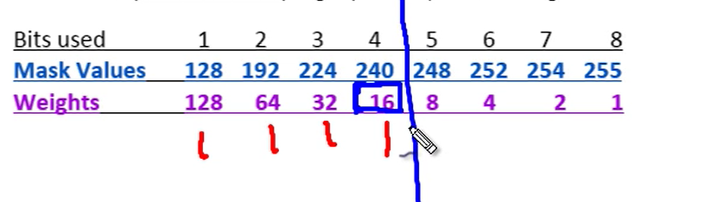

Subnets:

10.0.0.0/12

10.16.0.0/12

10.32.0.0/12

10.64.0.0/12

10.80.0.0/12

10.50.0.0/16 > 5-12 subnets >> 4host bits steal>> new mask (20)

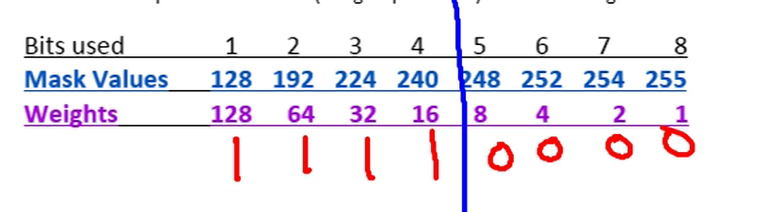

Subnets:

10.50.0.0/20

10.50.16.0/20

10.50.32.0/20

10.50.48.0/20

Range of valid IP address

7subnet needed

x.x.x.0/24 >> 3host bits needed

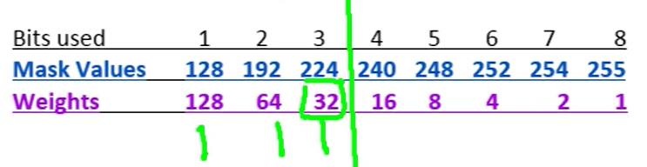



**C Type**

x.x.x.0/27

x.x.x.32/27

x.x.x.64/27

x.x.x.96/27

x.x.x.128/27 >> first host: x.x.x.129 / last host: x.x.x.158 / broadcast x.x.x.159

x.x.x.160/27

x.x.x.192/27 >> first host: x.x.x.193 / last host: x.x.x.158 / broadcast x.x.x.223

x.x.x.224/27

15new subnets needed >> 4host bits needed

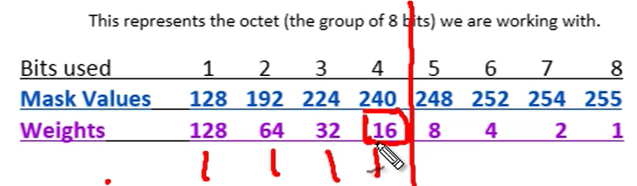

x.x.0.0/16

**B Type**

Subnets:

x.x.0.0/20 >> first host: x.x.0.1 / last host: x.x.15.254 / broadcast x.x.x.255

x.x.16.0/20

x.x.32.0/20 >> >> first host: x.x.32.1 / last host: x.x.47.254/ broadcast x.x.47.255

x.x.48.0/20

x.x.64.0/20

x.x.80.0/20

x.x.96.0/20

120new subnets needed >> 7host bits needed

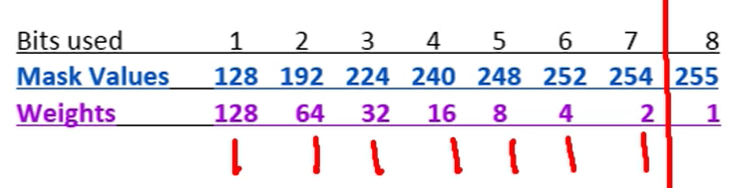

X.0.0.0 /8

**A Type**

Subnets

X.0.0.0 /15 >> first host: x.0.0.1 / last host: x.1.255.254/ broadcast x.1.255.255

X.2.0.0 /15>> >> first host: x.2.0.1 / last host: x.3.255.254/ broadcast x.3.255.255

X.4.0.0 /15

X.6.0.0 /15

X.8.0.0 /15

How Many Clients on subnet ??

* n= count number of host bits available (if mask length is 27 >> host available 32-27=5)

* how many clients> 2^n -2 (1subnet,1broadcast)= 30

IP&SUBNET MASK>>>>>subnet

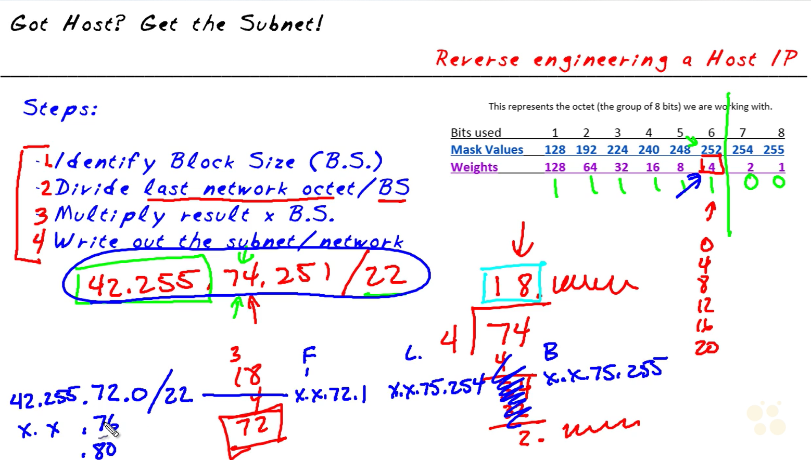

<http://www.subnet-calculator.com/subnet.php?net_class=A>

**IPV6**

16bit’lik (4oktet) 8parçadan oluşur,aralarına : konur

Kısaltma prosedürü:

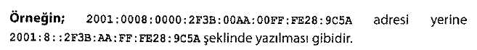

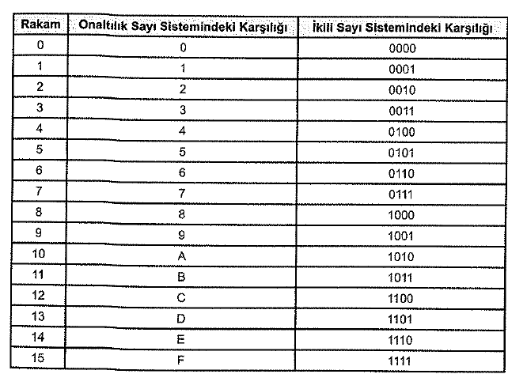

Ağ adresi (network address)>> 16it’lik ilk 3 parça

Alt ağ maskesi (subnet mask)>> Ağ adresinden sonraki ilk 16bitlik kısım

Ip address: son 16bitlik 4 parça

The prefix is equivalent to the network ID for IPv4 addresses

determine and configure appropriate IPv6 addresses

an IPv6 network interface typically has at least two addresses

An automatically generated **link-local address**, used for traffic on the local link

An additional **unicast address** (either a global address or a unique local address), used for traffic that needs to be routed beyond the local link

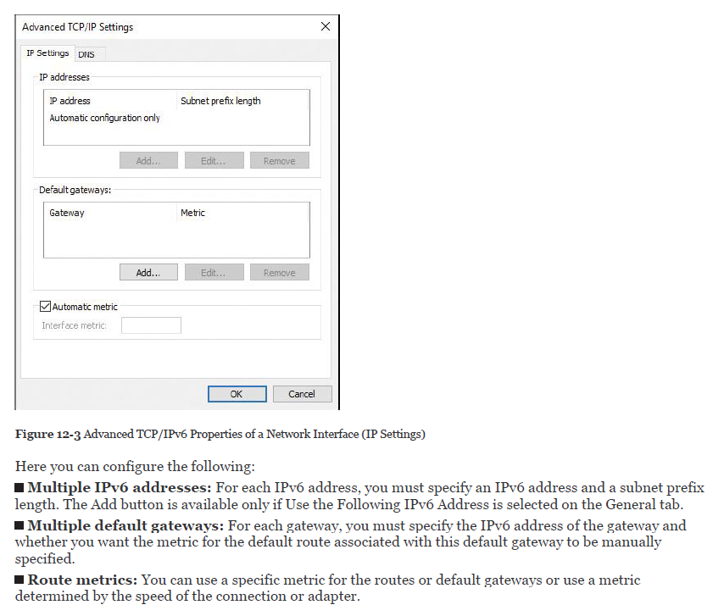

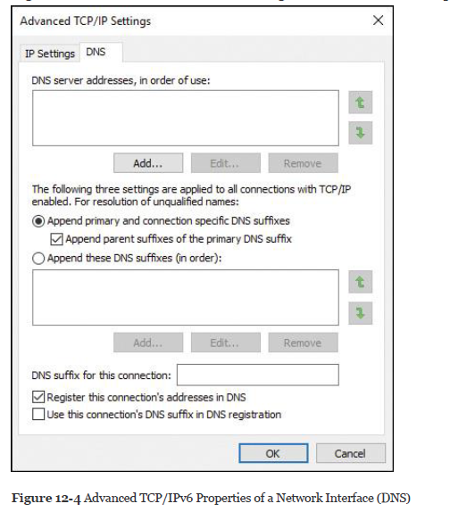

**DNS Server Addresses, in Order of Use:** Specifies the IPv6 addresses of DNS servers to query for resolving DNS domain names. DNS servers are queried in the order in which they are listed here.

**Append Primary and Connection-Specific DNS Suffixes:** Specifies that resolution for unqualified names is limited to the domain suffixes of the primary suffix and all connection-specific suffixes. The connection-specific DNS suffixes are configured in the DNS suffix for this connection.

**Append These DNS Suffixes (in Order):** Lists the DNS suffixes to search in the order listed.

**DNS Suffix for This Connection:** Provides a space for you to specify a DNS suffix for this connection, unless configured by stateful address autoconfiguration (DHCPv6).

**Register This Connection’s Addresses in DNS:** Specifies that the computer attempts dynamic registration of the IP addresses (through DNS) of this connection with the full computer name of this computer.

**Use This Connection’s DNS Suffix in DNS Registration:** If the checkbox is selected, this registration is in addition to the DNS registration of the full computer name.

IPv6 address assignment

Manually, by configuring one or more IPv6 addresses on the interface

Stateful, by using address autoconfiguration through a DHCPv6 server

Stateless, by using autoconfiguration based on the receipt of router advertisement messages

Stateful and stateless (both), by address autoconfiguration

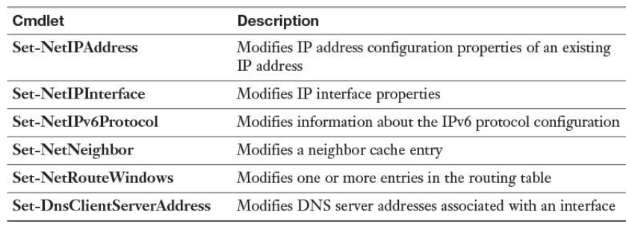



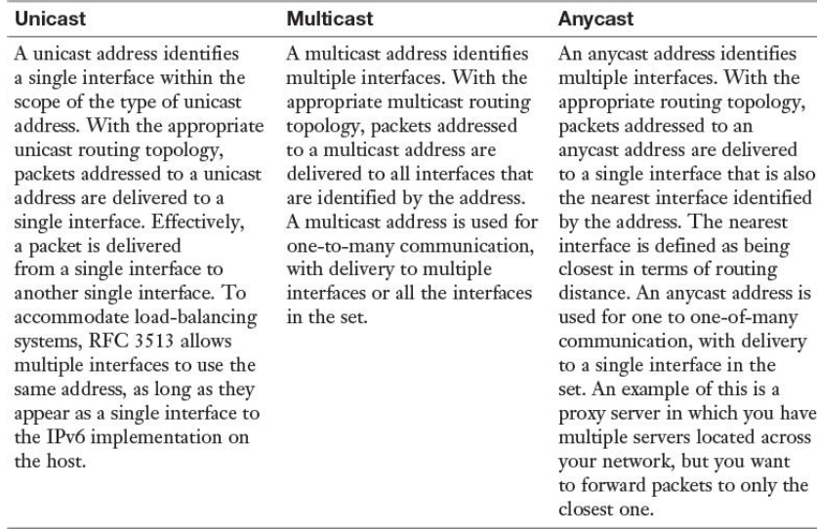

When a name can be resolved to both an IPv4 address and an IPv6 address, both addresses are returned to the client. The client then chooses which address to use, based on prefix polices. A higher precedence is preferred over a lower precedence.

**Get-NetPrefixPolicy**

* IPv6 Adreslerini powershell üzerinden vermek

New-NetIPAddress –InterfaceAlias “Ethernet” –IPAddress 2001:db8:6783::102 –PrefixLength 64

-DefaultGateway 2001:db8:6783::100

Örnek yapı

Ağ adresi+alt ağ maskesi>> fda8:06c3:ce53:a890

Cihazlar

fda8:06c3:ce53:a890:0000:0000:0000:0001 >> fda8:06c3:ce53:a890::1 (DC) >static yapılandırılır

fda8:06c3:ce53:a890:0000:0000:0000:0002 >> fda8:06c3:ce53:a890::2 (DHCP) >static yapılandırılır

fda8:06c3:ce53:a890:0000:0000:0000:0002 >> fda8:06c3:ce53:a890::3 (win81client)

fda8:06c3:ce53:a890:0000:0000:0000:0005 >> fda8:06c3:ce53:a890::10 (ağ geçidi)

DNS sunucuda ipv6 yapılandırılması

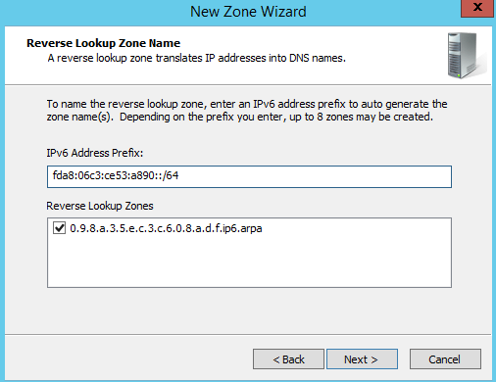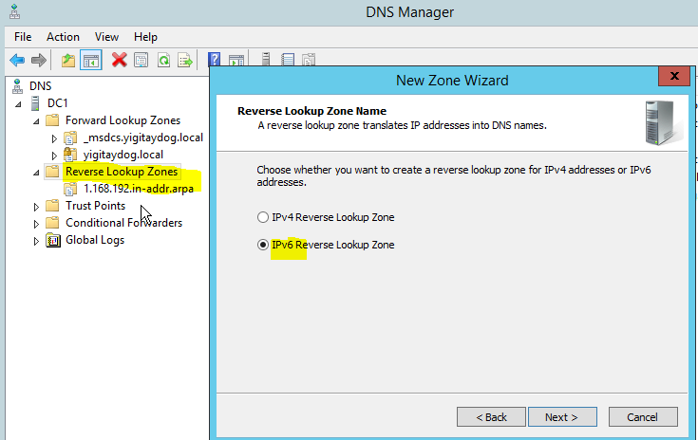Reverse lookup zone üzerinde

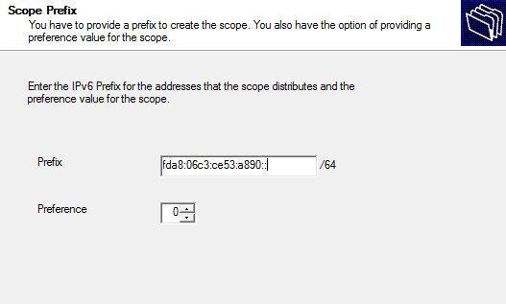DHCP sunucuda ipv6 yapılandırılması

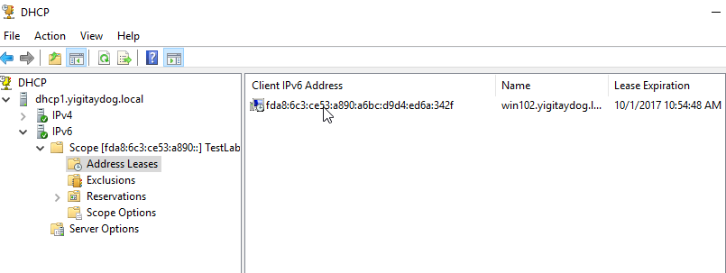

Ipv6 yapılandırıldıktan sonra 6to4, Teredo, IP-HTTPS (ipv6 trafiğini ipv4 ağı üzerinden https kullnarak dönüştürme) gibi dönüştürme standartları le ipv4 ağları üzerinden yönlendirilebilir

* DC ve DNS üzerinde ipv6 yapılandırılmalıdır
* Exchange,SQL,SharePoint de ipv6 yapılanmalı
* Ağ cihazları üzerinde ipv6 yapılandırılmalı

Private Address Ranges ipv6

FD ile başlayan adresler

Ipv6 ping

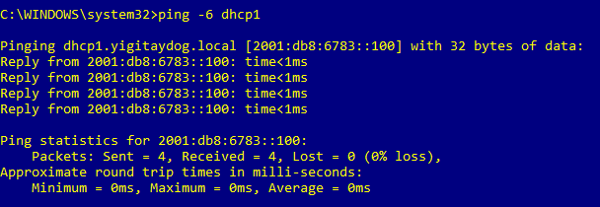

Scope

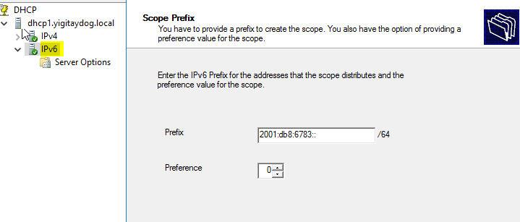

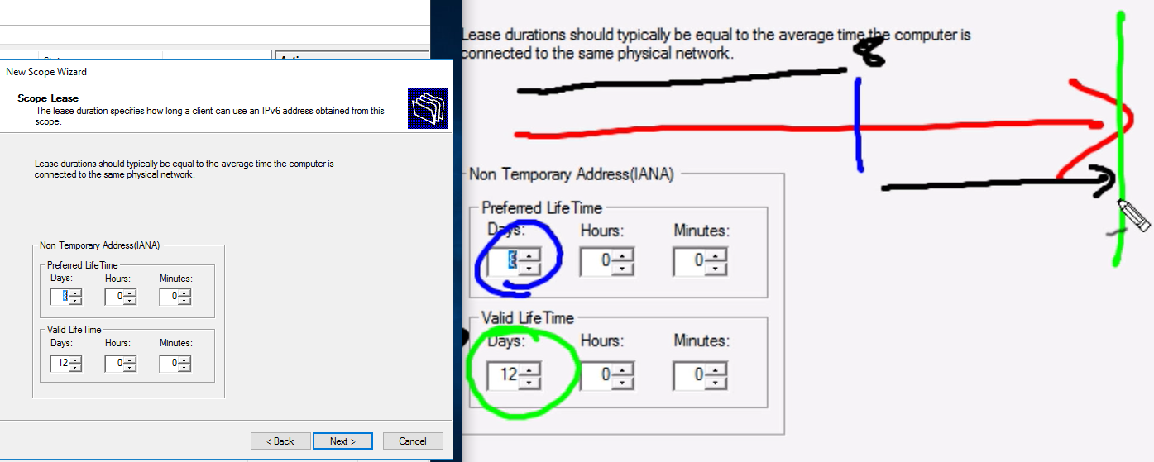

**Implement IPv6 Stateless Addressing**

With stateless autoconfiguration, IPv6 address configuration is based on the receipt of router advertisement messages only.

When you use an ISATAP router to provide stateless IPv6 to deliver an IPv6 IP address automatically to a host, forwarding *and* advertising must be enabled on the ISATAP interface

**New-NetRoute** -InterfaceIndex 22 -Destination Prefix 2001:db8:0:2::/64 -Publish Yes.

This command adds the IPv6 network 2001:db8:0:2::/64 to the routing table and enables IPv6 stateless configuration for that network for DHCPv6 clients.

**configure interoperability between IPv4 and IPv6 by using ISATAP, 6to4, and Teredo scenarios**

IPv6 over IPv4 Tunneling

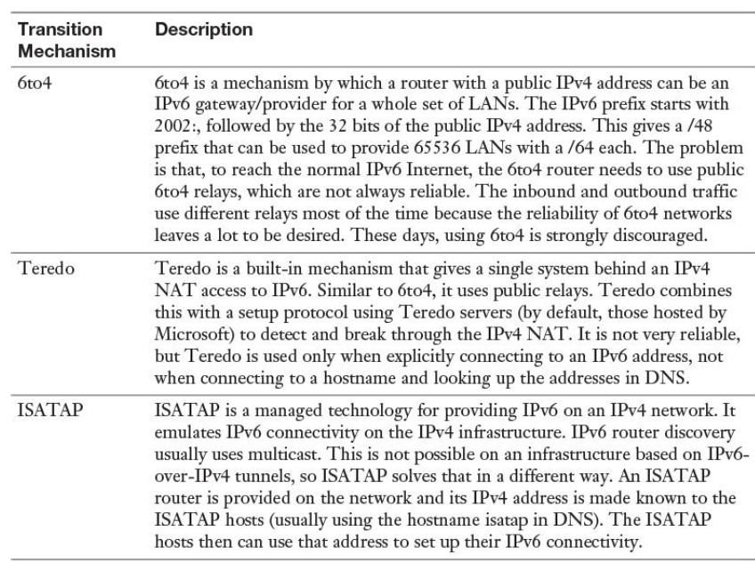

**6to4**

cannot work with NAT.

If the computer is configured with a public IP address, the operating system enables the 6to4 tunnel adapter so that the computer can be configured to connect to IPv6 by using the 6to4 technology

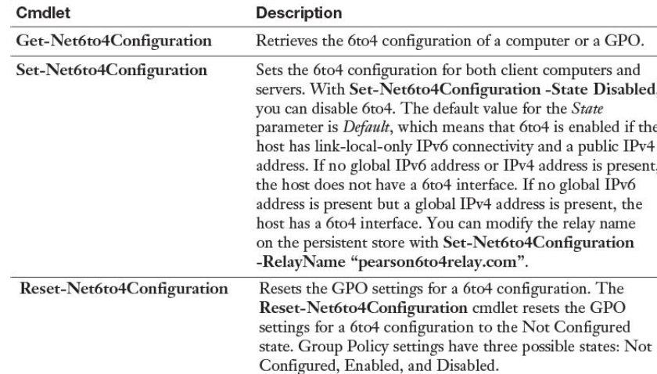

**Teredo**

Teredo does work with NAT.

IPv6 communication between two Teredo clients over the IPv4 Internet requires a Teredo server hosted on the IPv4 Internet.

both Teredo clients initiate communication with the Teredo server. After connection is initiated with the Teredo server, and after the NAT device has allowed outbound communication, any further communication occurs directly between the two Teredo clients.

You can configure a Windows Server 2016 server as the following:

Teredo client

Tereo relay

Teredo server

To configure Teredo, use the Windows PowerShell cmdlet **Set-NetTeredo-Configuration**. The default configuration for Teredo is as a client. When a computer is configured as a Teredo client, Teredo is disabled when the computer is attached to a domain network. To enable Teredo on the domain network, you must configure the computer as an enterprise client.

**IPAM (IP ADDRESS MANAGEMENT)**

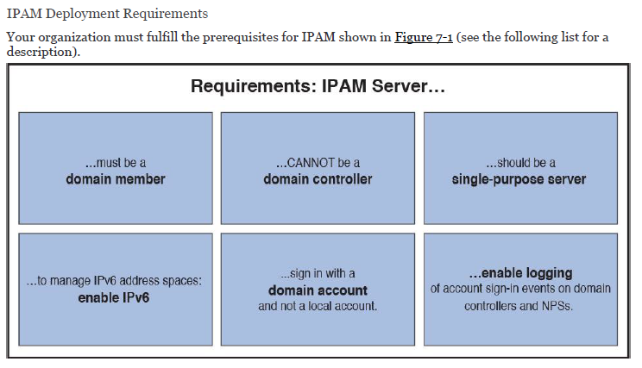

IPAM servers do not communicate with each other or share database information. No IPAM replication feature exists. If you deploy multiple IPAM servers, you must customize each server’s discovery scope locally on each IPAM server.

Server with ipam cannot be domain controller!

Feature üzerinden ipam rolü kurulur

2012R2 den itibaren kendi üzeride SQL database kurulabiliyor

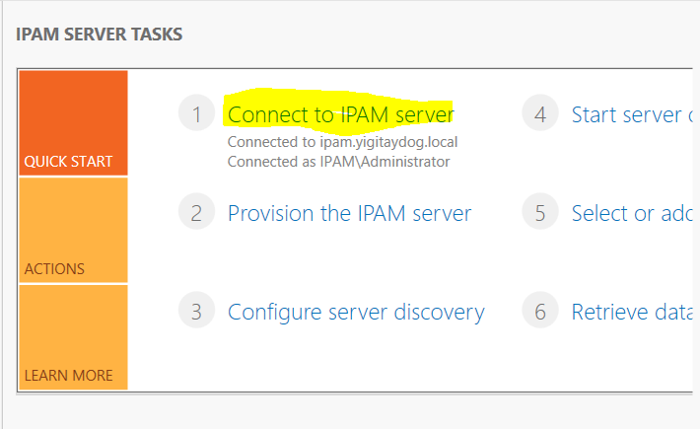

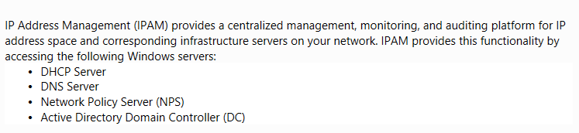

GPO based provisioning

so that the IPAM server can access the DHCP files in either the C:\windows\system32\dhcp folder for managed DHCP servers or the C:\windows\system32\dns folder for DNS servers

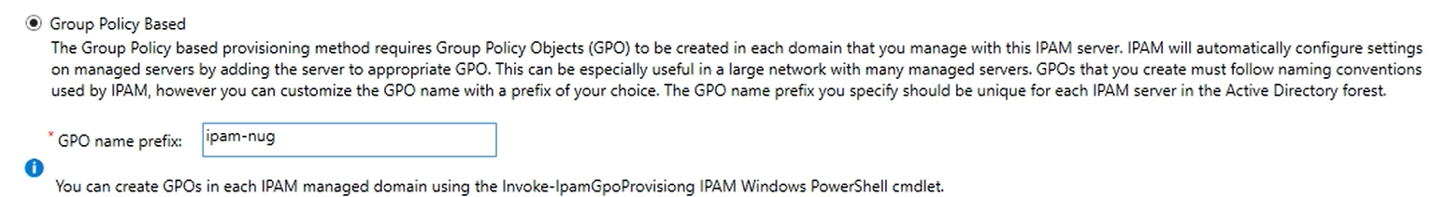

Ipam server üzerinde

Invoke-IpamProvisioning –Domain yigitaydog.local –GpoPrefixName ipam-nug

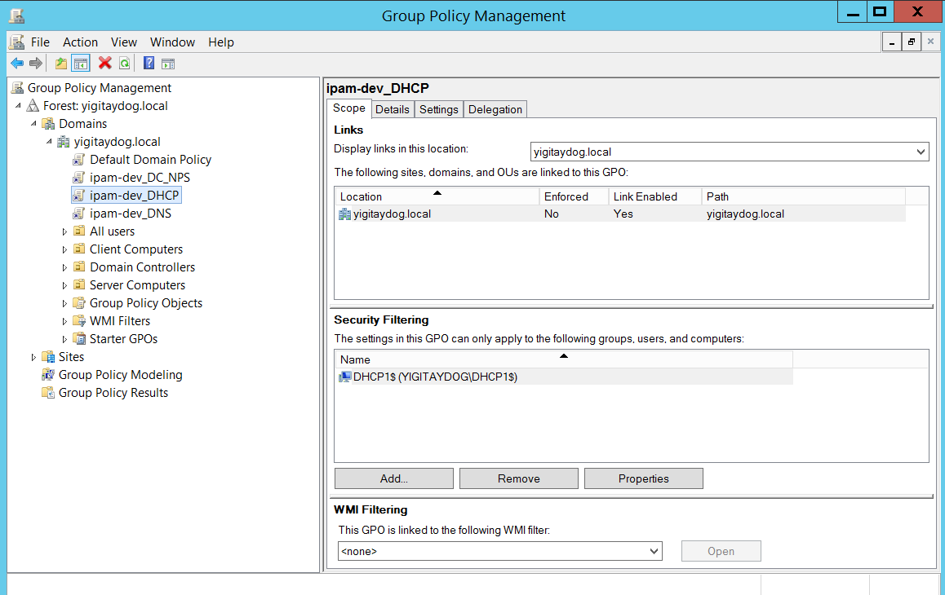

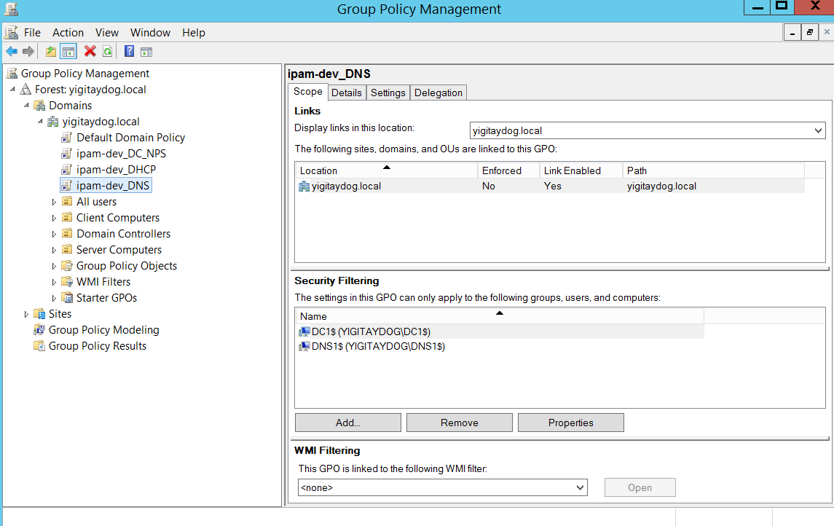

How it works?

IPAMUG is a domain security group that has IPAM server as a member. IPAMUG security group automatically becomes member of local EventLogReaders security group of the managed servers so that IPAM server can get access to DHCP events

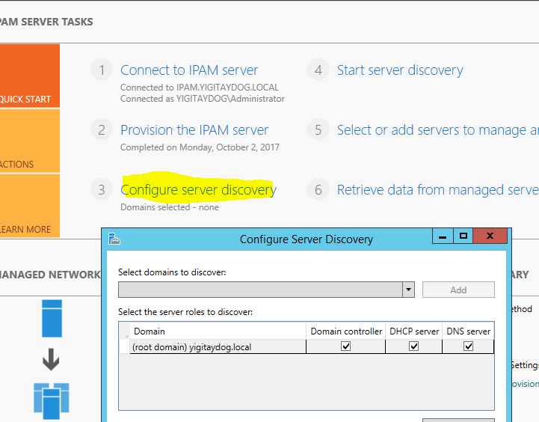

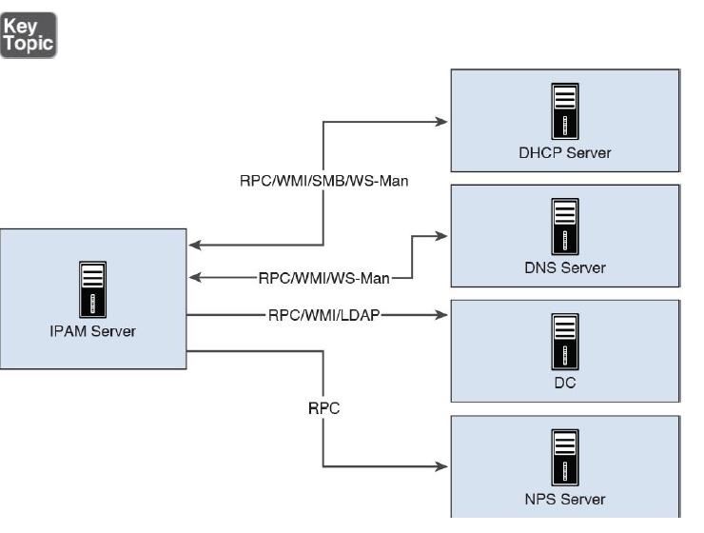

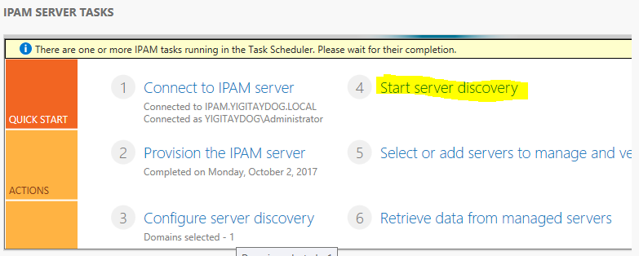

Start server discovery manually

Add-ipamdiscoverydomain>> Adds a new Active Directory domain to the list of domains in which IPAM discovers infrastructure servers.

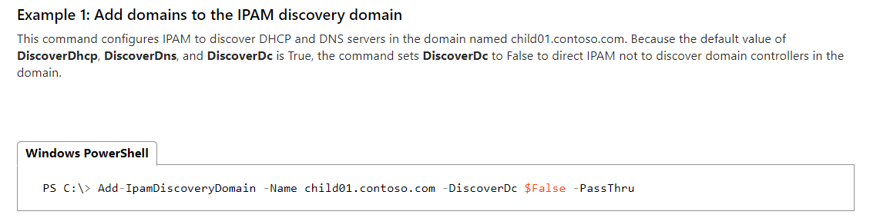

Add-ipamaddress >> adds an IP address to IP Address Management (IPAM)

Invoke-ipamserverprovisioning

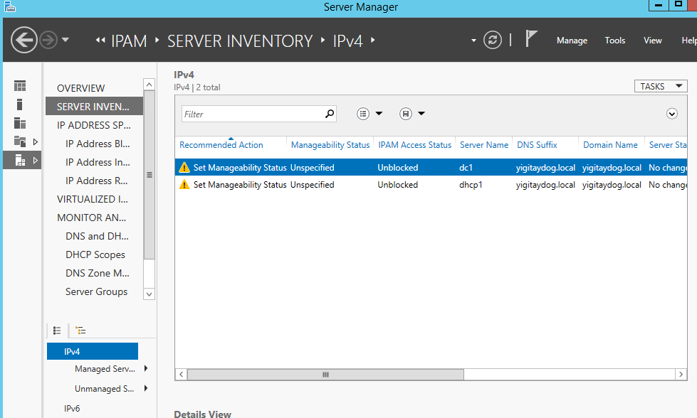

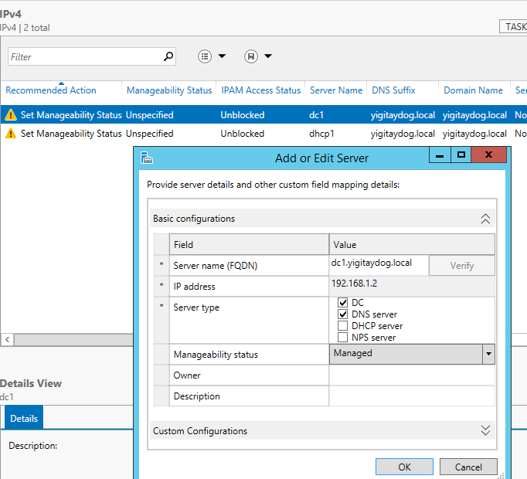

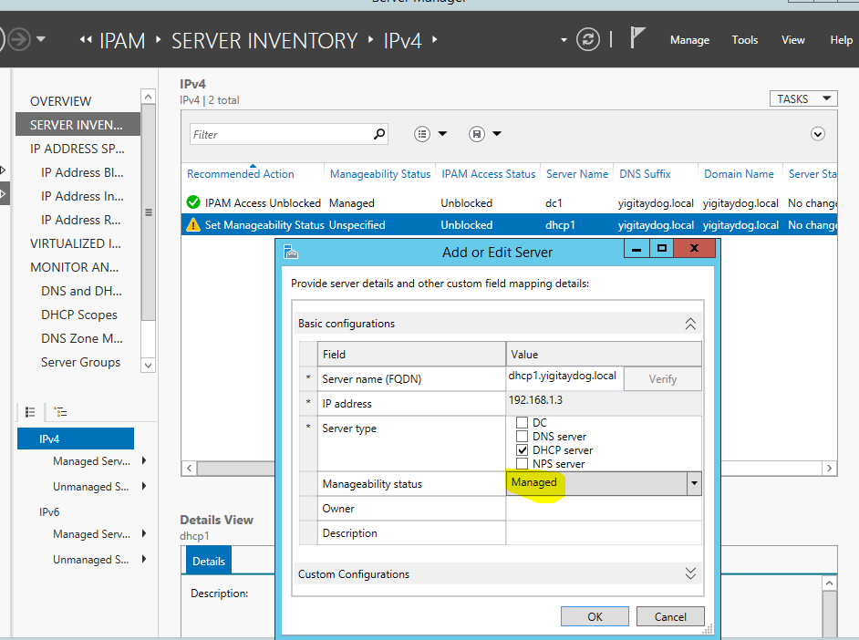

IPAM KONSOLU

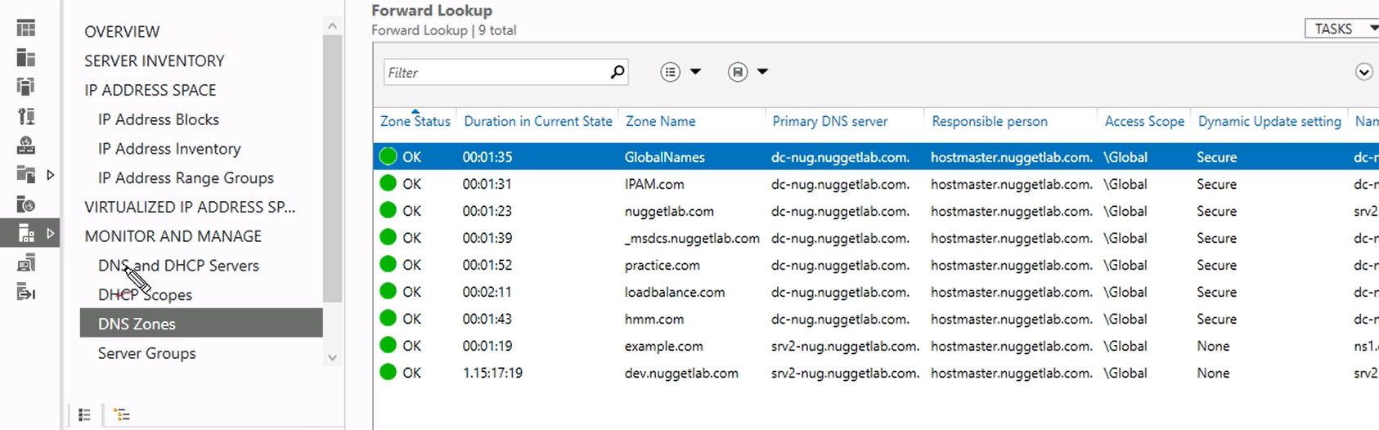

create and manage IP blocks and ranges

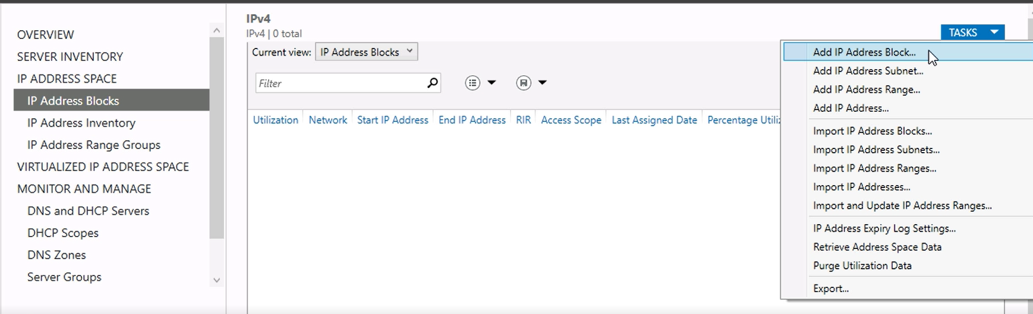

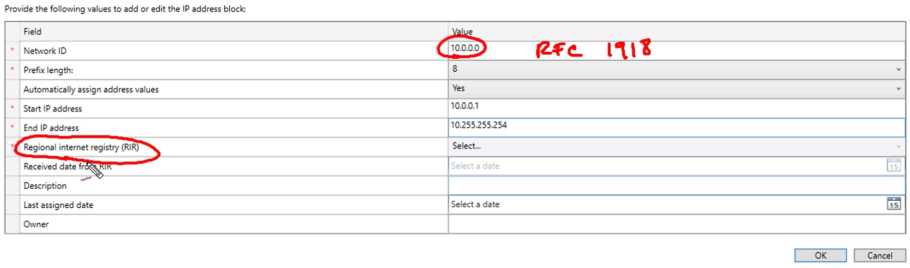

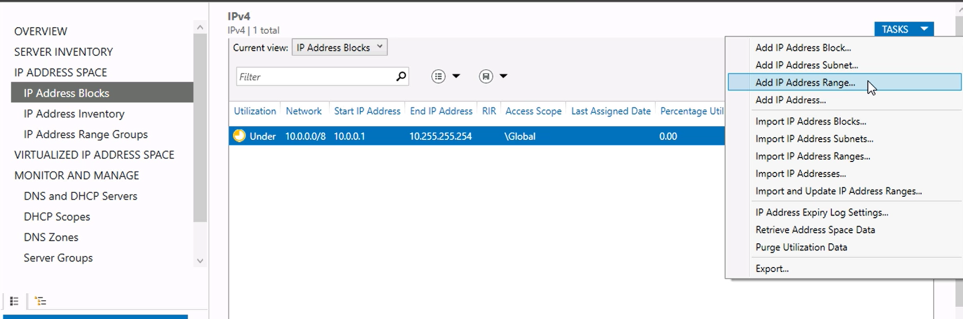

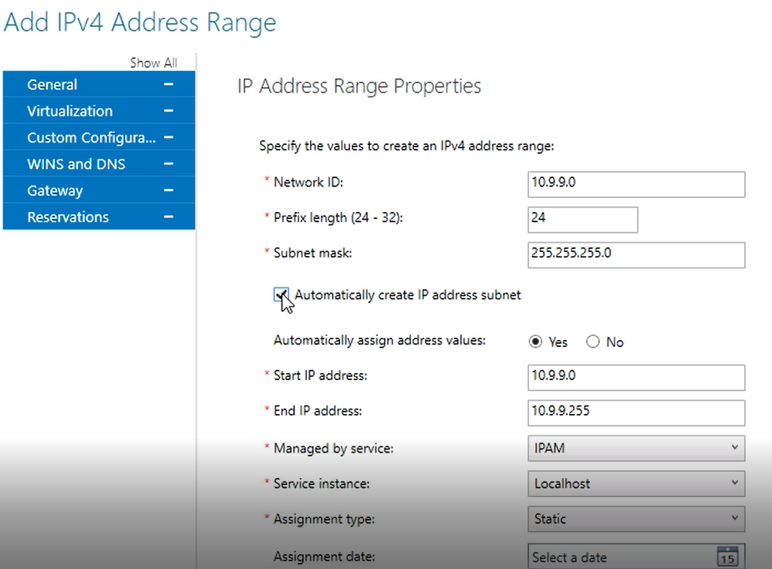

monitor utilization of IP address space,

IPAM maintains utilization data for IP address ranges, address blocks, and range groups. You can configure thresholds for the utilized percentage of the IP address space and then use those thresholds to determine under- or overutilization.

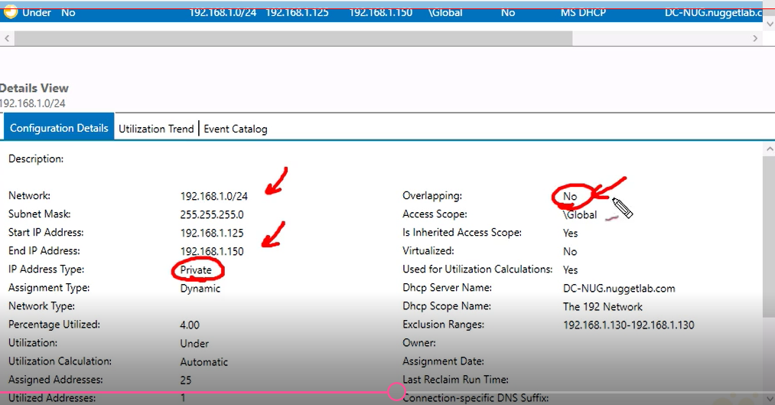

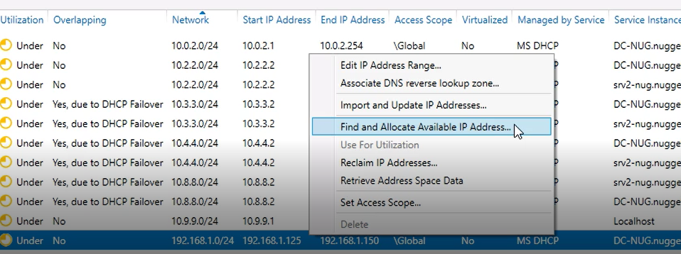

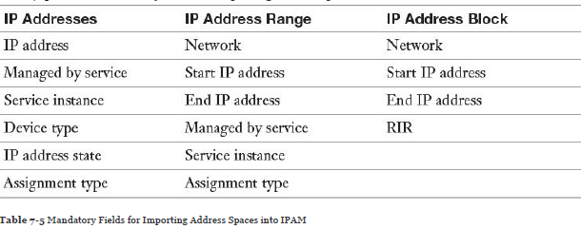

**configure IPAM database storage using SQL**

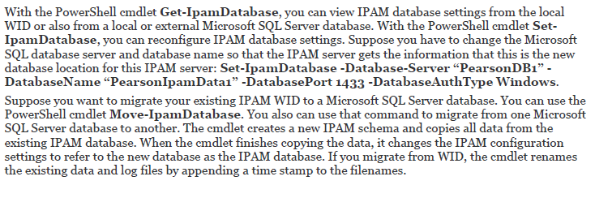

**Determine scenarios for using IPAM with System Center Virtual Machine Manager for physical and virtual IP address space management**

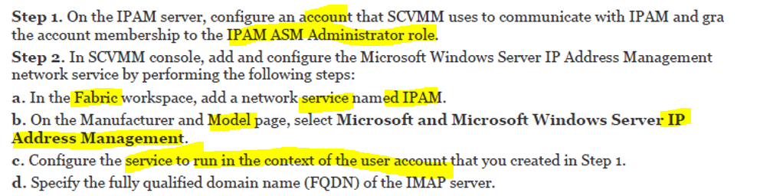

**delegate administration for DNS and DHCP using role-based access control (RBAC)**

user-role, access scope, access policy

An *access scope* defines the business hierarchy model based on the desired administration levels and controls. By default, IPAM includes an access scope named Global

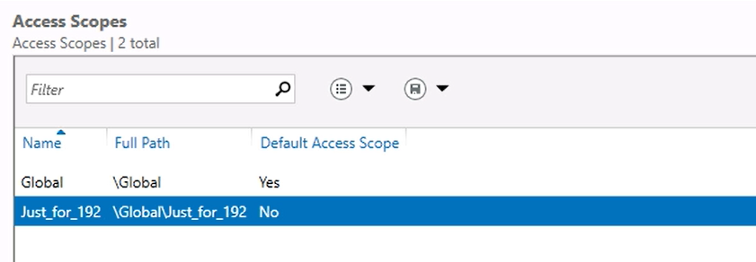

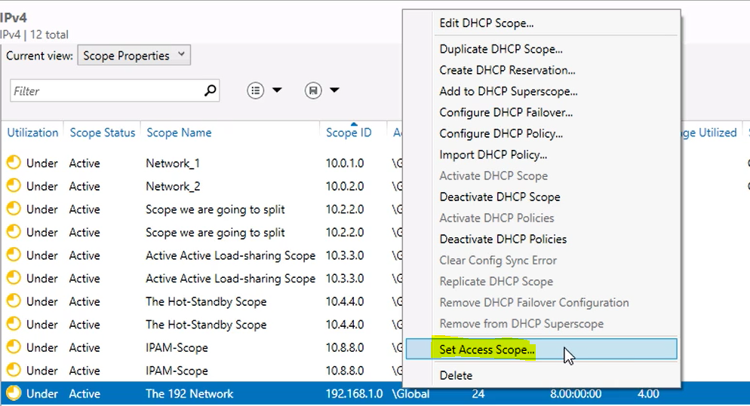

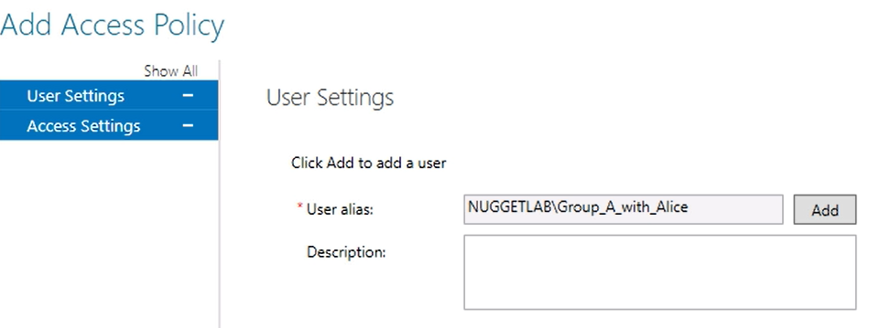

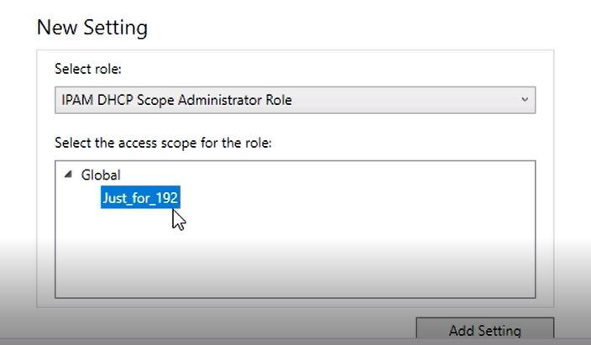

An *access policy* combines a role with an access scope to assign permissions to a user or group.

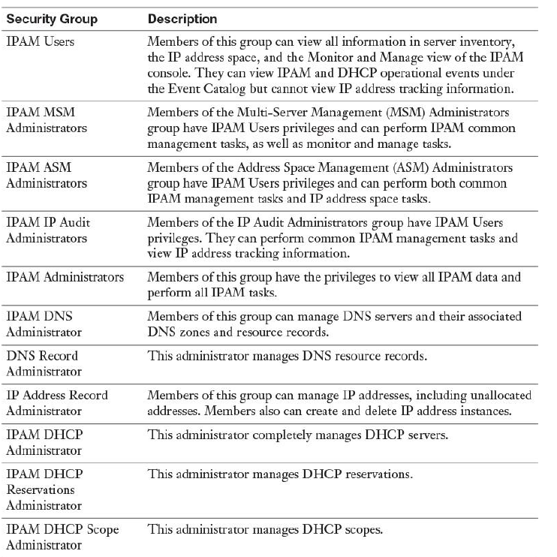

IPAMUG is created as part of IPAM server deployment. The IPAM server computer account automatically becomes a member of this group; it also has to become a member of the local security group Event Log Readers at the managed server, to grant the IPAM server permission to read DHCP or DNS events from the managed servers (DNS, DHCP) so that these events can be centrally viewed on the IPAM server.



**Auditing**

Event Catalog

DHCP Configuration Events

IP Address Tracking (between time interval)>> by ip, hostname, username, clientID (mac)

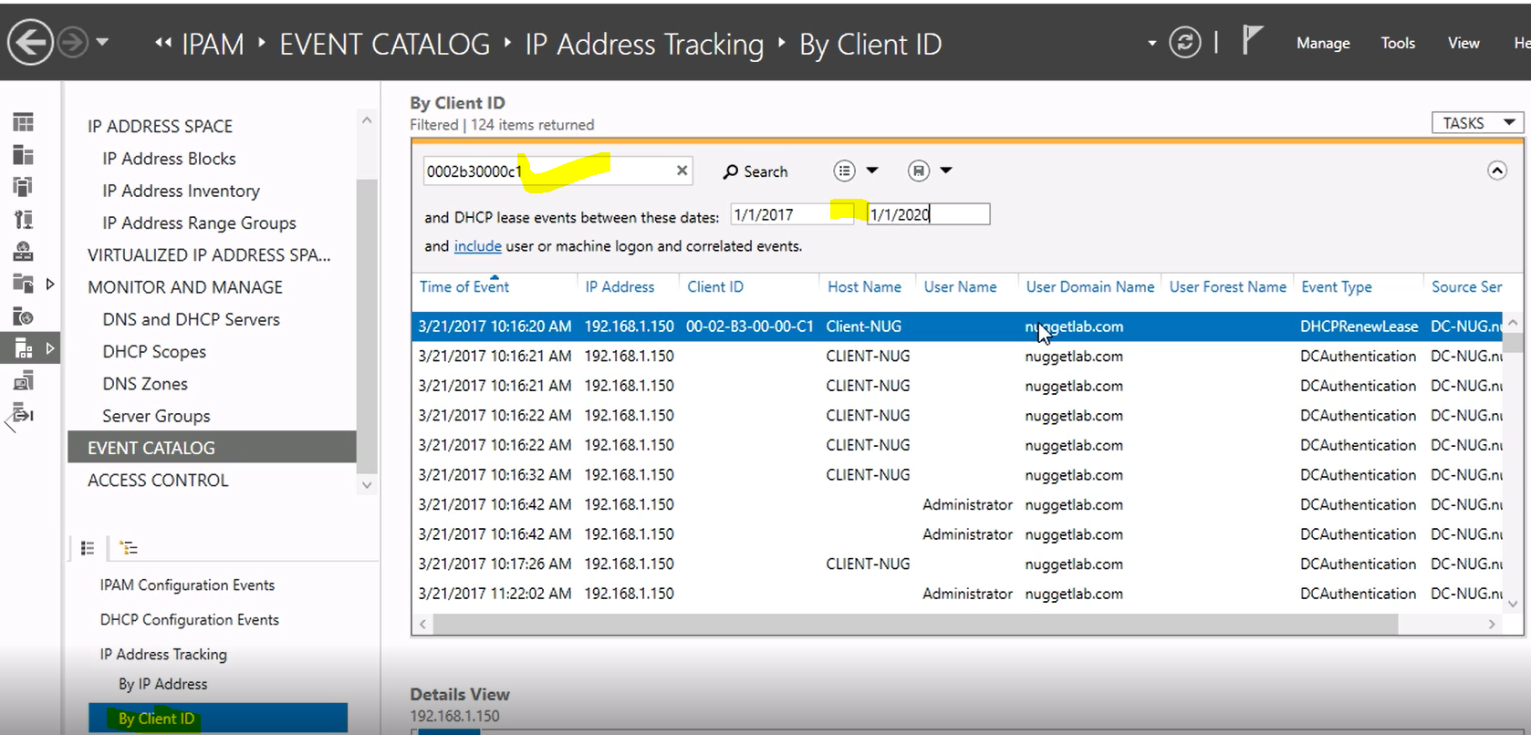

**Network Address Translation (NAT)**

 ([RFC 1631](http://www.faqs.org/rfcs/rfc1631.html))

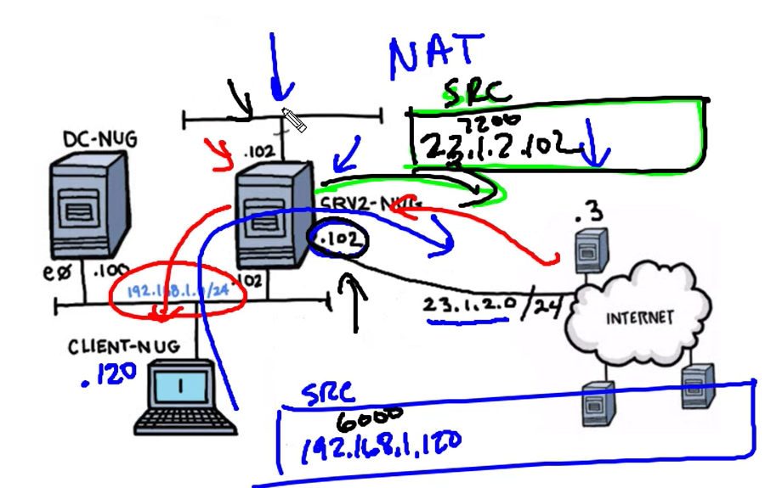

yerel ağın içinde olmayan bir adrese gitmek için bir talep gelince, NAT yönlendiricisi daha önceden kullanıcının ayarladığı NAT tablosuna bakarak, özel IP adresini genel bir IP adresine çevirir ve bu şekilde dış ağlara ya da İnternete çıkılmış olur. Yönlendiricinin çeviri yaparak değiştirdiği bu IP, kullanıcının İnternetteki bilinen IP’sidir. Aynı şekilde dış ağlardan bu bilinen IP’ye doğru bir istek gelince, yönlendirici tablosuna bakarak bu IP’yi kullanıcın özel IP adresine yönlendirir ve paketi kullanıcının bilgisayarına gönderir.

**Sabit NAT (Static NAT)**

Yerel ağda kullanılmakta olan özel IP’yi dışarıda kullanılacak olan genel IP'ye birebir çevirmedir. NAT türünde NAT tablosu doğrudan ağ yöneticisi tarafından doldurulur. Yani ağ yöneticisi kullanılacak olan özel IP'leri belirler ve bunları sahip olduğu genel IP adresleriyle kendisi eşleştirir.

**Dinamik NAT (Dynamic NAT)**

Ağ yöneticisi bir IP adres havuzu belirler/

Sabit NAT'tan farkı yönlendiricinin kendisinin eşleştirmeyi yapmasıdır.

**Aşırı Yükleme NAT (Overloading NAT)**

 Yerel ağda bulunan bir kullanıcıdan dışarıdaki ağlara bağlanmak için bir istek geldiğinde, yönlendirici bu kullanıcının özel IP adresini ve ona verdiği port numarasını NAT tablosuna kaydeder. Sahip olunan genel IP adresini yerel ağda bulunan kullanıcının özel IP adresi ve ona verdiği port numarası ile eşleştirerek İnternete erişmesini sağlar. Farklı bir özel IP’den aynı anda istek geldiği takdirde o IP’ye farklı bir port numarası verilir. PAT kullanılarak bütün yerel ağ daha az sayıda genel IP adresi kullanarak İnternete bağlanmış olur

**Implementing Remote Access and S2S VPN Solutions Using RAS Gateway**

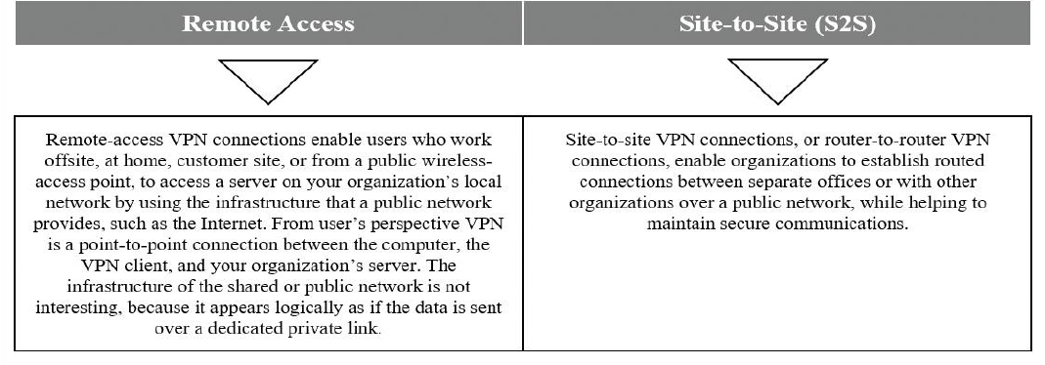

Tek kullanıcıyla yapıldığında Remote Access, tüm branch’e ait oldugunda site to site vpn

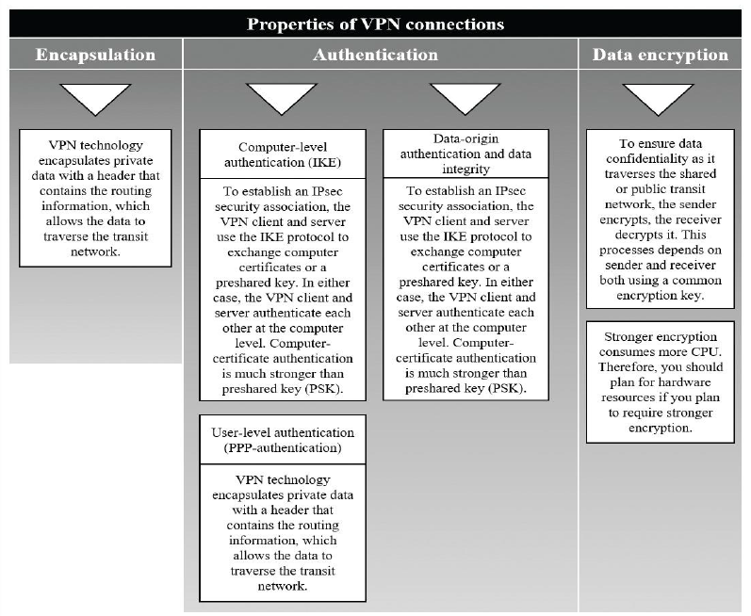

Remote Access Rolünün kurulumu (virtual private network (VPN), DirectAccess, routing, and Web Application Proxy ‘i içerir)

Feature> DirectAccess and VPN, Routing

Default gateway olmayan sunucular üzerinden routing yapılmak istendiğinde route eklenmelidir

Client üzerinde

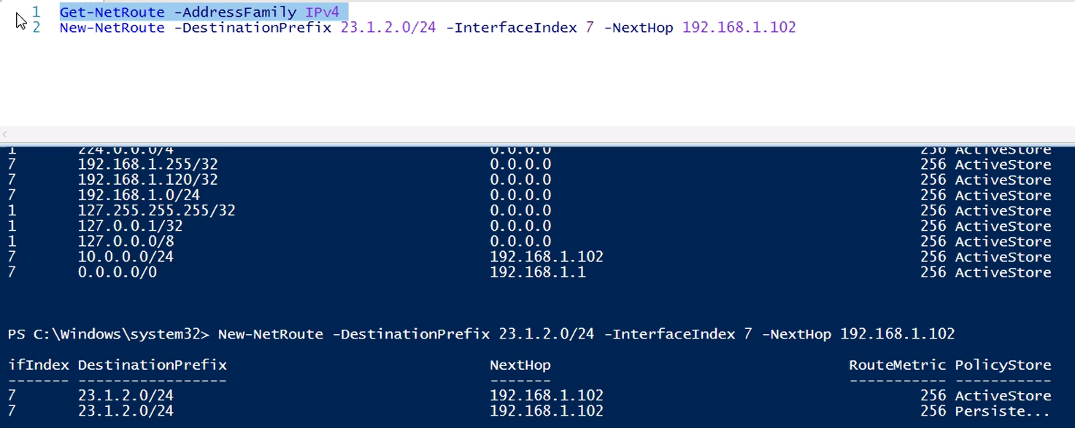

DC-nug üzerinde

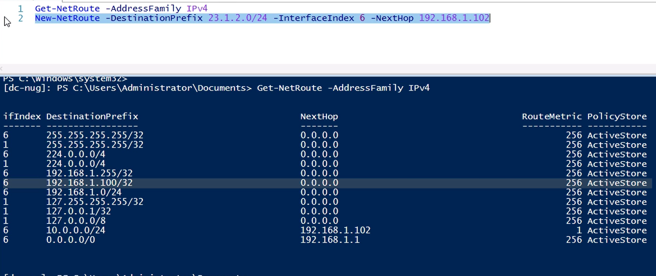

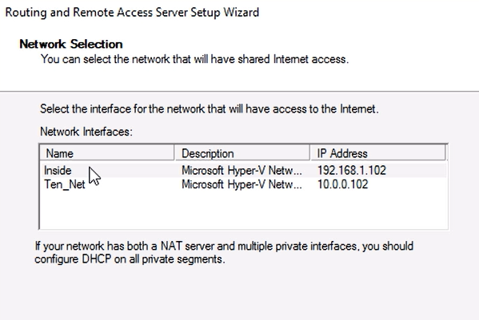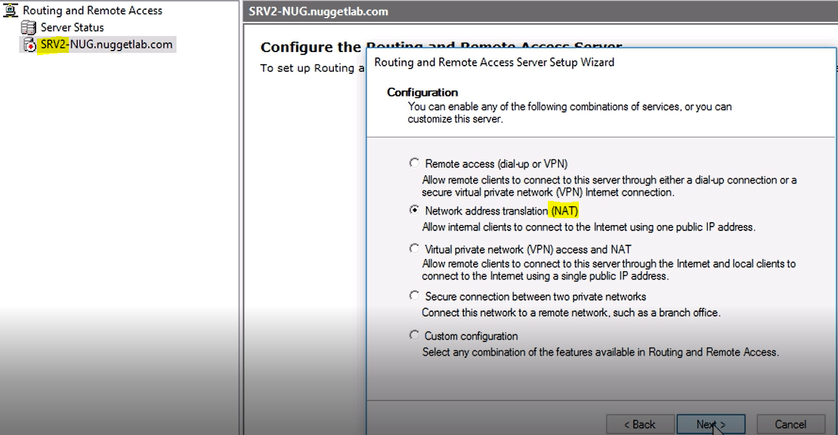

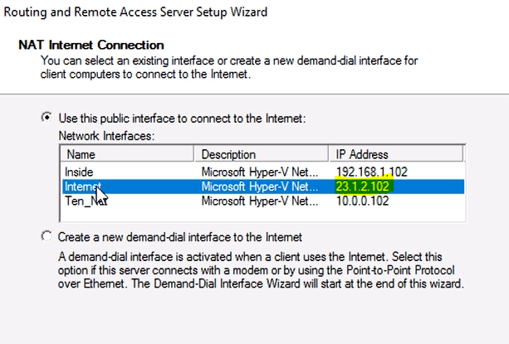

**NAT PORT FORWARDING**

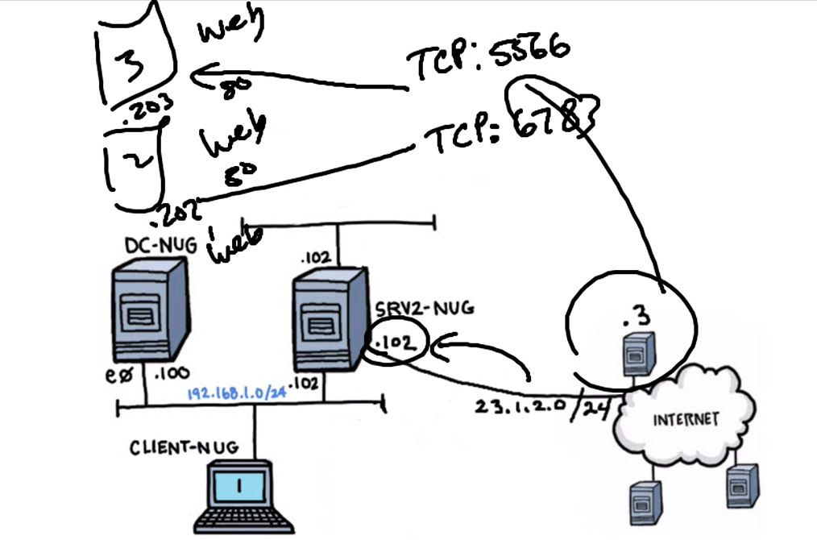

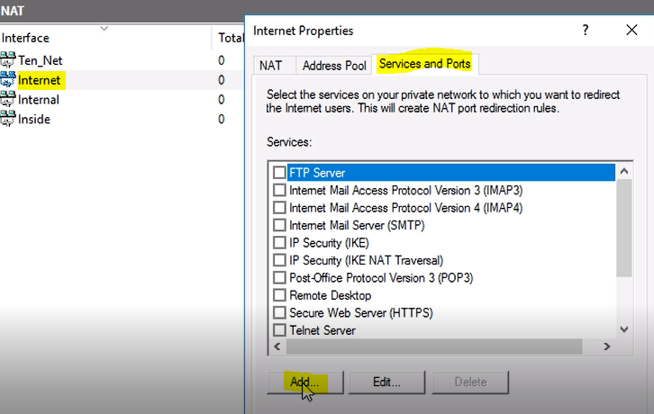

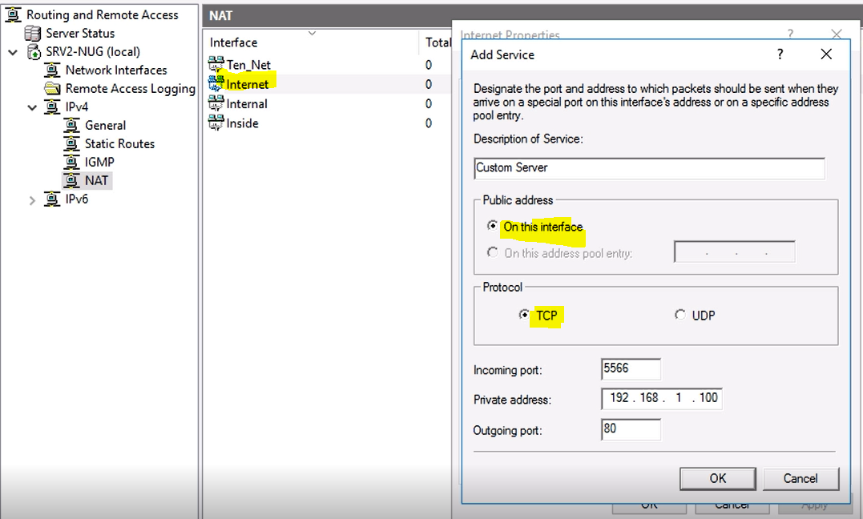

**VPN**

Protocols

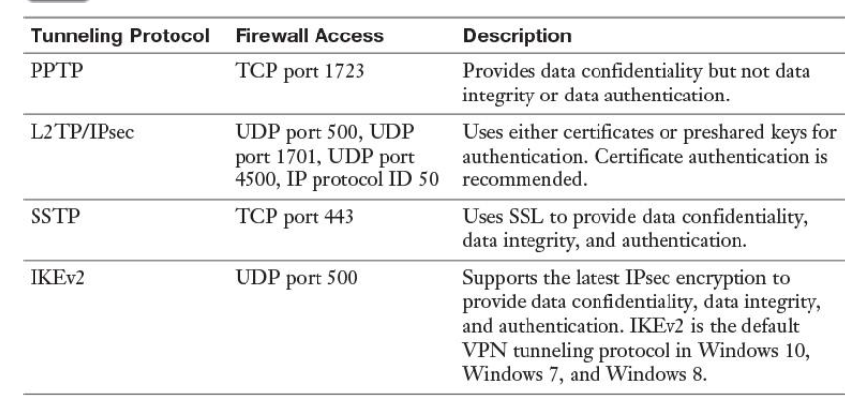

L2TP/IPSEC> ikev1

**Add-VpnIPAddressRange** -IPAddressRange 40.1.1.10, 40.1.1.30 –PassThru >> address pool for assignment to VPN clients:

**Disconnect-VpnUser >>** disconnect a VPN connection originated by a specific user or client

**Get-RemoteAccessConnectionStatistics>>** get information about the TotalConnections, TotalDAConnections, TotalVPNConnections, Total-UniqueUsers, MaxConcurrentConnections, TotalCumulativeConnections, TotalBytesIn, TotalBytesOut, and TotalBytesInOut.

VPN Connections with PPTP

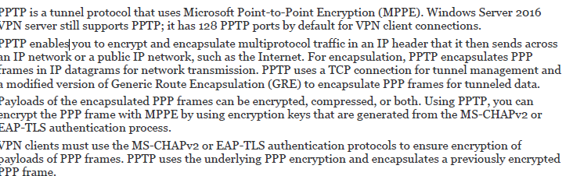

VPN Connections with L2TP/ IPSec

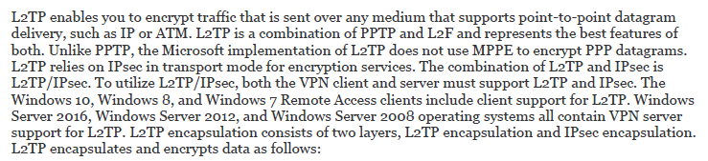

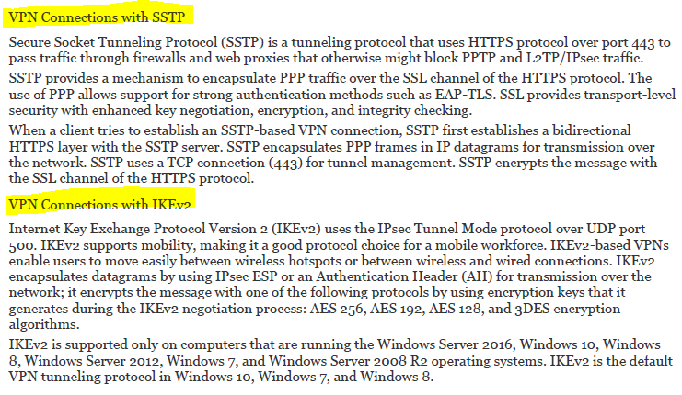

Authentication Protocols

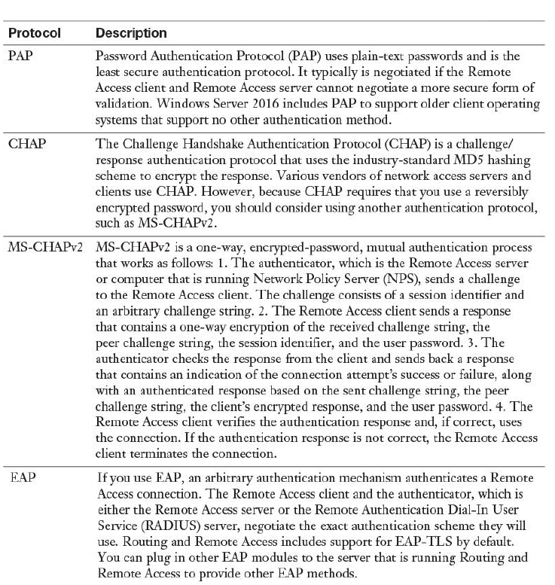

Get-VpnAuthProtocol >> to verify which user authentication protocols VPN server accepts

Set-VpnAuthProtocol –UserAuthProtocolAcepted EAP

Get-VpnConnection>> connection profile information

Get-VpnServerConfiguration >> VPN server properties

Server tarafında

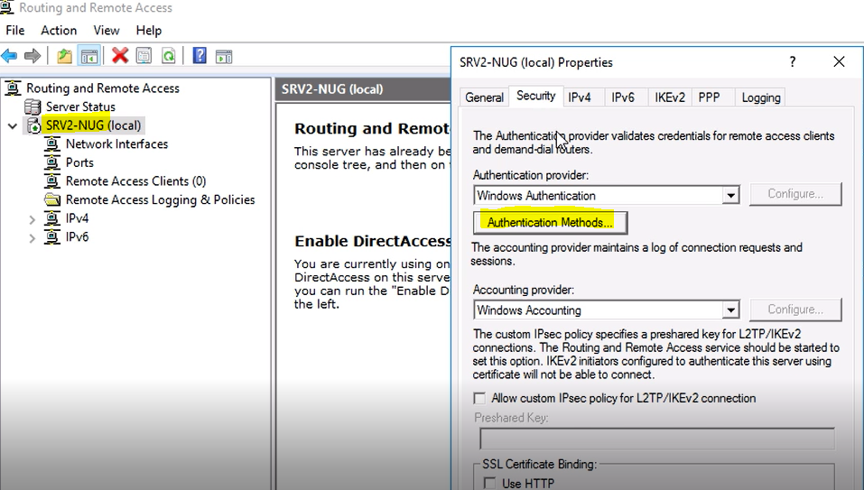

Allow custom IPSec policy for L2TP/IKEv2 >>server-client haberleşmesinin IPsec üzerinden şifre ile başlatılması

Bu ayar seçilirse cliet vpn başlatmadan şifreyi girmelidir

Client tarafında

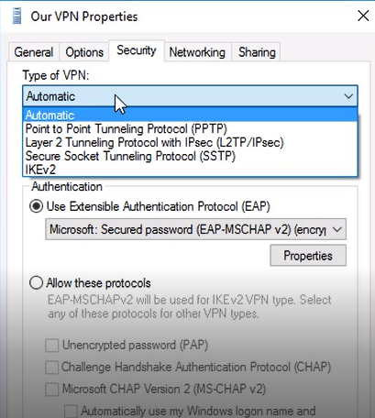

**REMOTE ACCESS VPN**

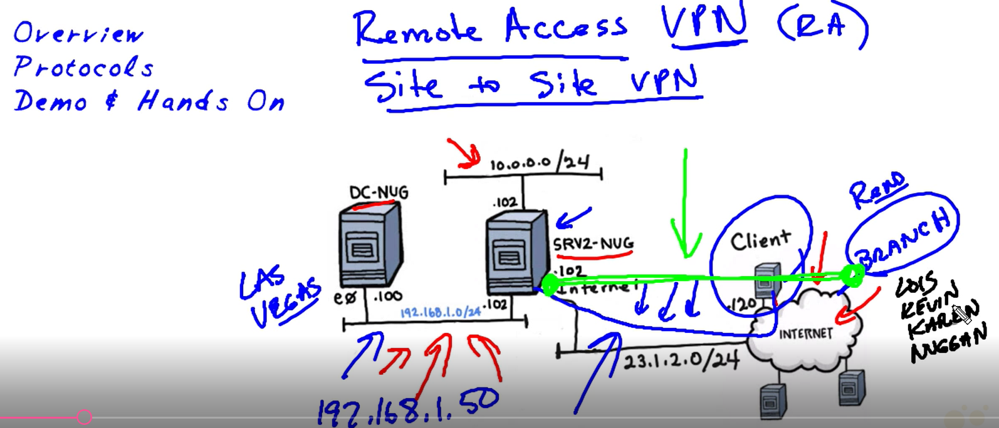

SRV2>> incoming VPN server

When client connects, they take ip from internal vpn

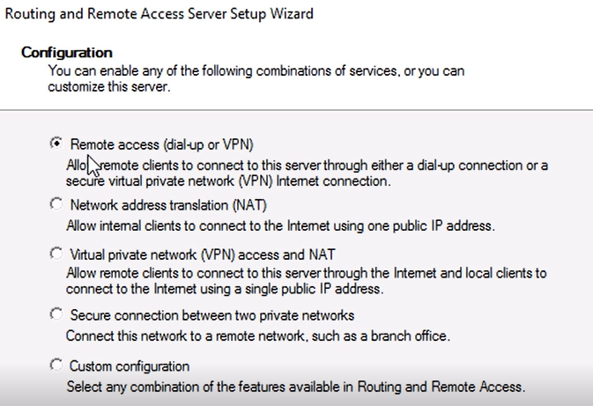

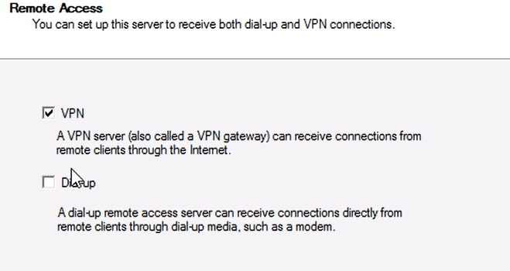

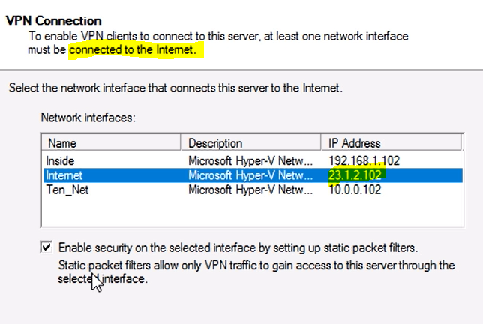

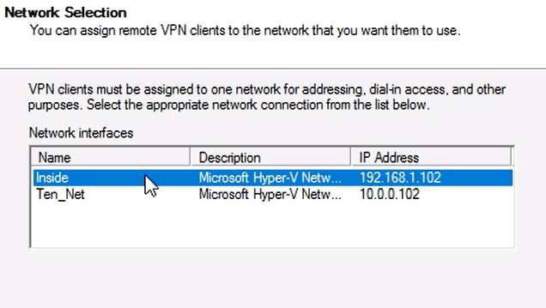

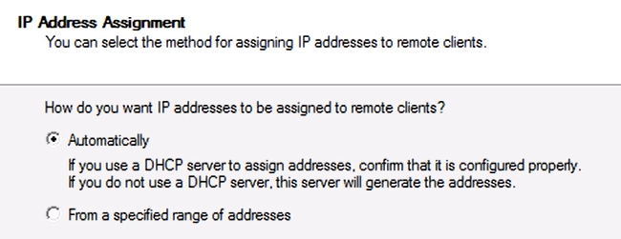

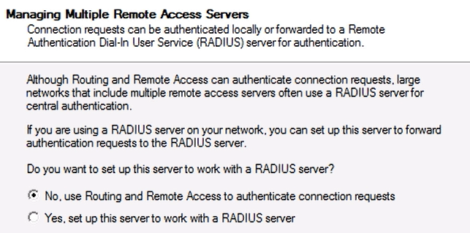

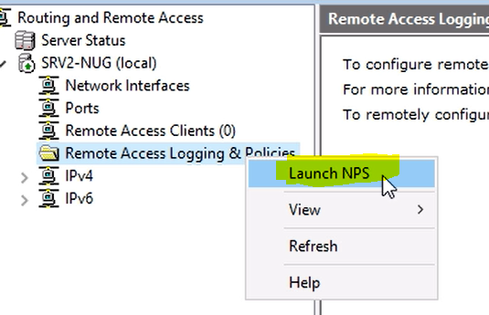

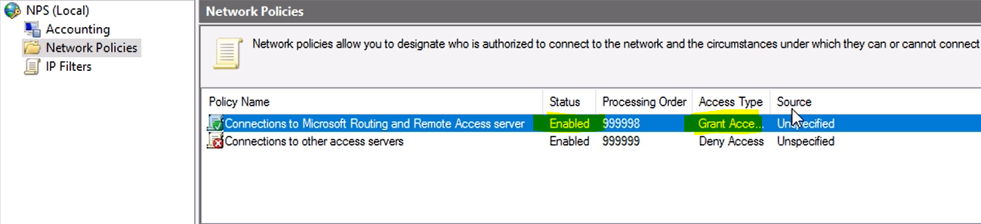

**Client**

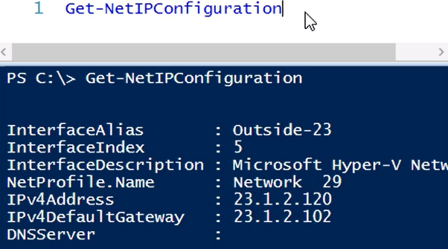

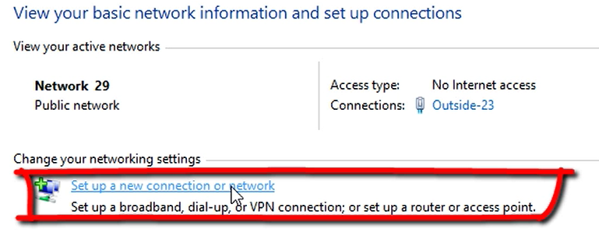

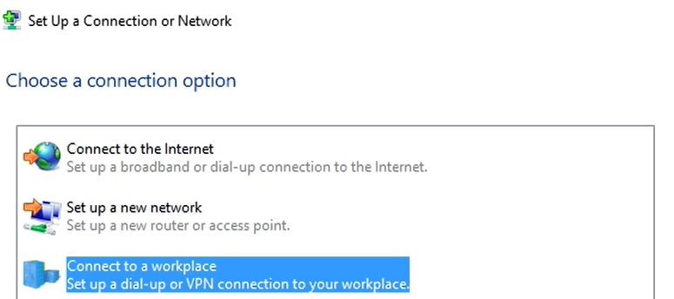

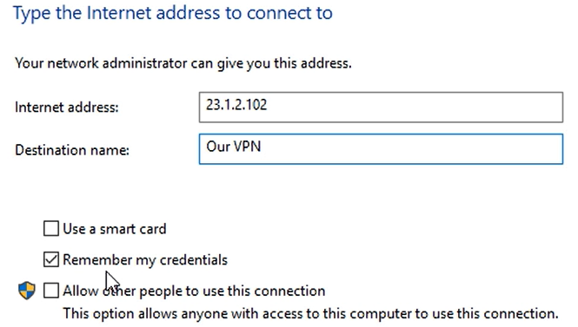

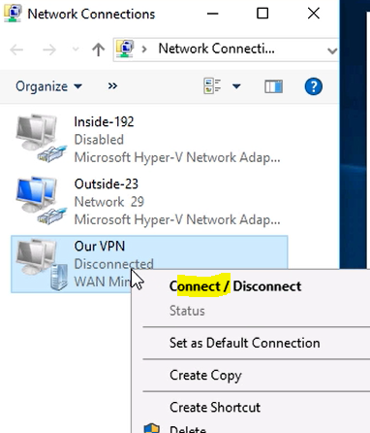

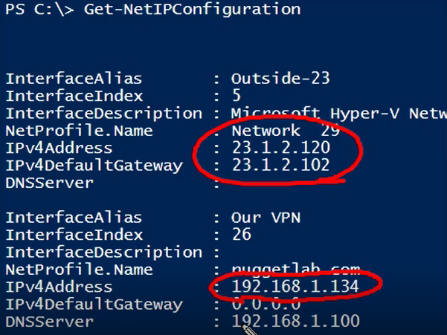

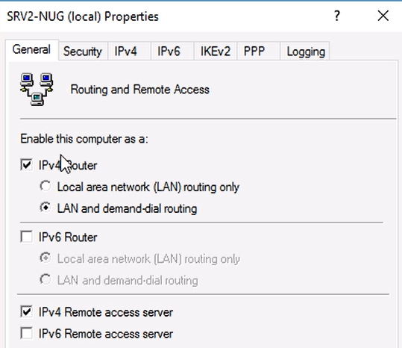

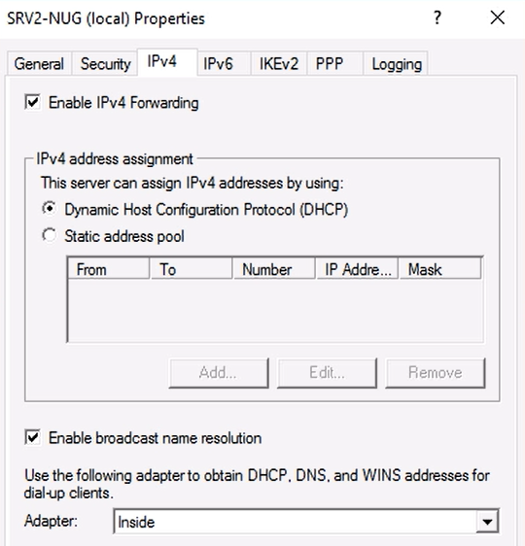

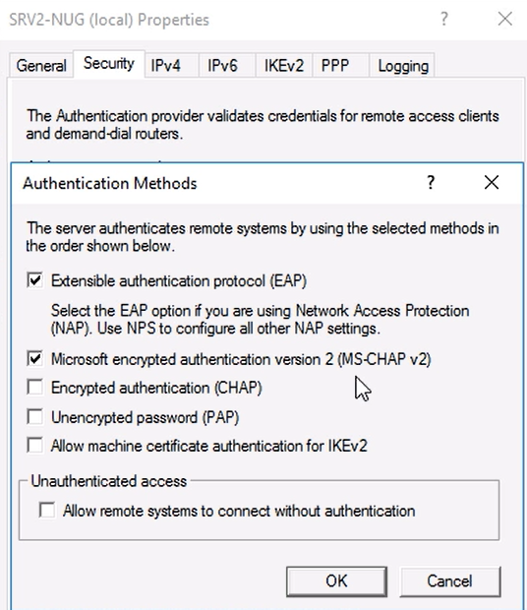

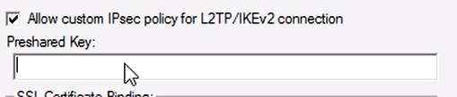

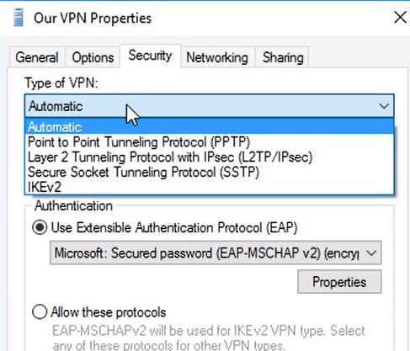

configure VPN reconnect

to enable users to access data continuously without interruption

VPN connection, which reconnects automatically if connectivity disconnects.

With VPN Reconnect, Windows 10 clients automatically reestablish active VPN connections when the network reestablishes Internet connectivity.

System requirements for using the VPN Reconnect feature follow:

**Server:** Windows Server 2008 R2, Windows Server 2012, or Windows Server 2016

**Client:** Windows 10, Windows 8, or Windows 7

**PKI:** A computer certificate from an internal or public CA

Prerequists

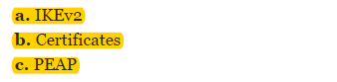

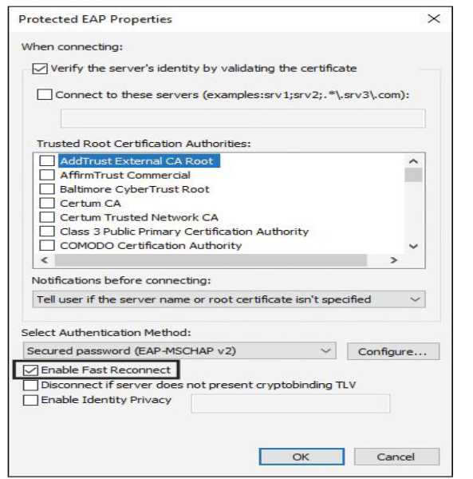

create and configure connection profiles

Connection Manager Administration Kit (CMAK) to customize users’ remote connection options by creating predefined connections to remote servers and networks. CMAK is an optional component and is not installed by default. You must install CMAK to create connection profiles that your users can install to access remote networks. Connection Manager Administration Kit

Server> Install-WindowsFeature -name CMAK

Client> Programs and Features

creating predefined connections to remote servers and networks.

Server üzerinde

Tools>> Connection Manager Administration Kit

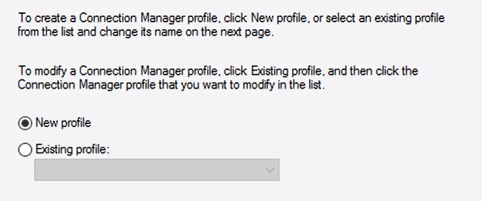

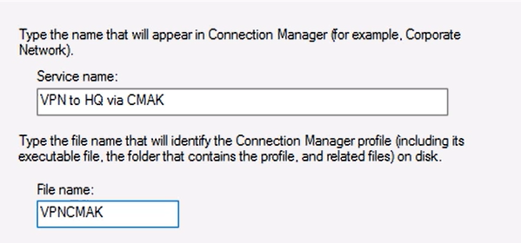

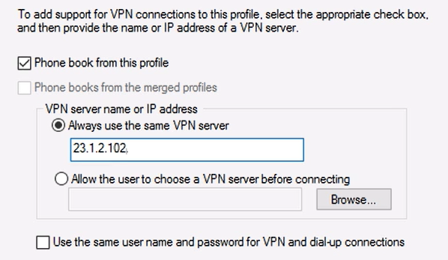

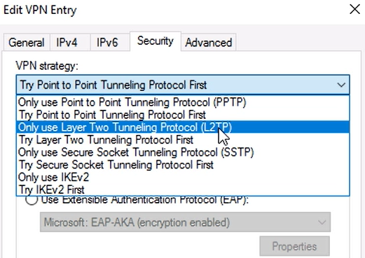

Bu işlemin sonunda .exe oluşturulur

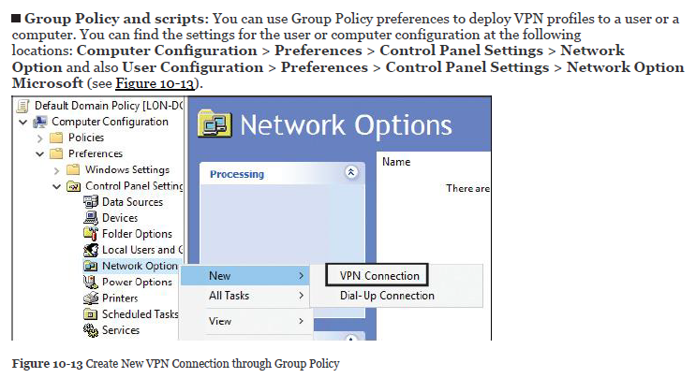

Connection profile creation option:

CMAK,Microsoft Intune,SCCM,GPO

**SITE2SITE VPN**

Two portions of a private network are connected.

The VPN client authenticates itself to the VPN server.

You must create a demand-dial interface.

You can create three types of site-to-site VPNs: Point-to-Point Tunneling Protocol (PPTP), Layer 2 Tunneling Protocol (L2TP), and Internet Key Exchange Version 2 (IKEv2).

A persistent or on-demand connection can be used.

Persistent connection>> from properties page of demand dial in interface on options tab

Or Network Policy of answering router by clearing the idle timeout and session timeout settings

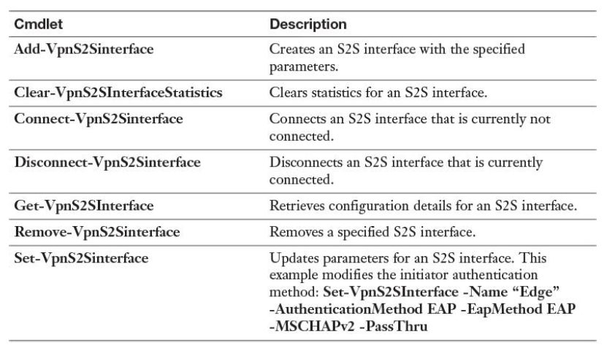

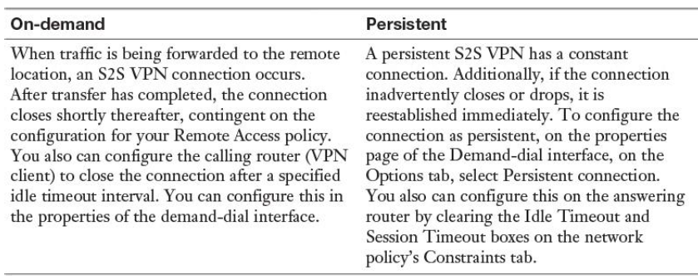

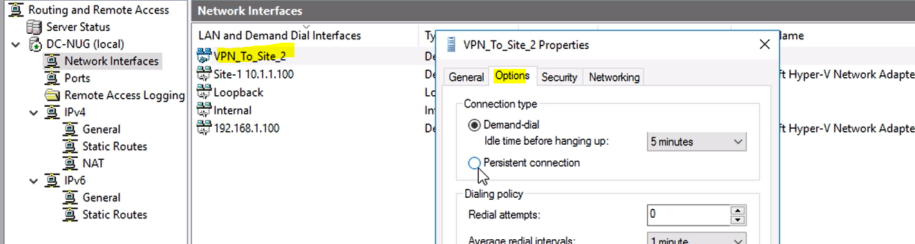

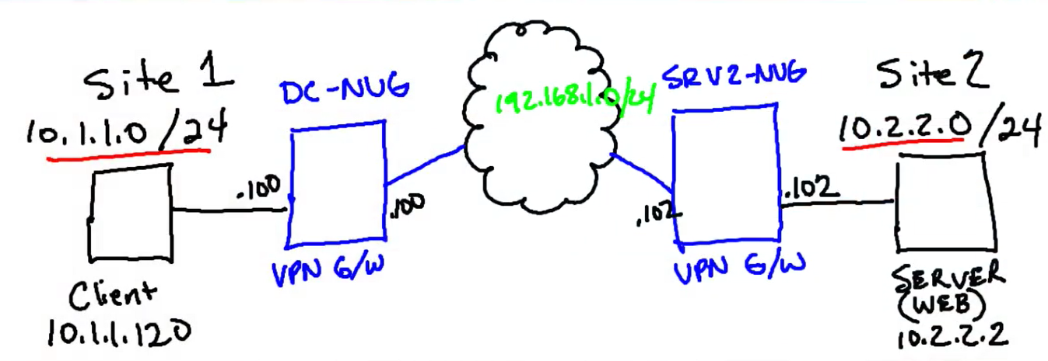

On DC-NUG

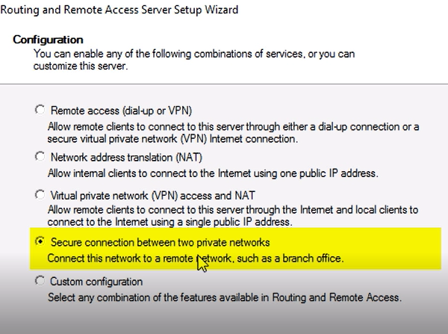

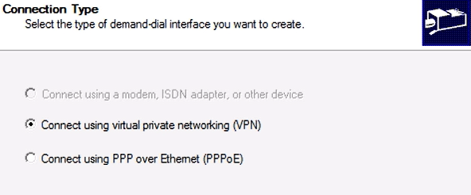

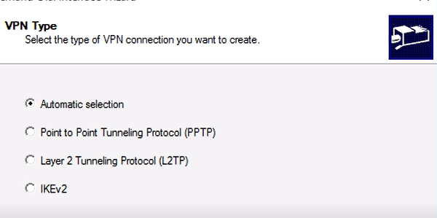

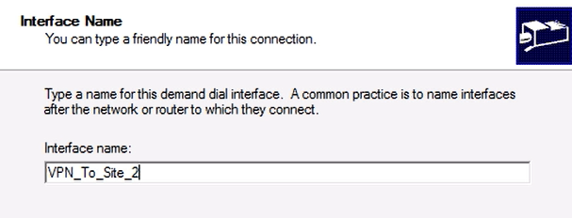

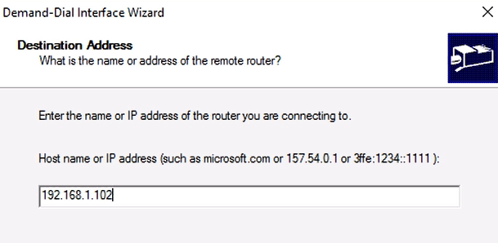

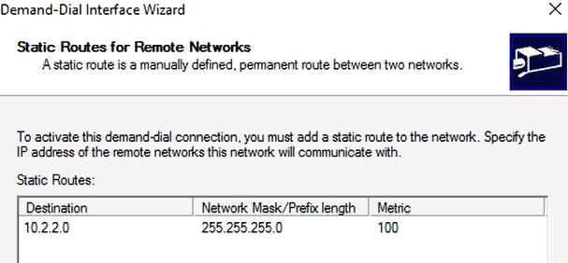

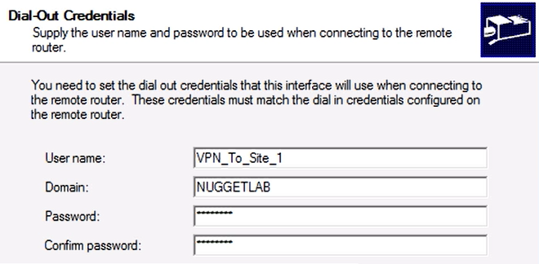

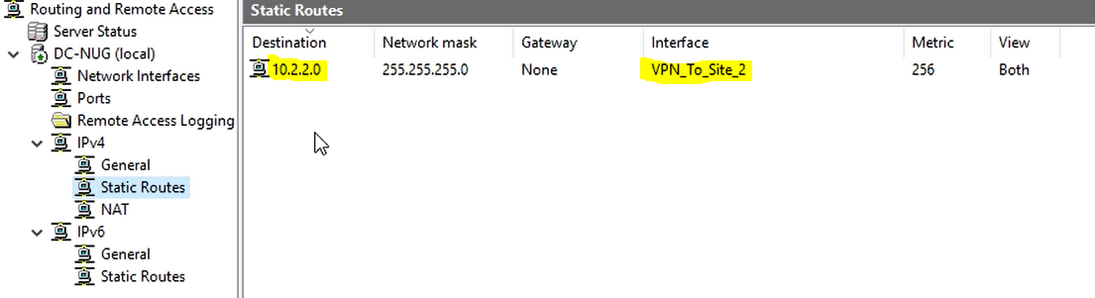

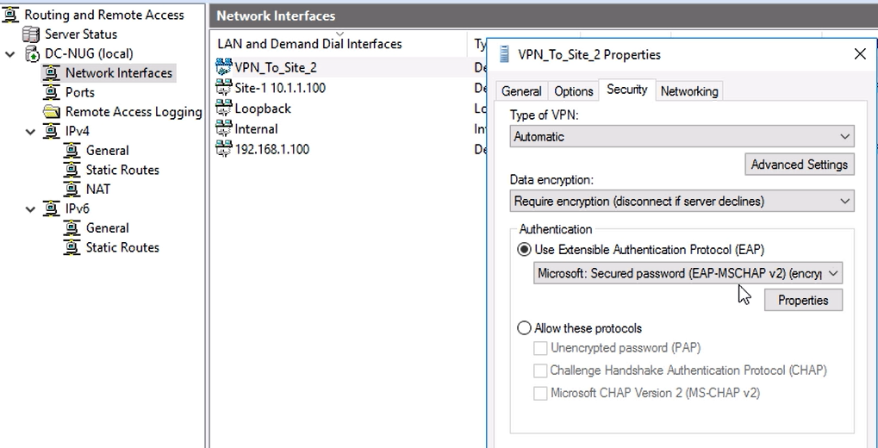

Bu işlem için vpn_to_site1 kullanıcı hesabı oluşturuldu

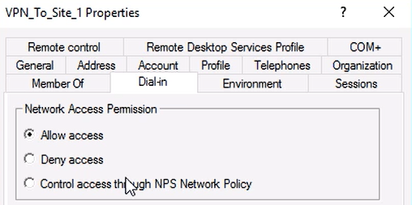

Aynı işlem SRV2 için de yapılır

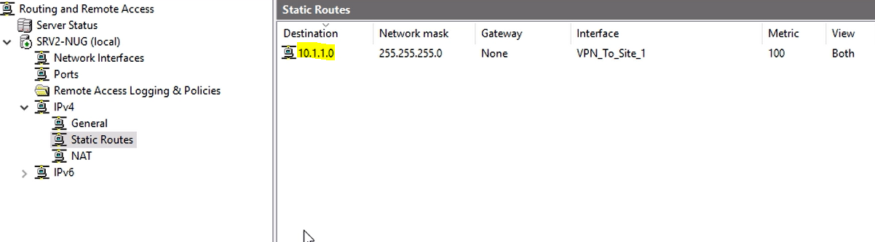

Client

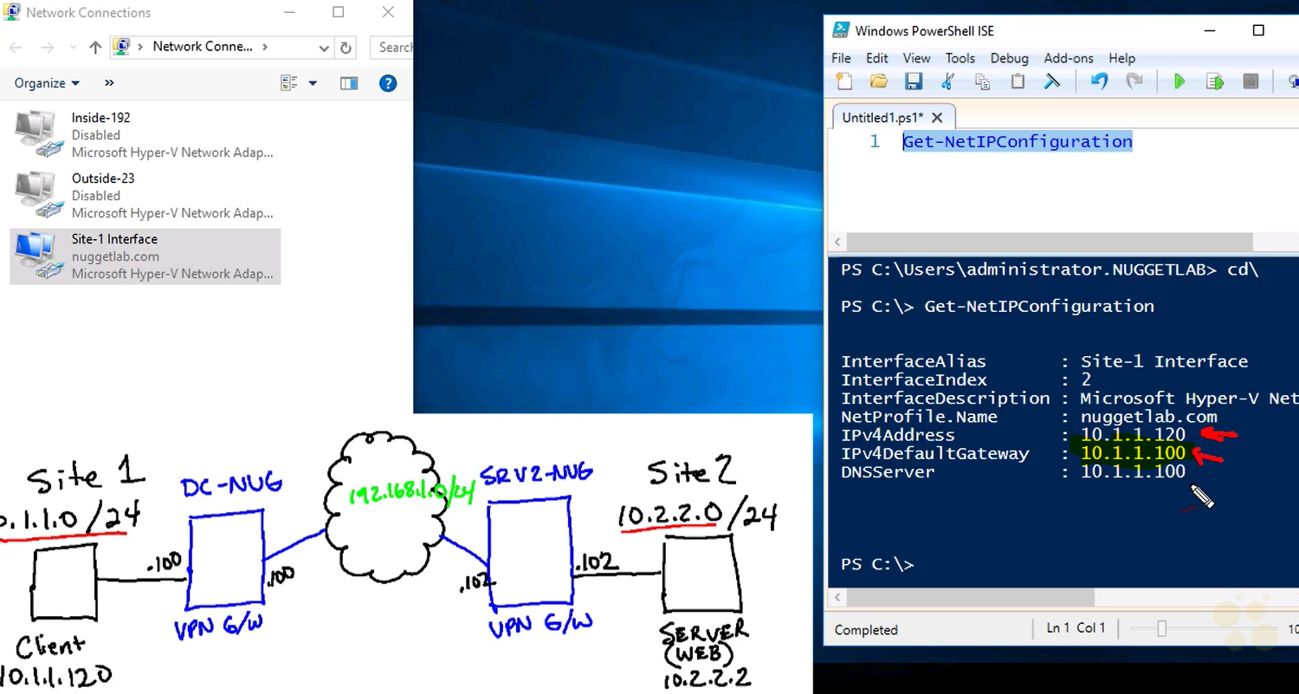

**CERTIFICATES AND VPN**

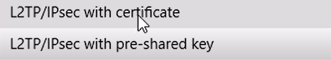

Diğer ihtimal preshared key (password kullanmak)user certificate on client

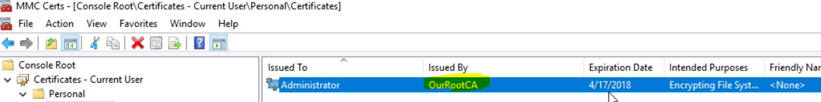

Machine certificate

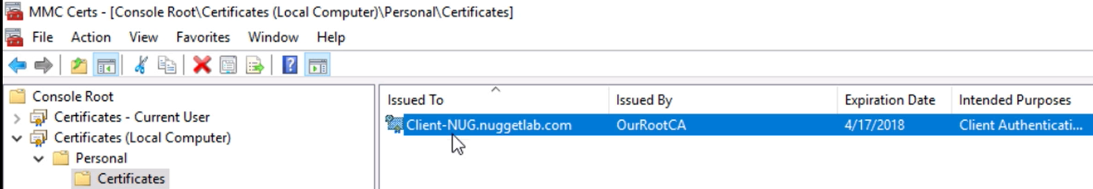

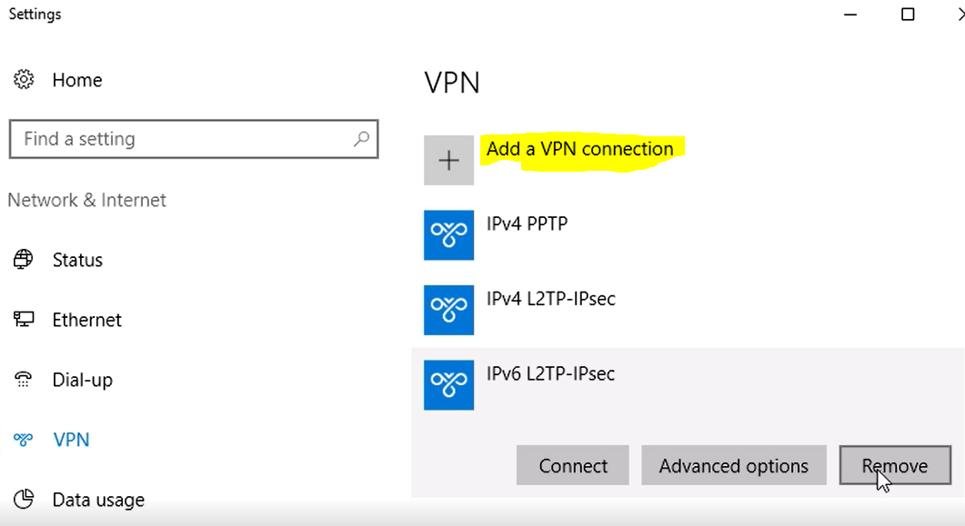

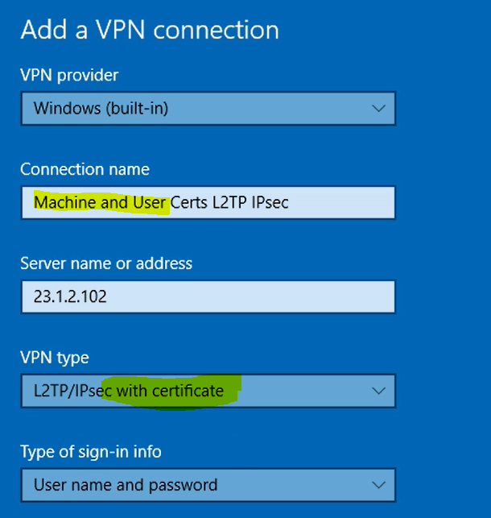

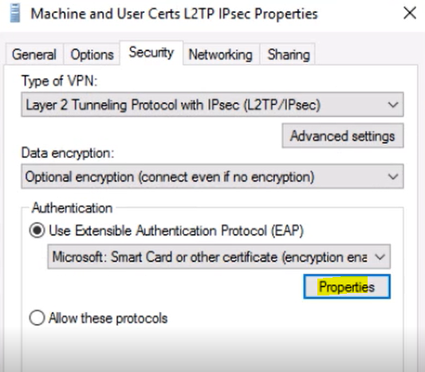

RootCA sertifikası Properties’den seçilir

Client’ın hangi site’a bağlı olduğu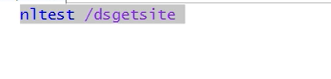

**INSTALL AND CONFIGURE DIRECT-ACCESS**

**From Remote Access management from Server Manager**

providing seamless access to corporate resources without any user interaction or VPN client

It allows users to move their device among internal, public, and home networks while retaining access to internal servers.

The connection is established in the background without requiring user interaction.

prerequisites

* At least one Active Directory domain.
* Workgroups not supported.
* DirectAccess clients required to be domain members.
* DirectAccess server required to have minimum one network adapter.
* At least one domain controller and DNS server.
* PKI required to issue certificates. External certificates are not a requirement.
* IPsec policies required to specify protection for network traffic.
* A client running a minimum of Windows 7 (or Windows 8), for DirectAccess.
* Tunneled IP traffic allowed to pass through the perimeter firewall.

**Components**

**Client**

DirectAccess clients connect into the tunnel by using IPv6 and IPsec. If a native IPv6 network is not available, the client establishes an IPv6-over-IPv4 tunnel by using 6to4 or Teredo. The user does not have to be logged on to the computer. If a firewall or proxy server prevents the client computer using 6to4 or Teredo from connecting to the DirectAccess server, the client computer automatically attempts to connect by using the IP-HTTPS protocol, which uses an SSL connection.

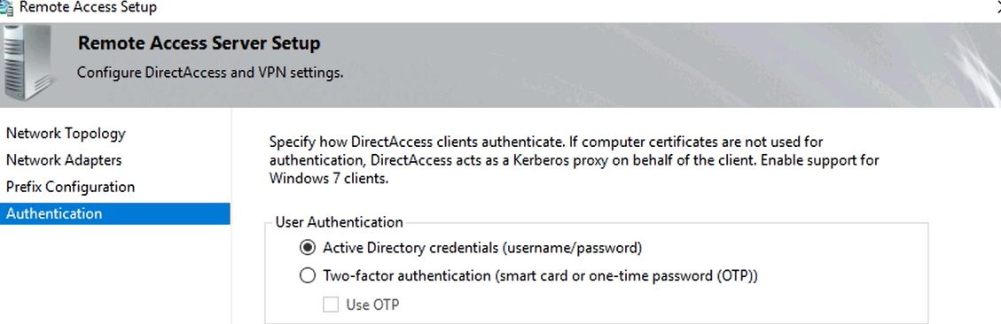

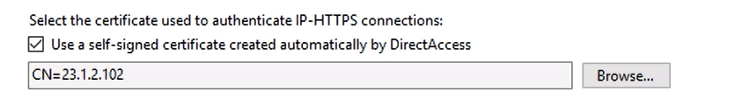

**CONNECTION:WORKPLACE CONNECTION**

**Active Directory**

DirectAccess enables client authentication requests to be sent over an HTTPS-based Kerberos proxy service (KDC Proxy) that is running on the DirectAccess server.

The Kerberos proxy sends Kerberos requests to domain controllers on behalf of the client.

The DirectAccess clients get the Name Resolution Policy Table (NRPT) settings through the DirectAccess Group Policy. The NRPT is used from DirectAccess clients to find out which DNS server they have to use to resolve the names of resources they access. For internal resources, the clients use the internal DNS servers (delivered through NRPT); for resources on the Internet, they use their locally configured DNS server.

**DNS SERVER**

works as an Edge, a self-signed certificate for IP-HTTPS automatically is created. In this case, the name of this certificate becomes the external IP address defined as an external public name (see Figure 10-15) in the Getting Started Wizard. This eliminates the use for external name resolution because the DirectAccess client has to identify the certificate only through IP address, not through FQDN.

**DirectAccess Solution Component: Certificates**

The DirectAccess client must have a trusted root certificate for the DirectAccess server authentication certificate. If the client is a domain member, it can be delivered directly through GPO.

In such a case, the client has no problem establishing a DirectAccess connection from outside the company and can use that trusted root certificate to verify the DirectAccess server authentication certificate.

**Group Policy**

The default configuration is that the GPOs are created at the domain level with the default names DirectAccess Client Settings and DirectAccess Server Settings

**Direct Access Client Requirements**

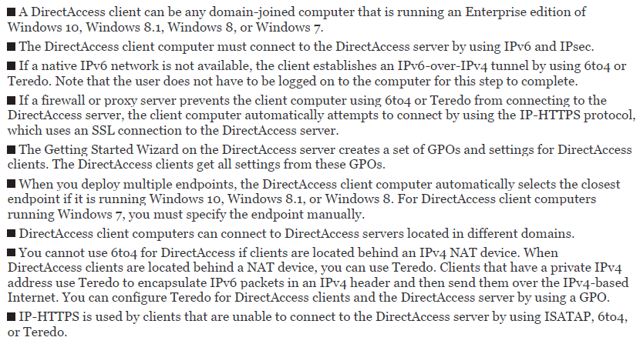

**DFS**

DFS replicates a file only after it is closed.

You can use DFS namespaces to create a virtual representation of shared folder structures. Two types of DFS namespaces exist:

Domain-based

Standalone

A domain-based namespace can be used in these cases:

HA (high availability) for namespace is required. This is accomplished by replicating the namespace to multiple namespace servers.

To use the DFS features, the following requirements must be met:

The forest must be at the forest functional level of Windows Server 2008 or newer.

The domain must be at the domain functional level of Windows Server 2008 or newer.

The namespace servers must be running Windows Server 2008 or newer.

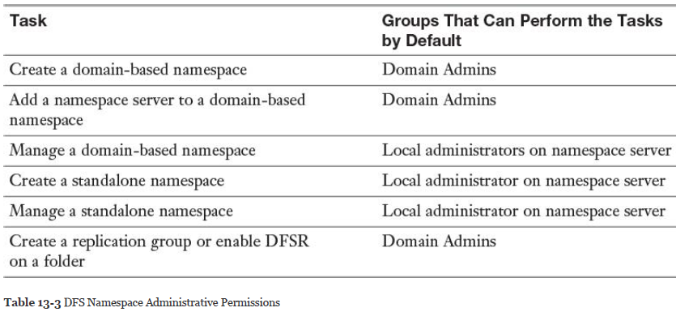

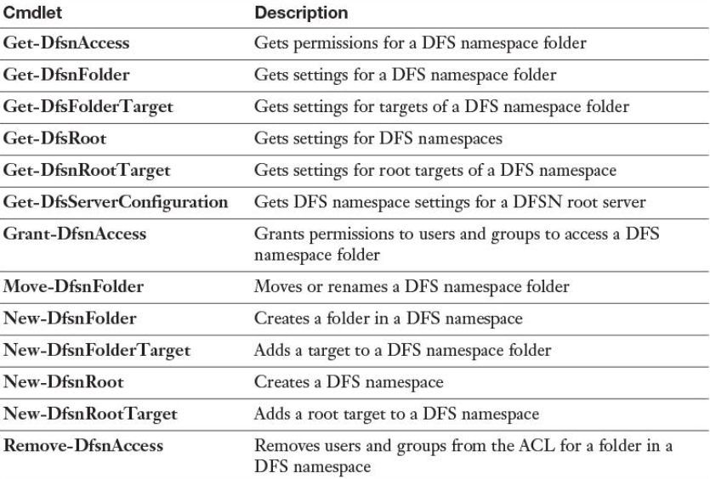

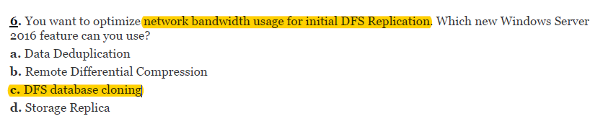

Configure Remote Differential Compression (RDC) Settings

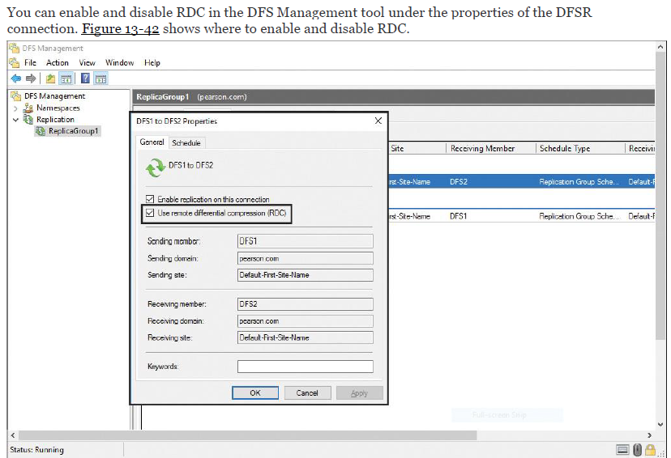

RDC detects insertions, removals, and rearrangements in files, enabling DFSR to replicate only the changed file blocks when files are updated.

By default, RDC is used only for files that are 64 KB or larger.

**Configure Fault Tolerance**

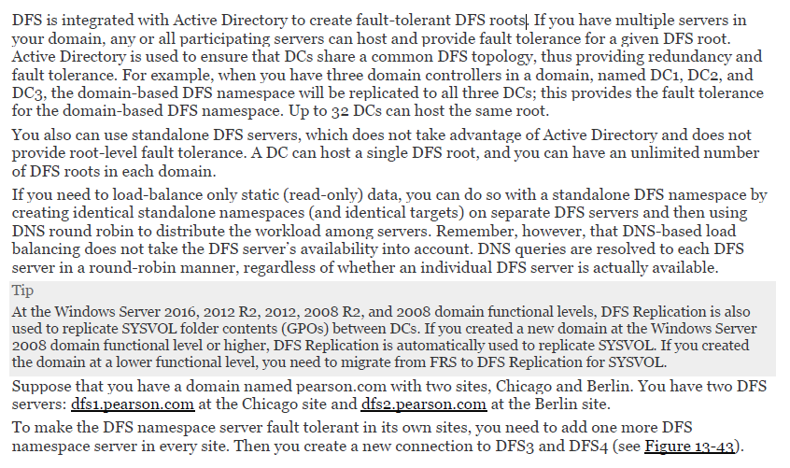

**Recover DFS Databases**

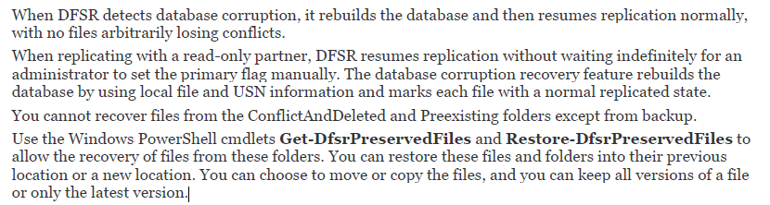

**BRANCH CACHE**

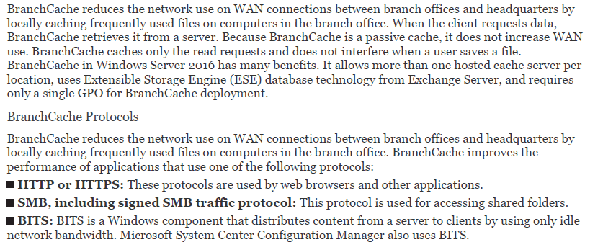

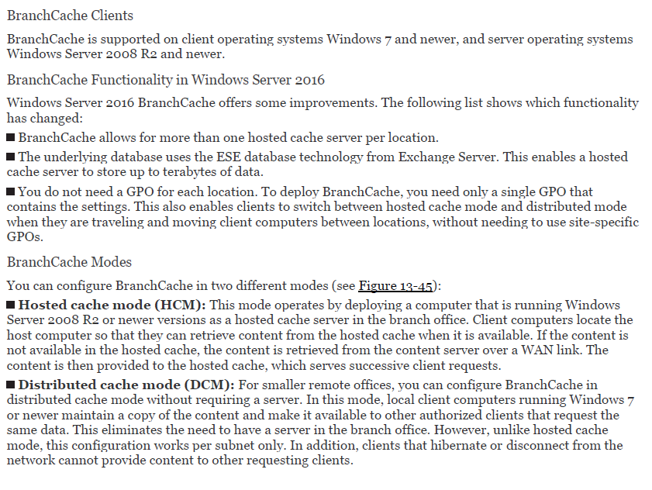

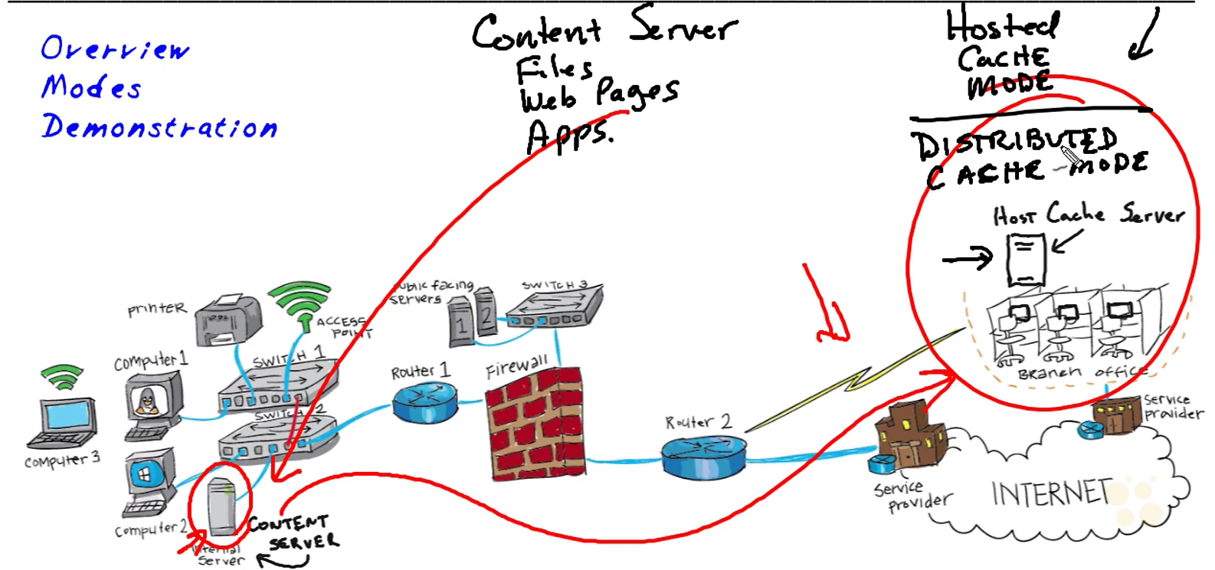

Hosted Cache mode>> uzak ofiste sunucu var ve dosyalar orada cache’leniyor

Distributed cache mode>> uzak ofiste sunucu yok, bilgisayarlar dosyaları birbirinden çeker

Uzak ofis’teki client’lar content server’daki dosyaları host cache server üzerinden alır böylece yavaş network bağlantısı kullanılmamış olur

* Branchcache rolü ve feature’u content server ve host cache server’da kurulur
* Content serverda Share oluşturulur

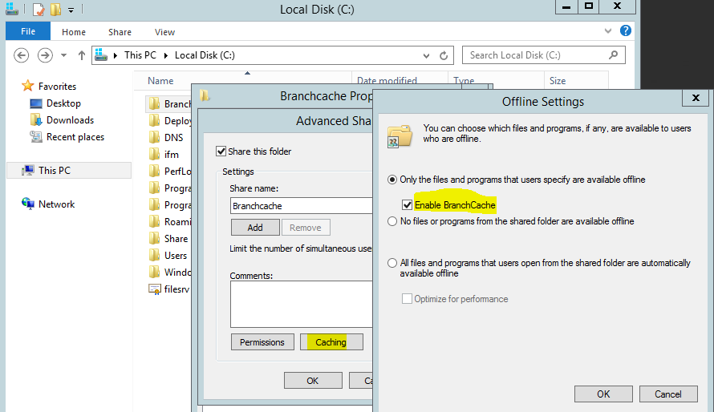

* Uzak sunucuda hosted cache mode enable’edilir. Başlangıçta enable değil

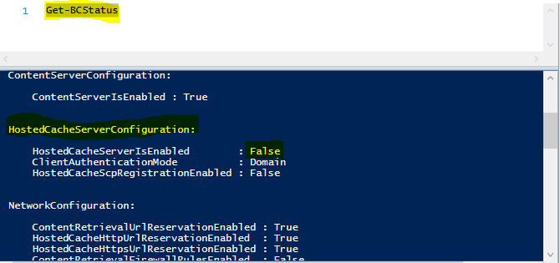

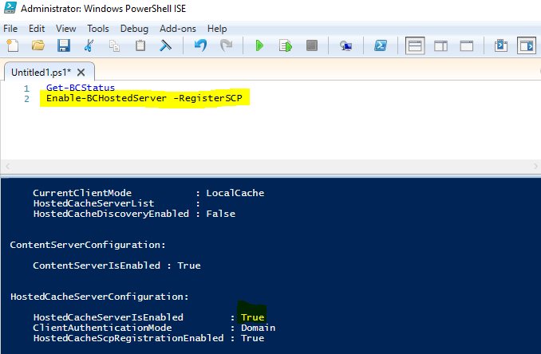

* Client ve uzak sunucu üzerinde policy aktivasyonu

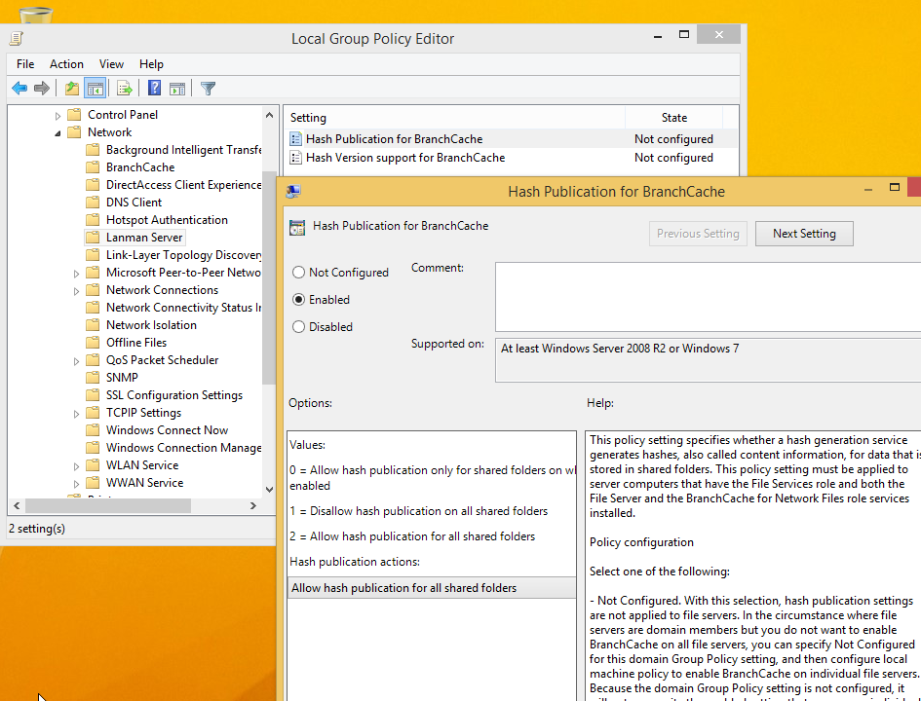

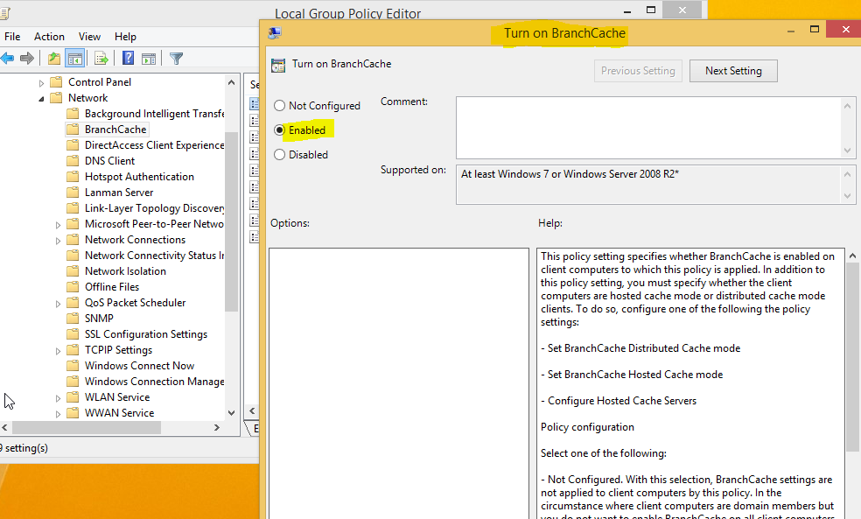

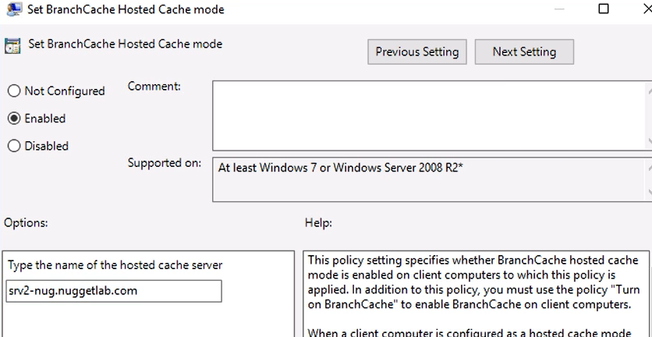

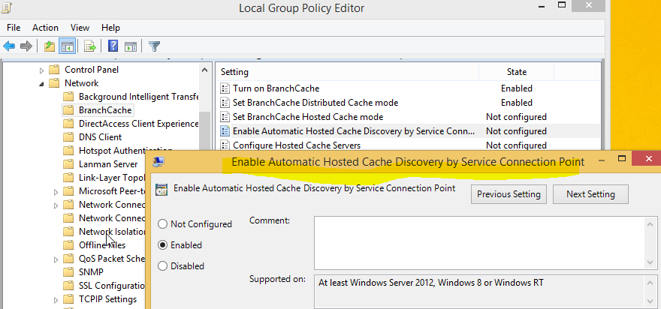

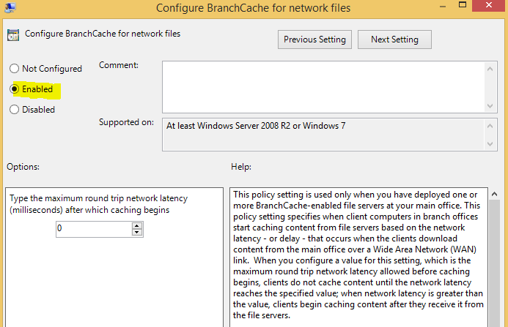

**Implement BranchCache for Web, File, and Application Servers**

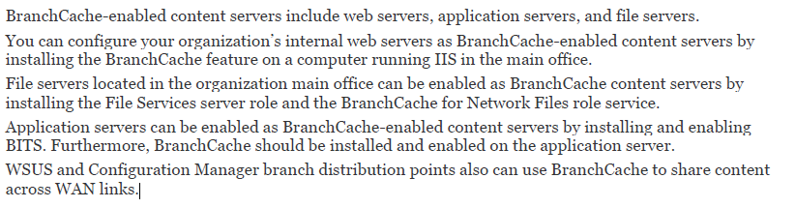

**Troubleshoot BranchCache**

**netsh branchcache show status all** command to display the BranchCache service status

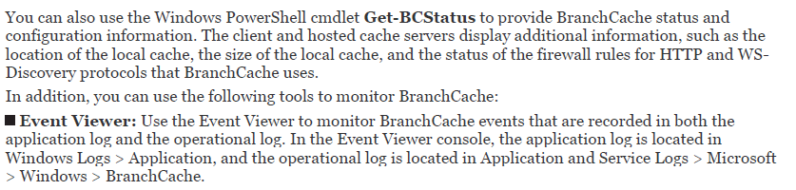

[Implement an advanced network infrastructure (10–15%)](https://www.microsoft.com/en-us/learning/exam-70-741.aspx#syllabus-6)

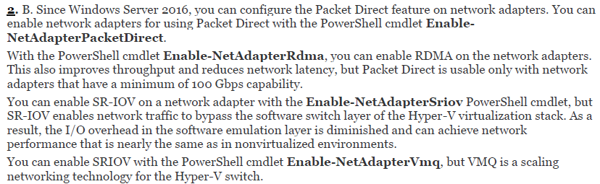

Switch Embedded Teaming (SET) solution

within a Hyper-V virtual switch to team up to eight physical NICs into one or more software-based virtual NICs. SET member network adapters in the same physical Hyper-V host so they are placed in a SET team.

manage the Hyper-V SET using Windows PowerShell or SCVMM

SET is supported in the Hyper-V virtual switch only in Windows Server 2016.

New-VMSwitch -name SETSW -NetAdapterName "NIC1", "NIC2" -EnableEmbeddedTeaming $true

Add-VMNetworkAdapter -SwitchName MyRDMAswitch -Name SMBRDMA1 Add-VMNetworkAdapter -SwitchName RDMAswitch -Name SMBRDMA2 Enable-NetAdapterRDMA "vEthernet (SMBRDMA_1)", "vEthernet (SMBRDMA_2)"

supports only Switch Independent mode.

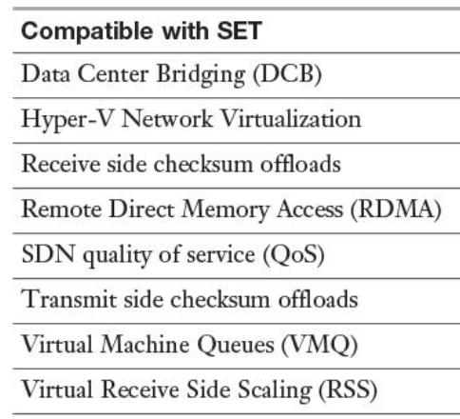

**NIC TEAMING**

NIC Teaming is integrated into the Hyper-V virtual switch

Operation system configured to do so

Multiple network cards

Modes: Teaming (static teaming, dynamic teaming-LACP, switch independent)

NIC Teaming provides the choice of three different teaming modes > Load Balancing (hash, hyperV port, dynamic)

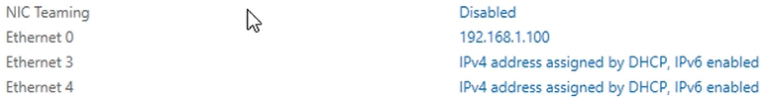

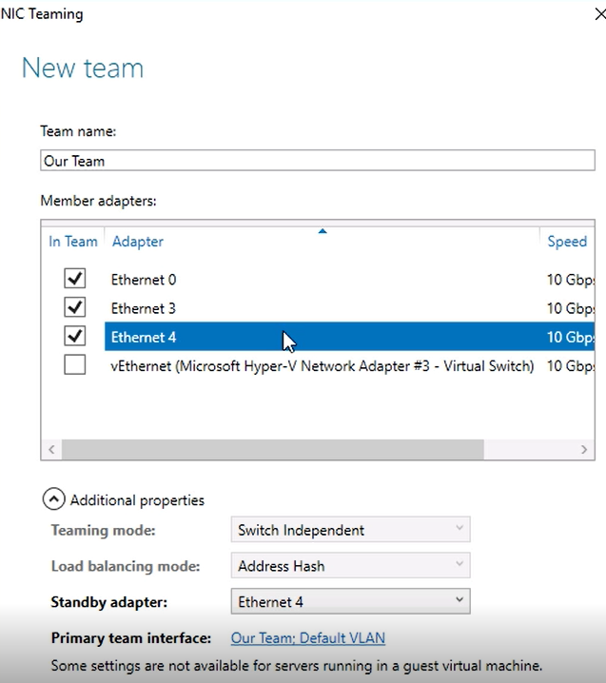

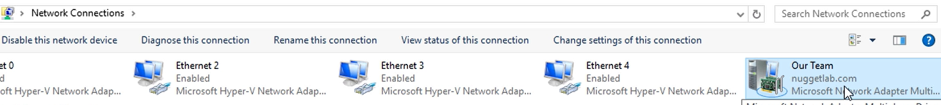

enable and configure Receive Side Scaling (RSS)

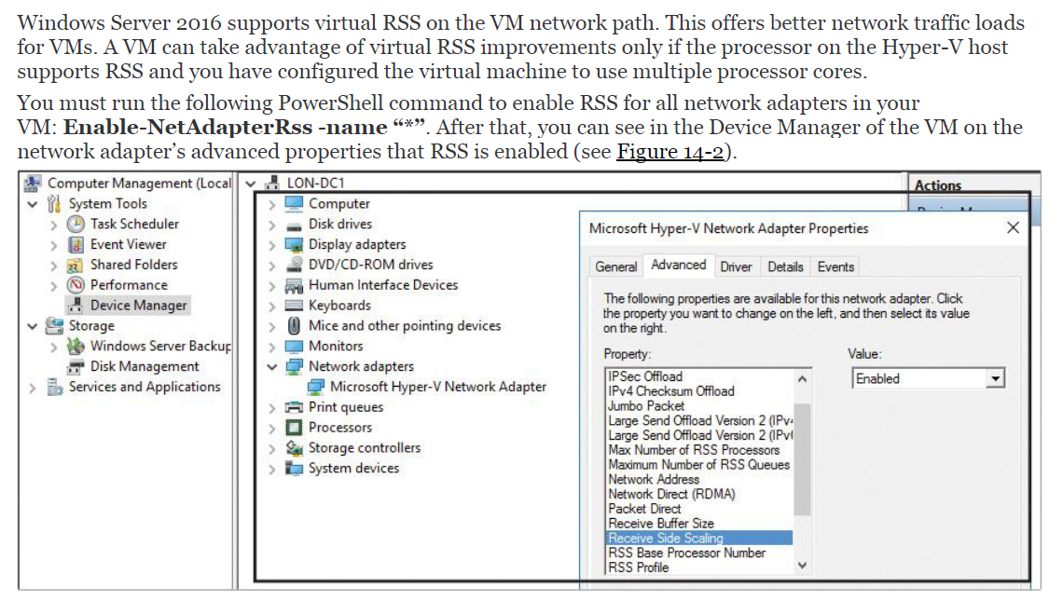

(packetler host ulaştığında, bu paketlerin birden çok işlemci tarafından işlenmesi)

**netsh interface tcp set global rss=enabled**

Quality of Service (QoS) with Data Center Bridging (DCB)

prioritize traffic with precedences and higher-priority processes first

DCB provides hardware-based bandwidth allocation to a specific type of traffic and enhances Ethernet transport reliability with the use of priority-based flow control.

RDMA

RDMA over Ethernet is a technology that can transfer data more efficiently between two computers. RDMA-capable NICs can transfer data at full speed with low latency while using very little CPU power.

Get-NetAdapterRdma

Enable-NetAdapterRdma “interfacename”

Windows Server 2016 and Windows Server 2012 use RDMA to provide the SMB Direct functionality

**Disable-NetAdapapterRmda** and **Enable-NetAdapterRdma**.

SMB Direct on Remote Direct Memory Access (RDMA) enabled network adapters

SMB Direct is enabled by default on Windows Server 2016.

SMB Direct supports network adapters that have RDMA capability

SMB Multichannel

SMB Multichannel enables you to aggregate network bandwidth and network fault tolerance if multiple paths are available between the SMB client and SMB server

SMB Multichannel enables server applications to take advantage of all available network bandwidth to a branch office and makes them resilient if a WAN link fails, as long as multiple paths are available over the network to the branch office.

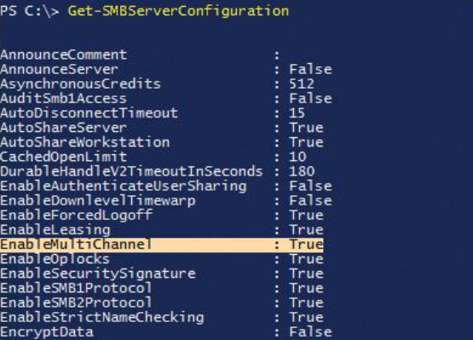

Clustering automatically recognizes all NICs on nodes that are using the same switch or subnet.

SMB Multichannel is enabled automatically.

Receive Side Scaling on a VMQ-Capable Network Adapter

**Virtual Machine Queue:** tek host üzerinde calısan WM’lerin paketleri hosttan bağımsız direk olarak alabilmesi

**Enable-NetAdapterVmq** and **Disable-NetAdapterVmq**

Dynamic VMQ is enabled by default in Windows Server 2016

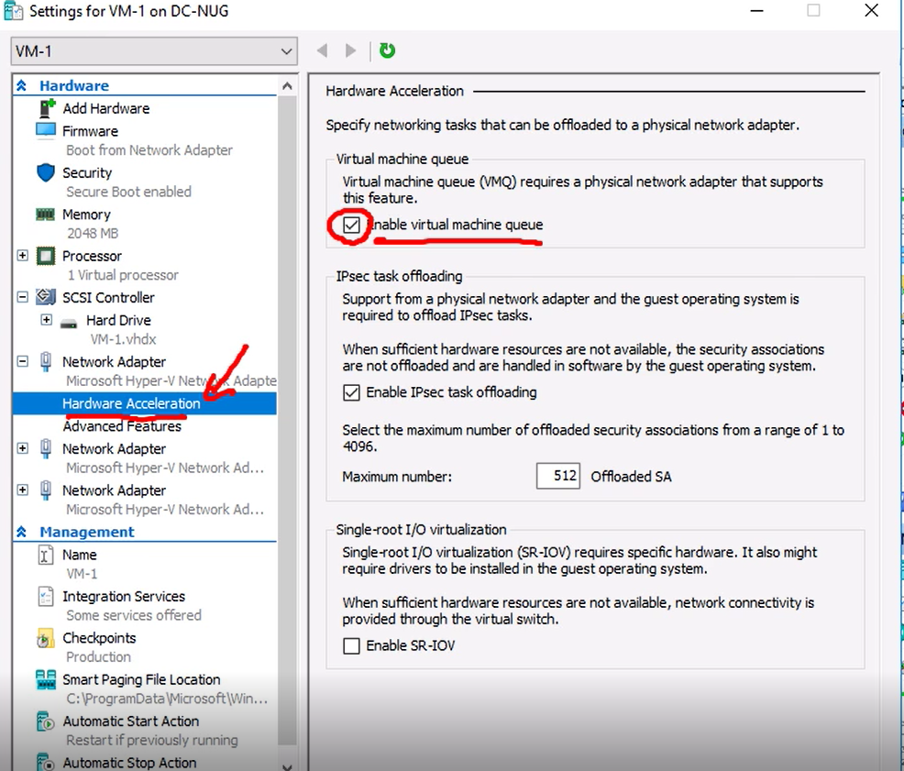

spreading the calculations across multiple CPU cores

Dynamic VMQ dynamically distributes incoming network traffic processing to physical host CPU cores based on processor usage and network load.

During periods of heavy network loads, dynamic VMQ automatically employs more processors

Single-Root I/O Virtualization (SR-IOV)

enables multiple VMs to share the same PCI Express physical hardware resources. Only network adapters specific to Hyper-V support this feature.

Receive Side Coalescing (RSC) is an offload technology that helps you reduce how much CPU time is used in network processing

**EnableNetAdapterRsc**

to use RSC in a virtualized environment, the network adapter must support SR-IOV

deployment scenarios and network requirements for deploying SDN

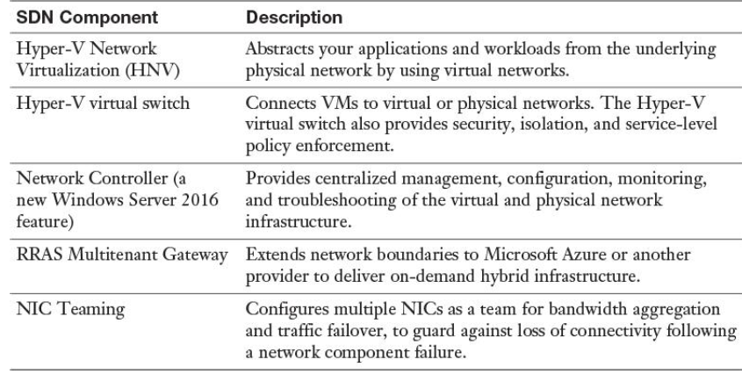

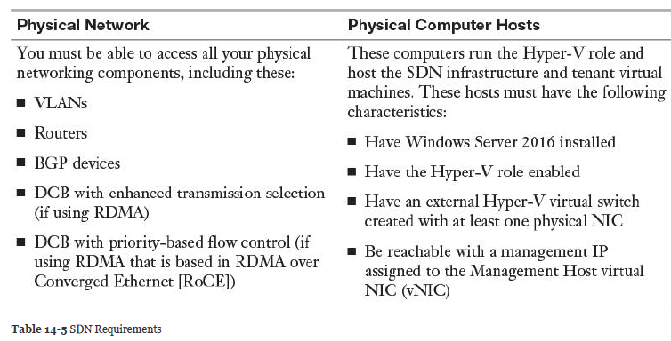

,

scenarios for implementation of Software Load Balancer (SLB) for North-South and East-West load balancing

SLB maps virtual IP addresses (VIPs) to dynamic IP addresses (DIPs) that are part of a cloud service set of resources in the datacenter. When public traffic arrives from the Internet, the SLB MUX examines the traffic, which contains the VIP as a destination, and maps and rewrites the traffic so that it arrives at an individual DIP

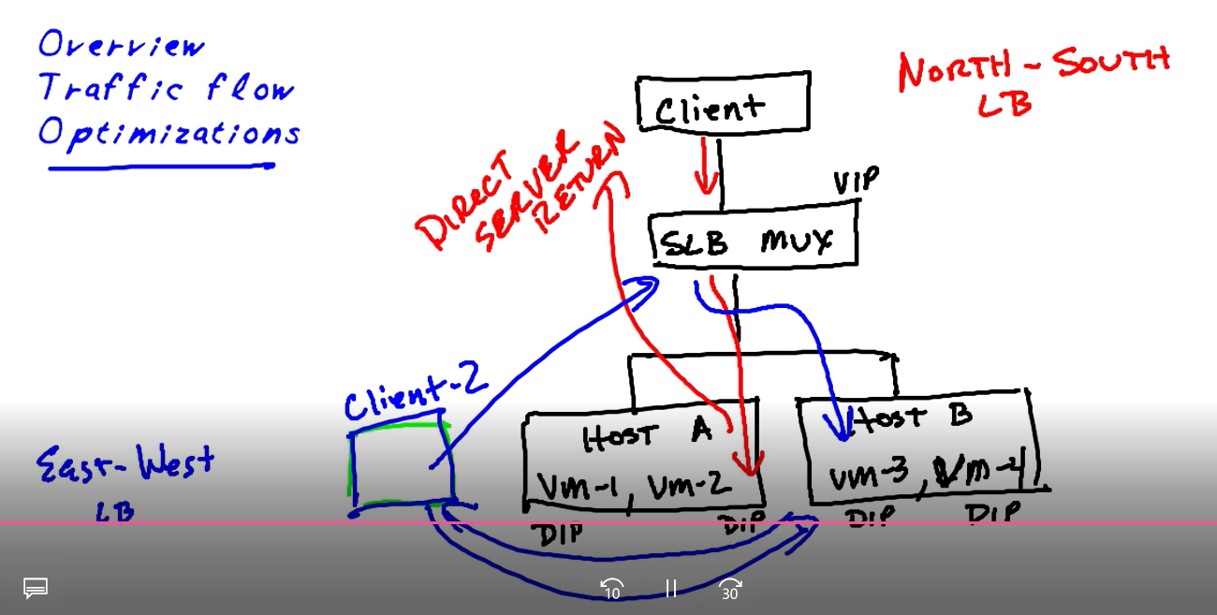

**NPS**

Routing and remote access’den ulaşılır

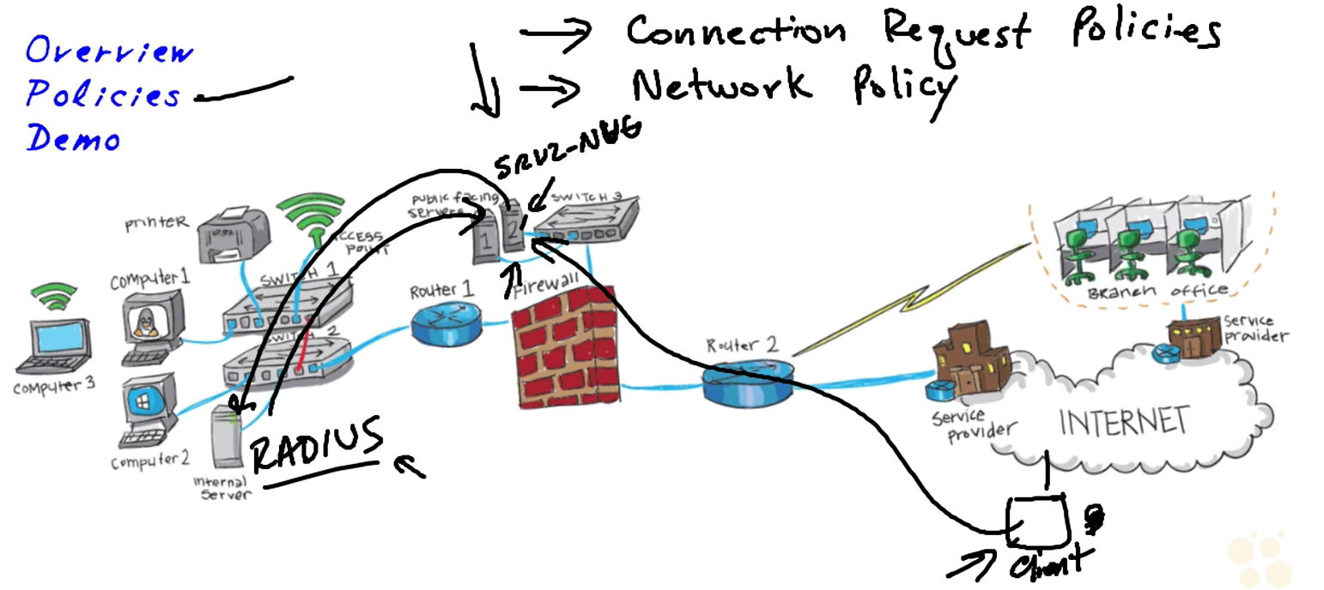

SRV-2: remote Access rolü kurulmuş sunucu

Eğer ayrı bir Radius server yapılandırılmadıysa Remote Access sunucusu üzerinde politikalar gözükür

AD integration

A Windows Server 2016 NPS server should be registered in Active Directory

1. the computer account of the NPS server as a member of the RAS and IAS Servers computer security group
2. 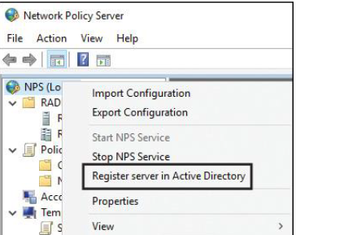

Membership in the Domain Admins security group (or equivalent) is the minimum required to complete this procedure.

**RADIUS ENTEGRASYONU**

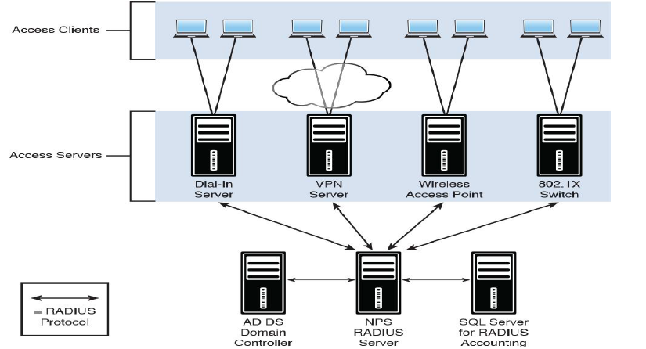

Ports:

By default, Windows Server 2016 NPS listens for RADIUS traffic on ports 1812, 1813, 1645, and 1646 for both IPv6 and IPv4 for all installed network adapters. However, many access servers use ports 1645 for authentication requests and 1646 for accounting requests.

RADIUS clients are network access servers such as wireless access points, 802.1X-capable switches, and VPN and dial-up servers because they use the RADIUS protocol to communicate with RADIUS servers such as Windows Server 2016 NPS servers

You can use a Windows Server 2016 NPS server as a RADIUS server, client, or proxy to forward connection requests to another NPS server or RADIUS server.



Srv2 bu durumda radius client olur

Remote Access sunucusu üzerinde

Radius Server’ın kurulması

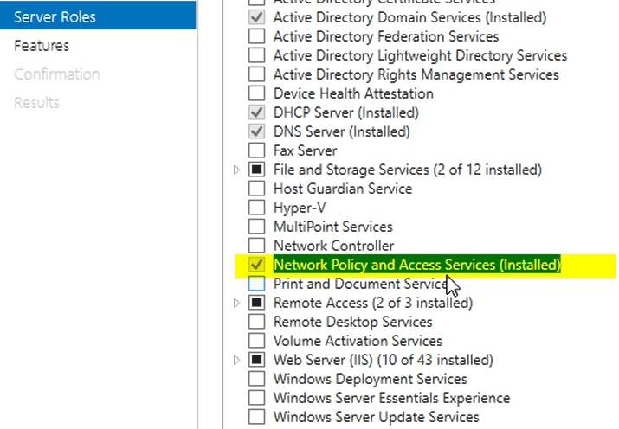

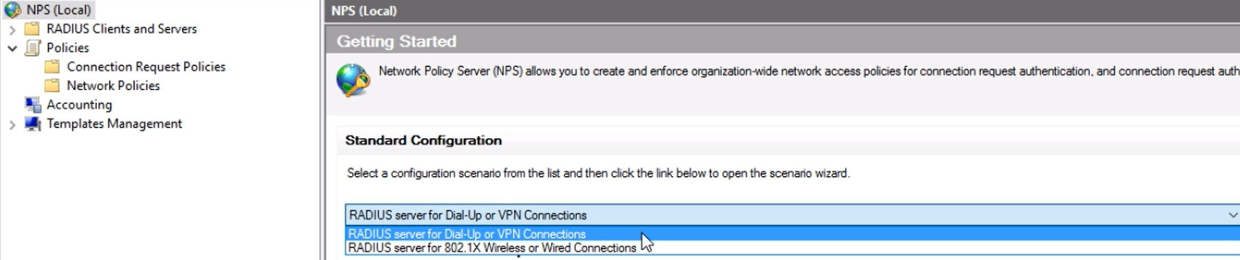

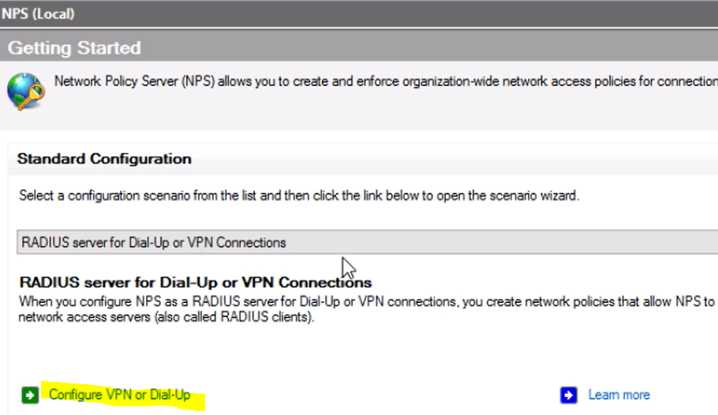

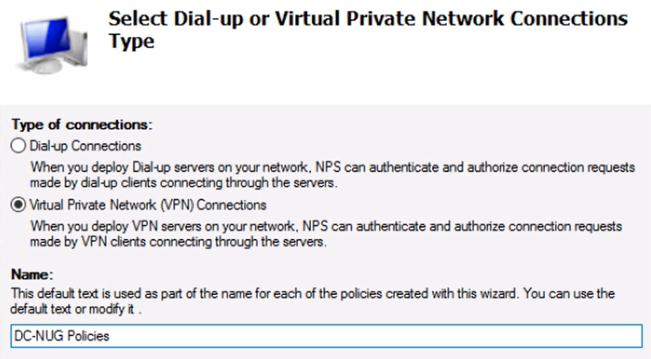

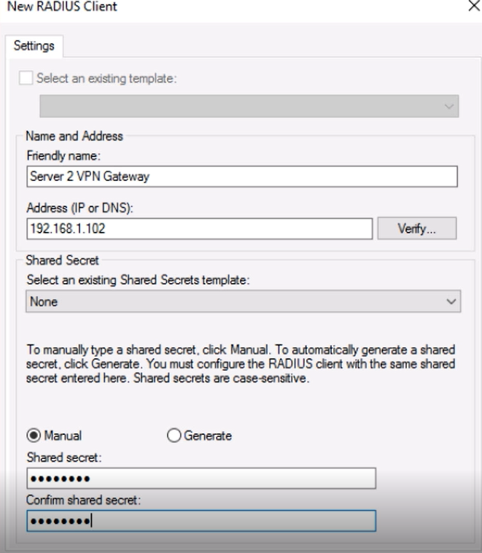

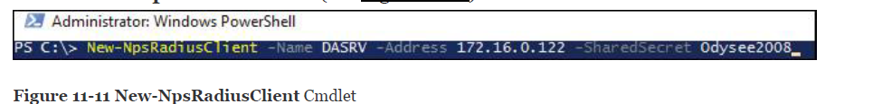

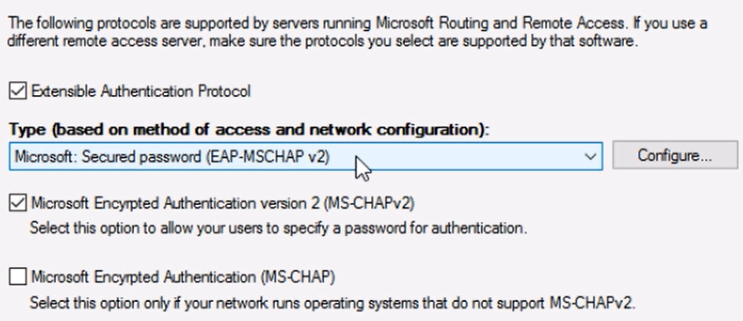

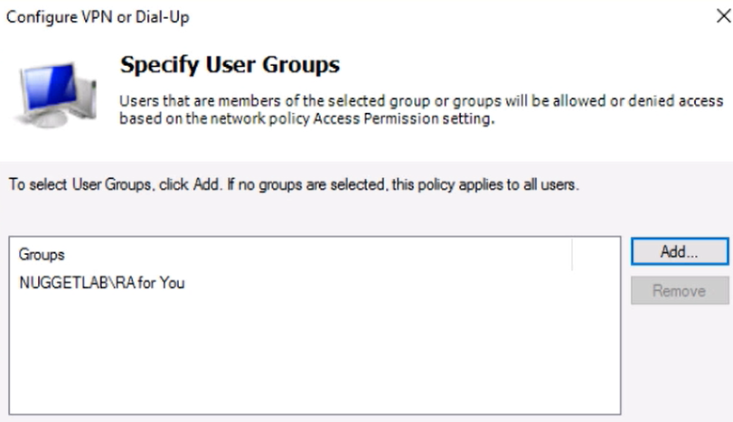

Radius Client’ın yapılandırılması

Connection policy’de Radius server olduğunu belirt

Authentication’u artık NPS sunucusu yapacak

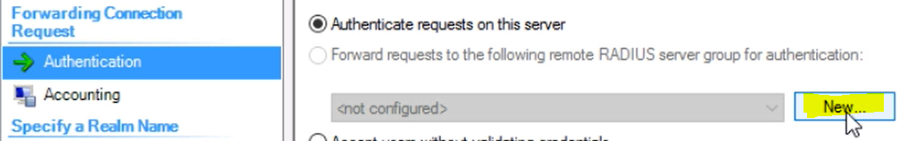

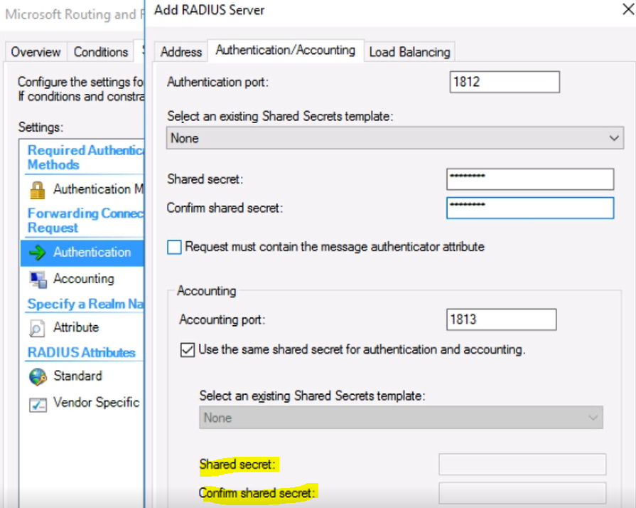

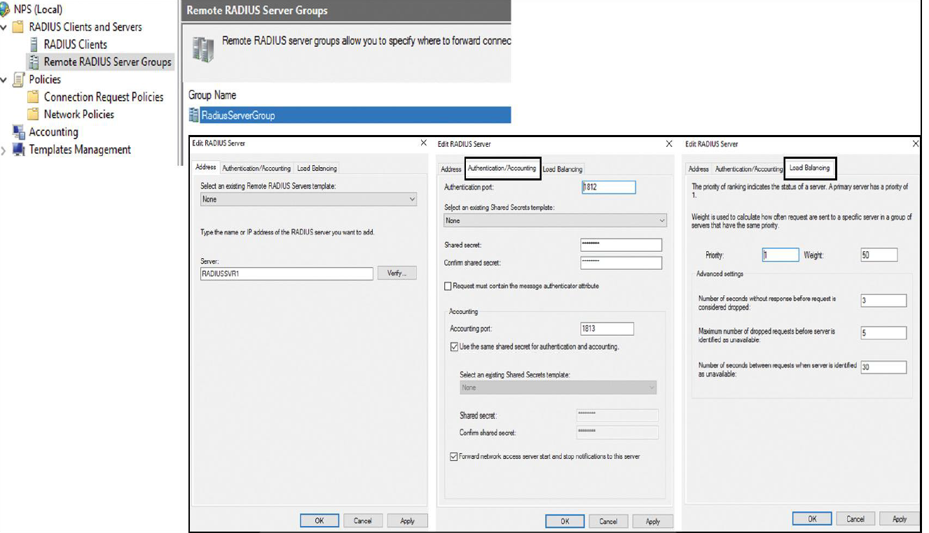

**RADIUS PROXY**

Between radius server and radius client

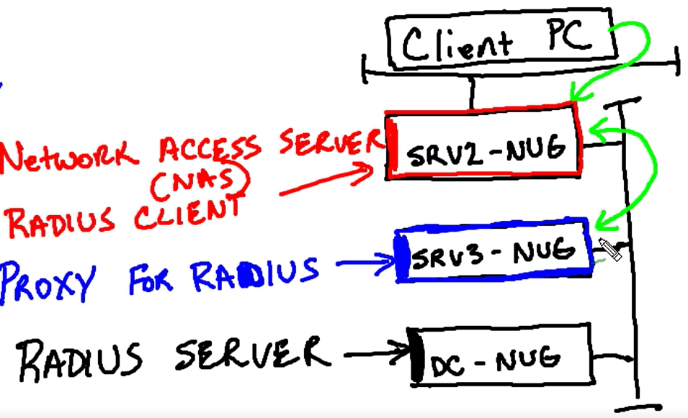

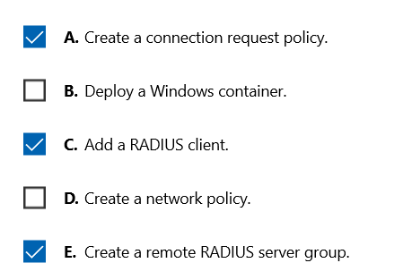

**configure NPS templates**

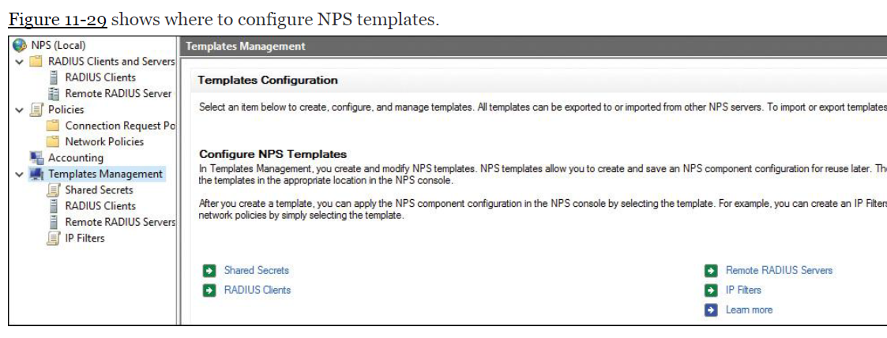

Using templates

You can apply a RADIUS client and Shared Secret NPS template in the New RADIUS Client window; you can apply a Remote RADIUS Server NPS template in the Add RADIUS Server window.

IP filters’ın kullanıldığı yer >> 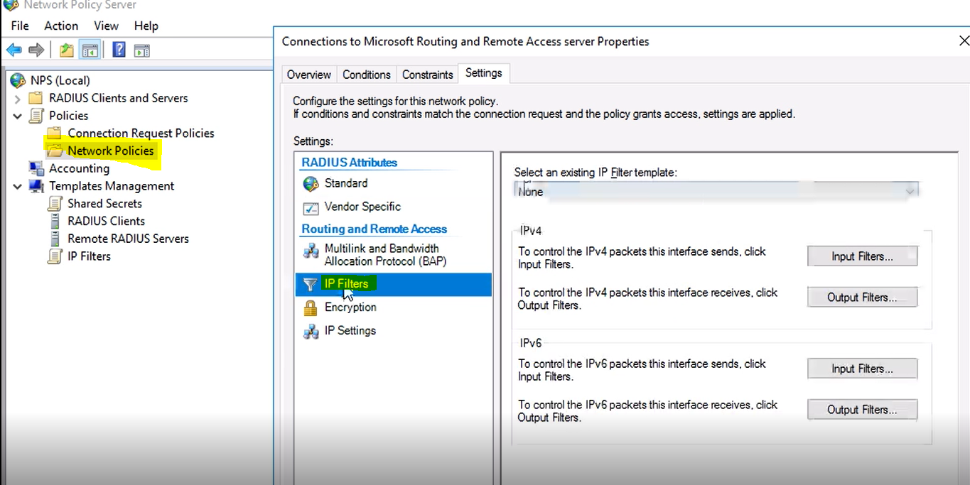

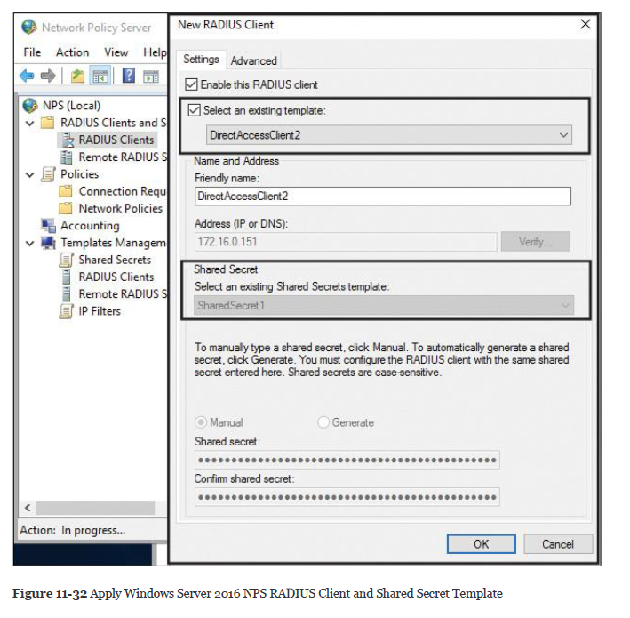

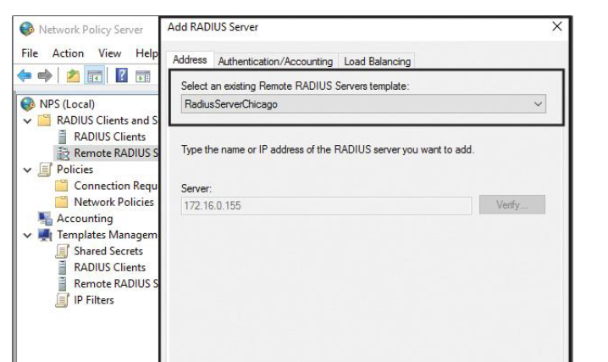

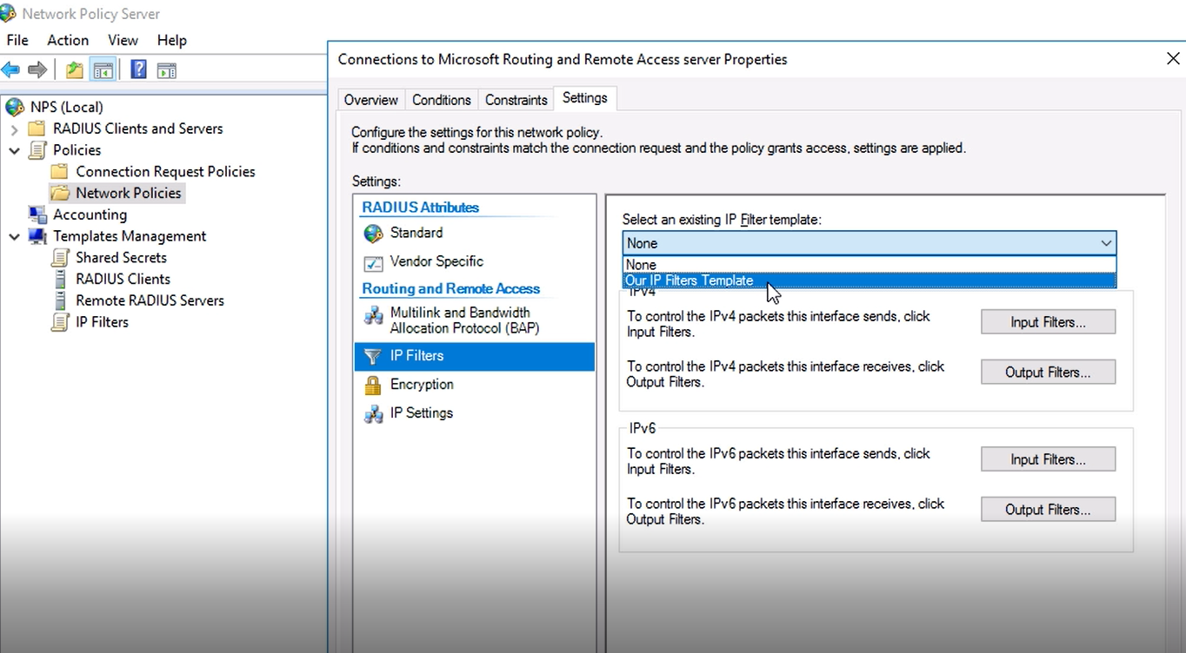

configure RADIUS accounting

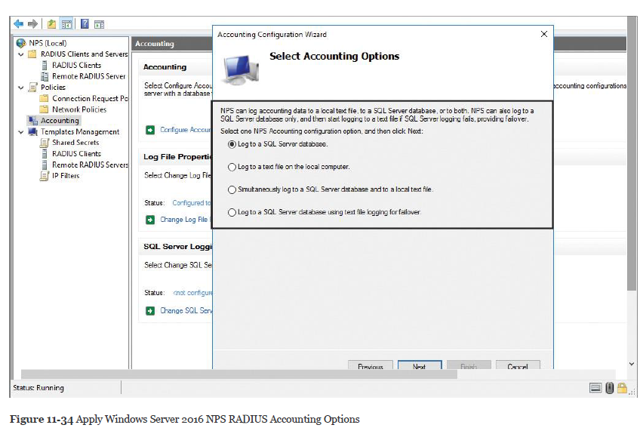

**SQL logging only:** With this choice, you can configure a data link to a SQL Server that allows NPS to connect to and send accounting data to the SQL Server. In addition, the wizard can configure the database on the SQL Server to ensure that the database is compatible with NPS SQL Server logging.

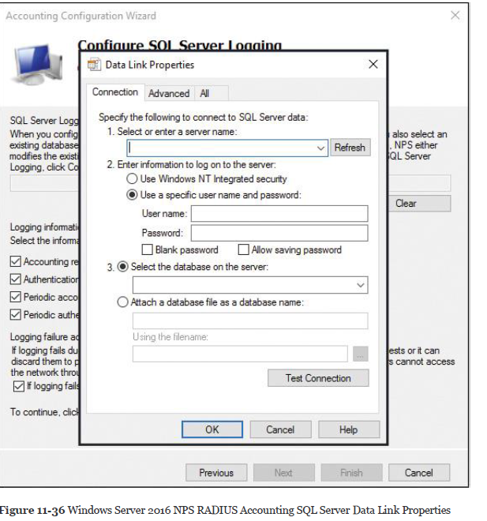

**Text logging only:** With this setting, you can configure NPS to log accounting data to a text file.

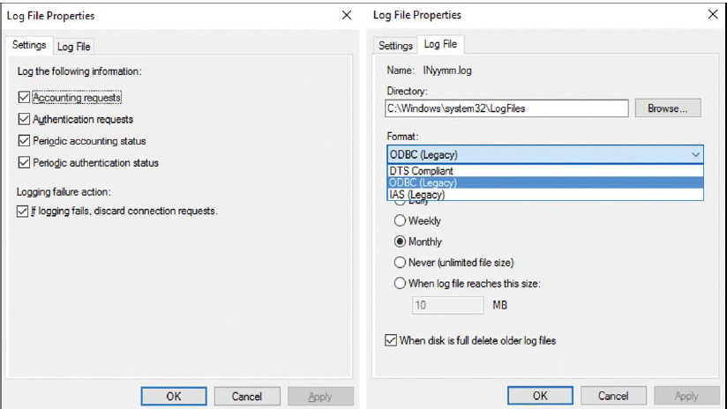

**Parallel logging:** With this setting, you can configure the SQL Server data link and database. You can also configure text file logging so that NPS logs simultaneously to the text file and the SQL Server database.

**SQL logging with backup:** With this setting, you can configure the SQL Server data link and database. In addition, you can configure text file logging that NPS uses if SQL Server logging fails.

NPS Proxy’den Radius of Logları göndermek

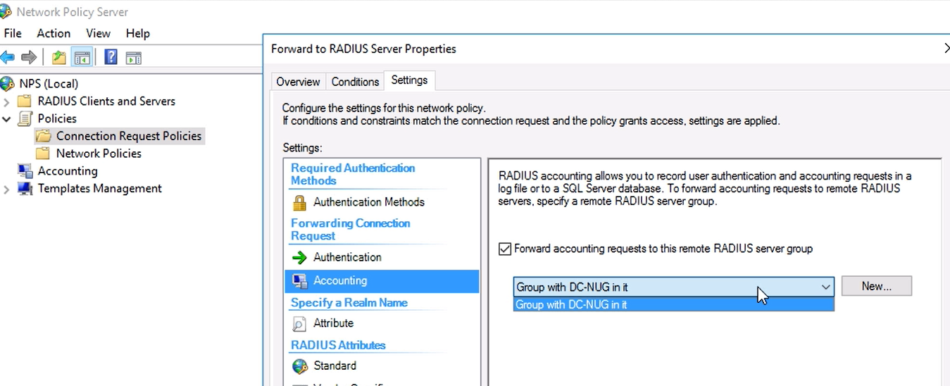

**Connection Request Policies**

*Connection request policies* are condition sets and settings that allow administrators to designate which RADIUS servers do the authentication and authorization of connection requests that the NPS server receives from RADIUS clients.

Time of day and day of the week

Realm name in the connection request

Connection type you are requesting

RADIUS client’s IP address

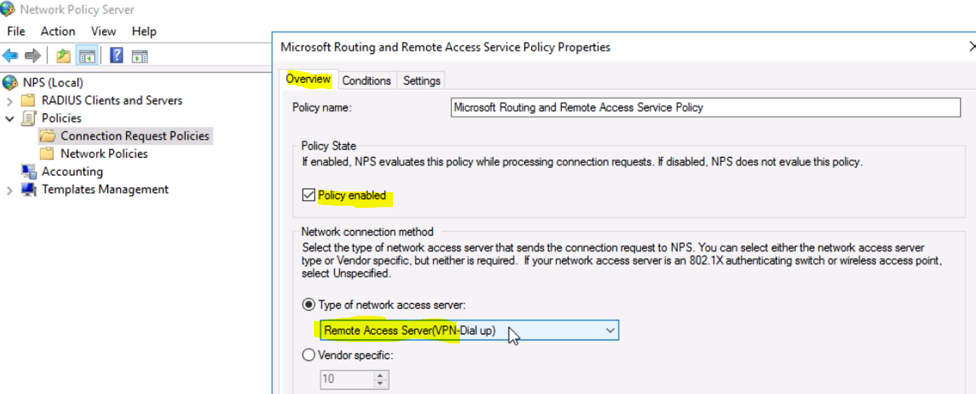

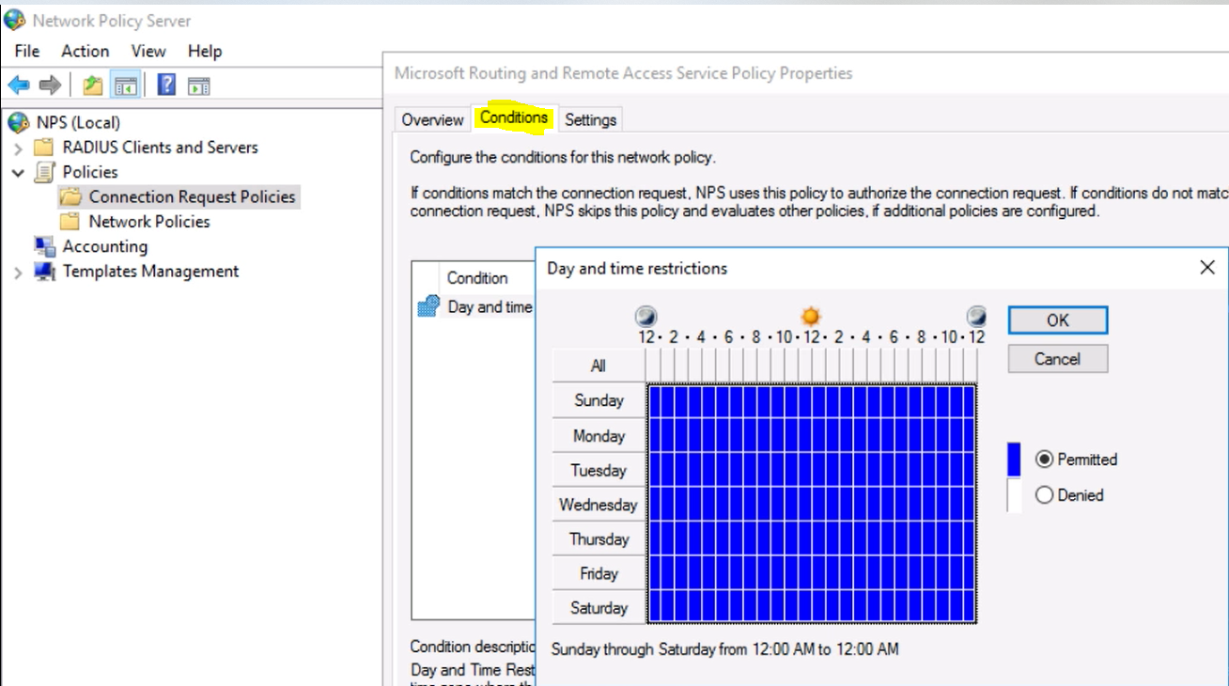

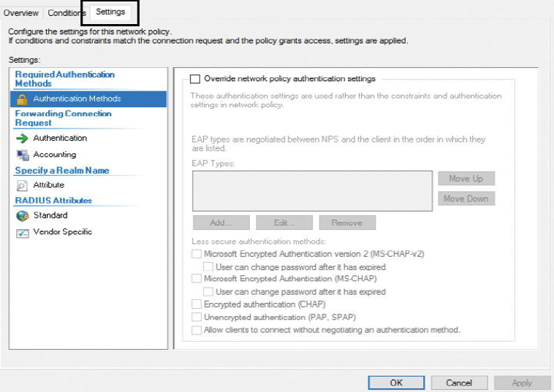

**Network Policies for VPN Wireless and Wired Clients**



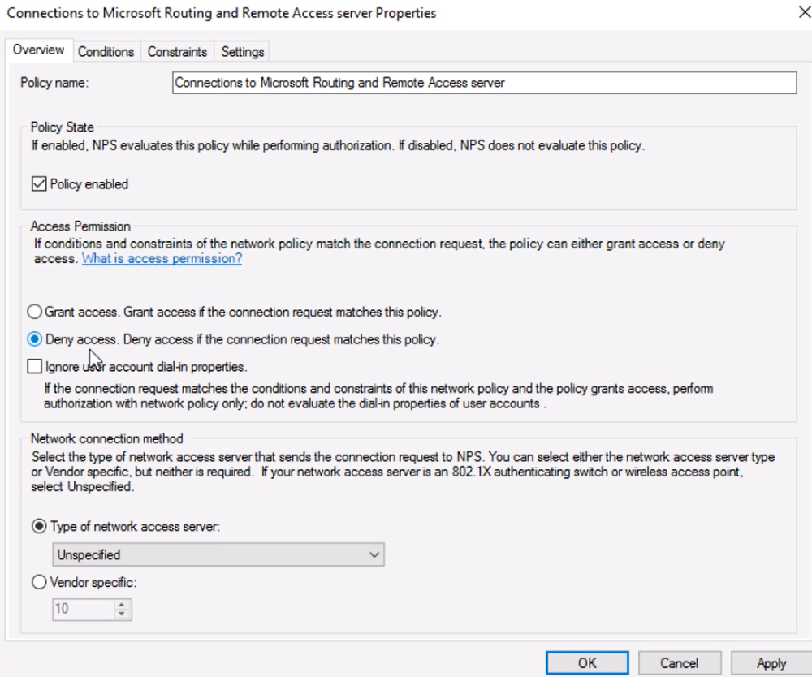

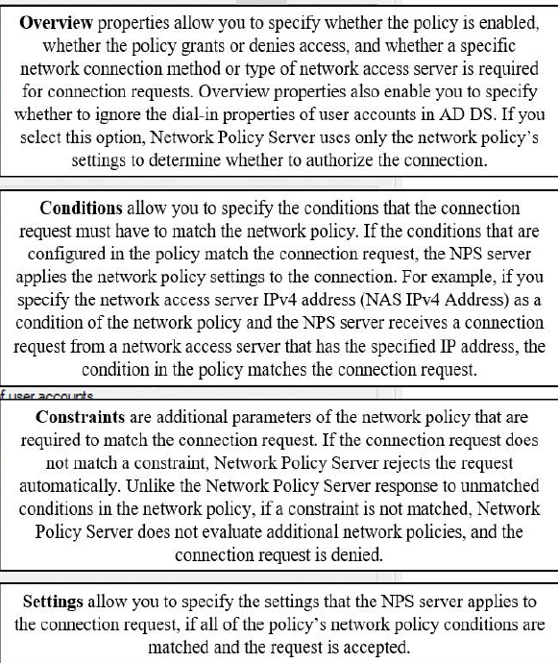

If the dial-in properties of the user account are configured to grant access or control access through network policy and the connection request is authorized, NPS applies the settings that are configured in the network policy to the connection.

If NPS does not find a network policy that matches the connection request, the connection request is rejected unless the dial-in properties on the user account are set to grant access.

If the dial-in properties of the user account are set to deny access, NPS rejects the connection request

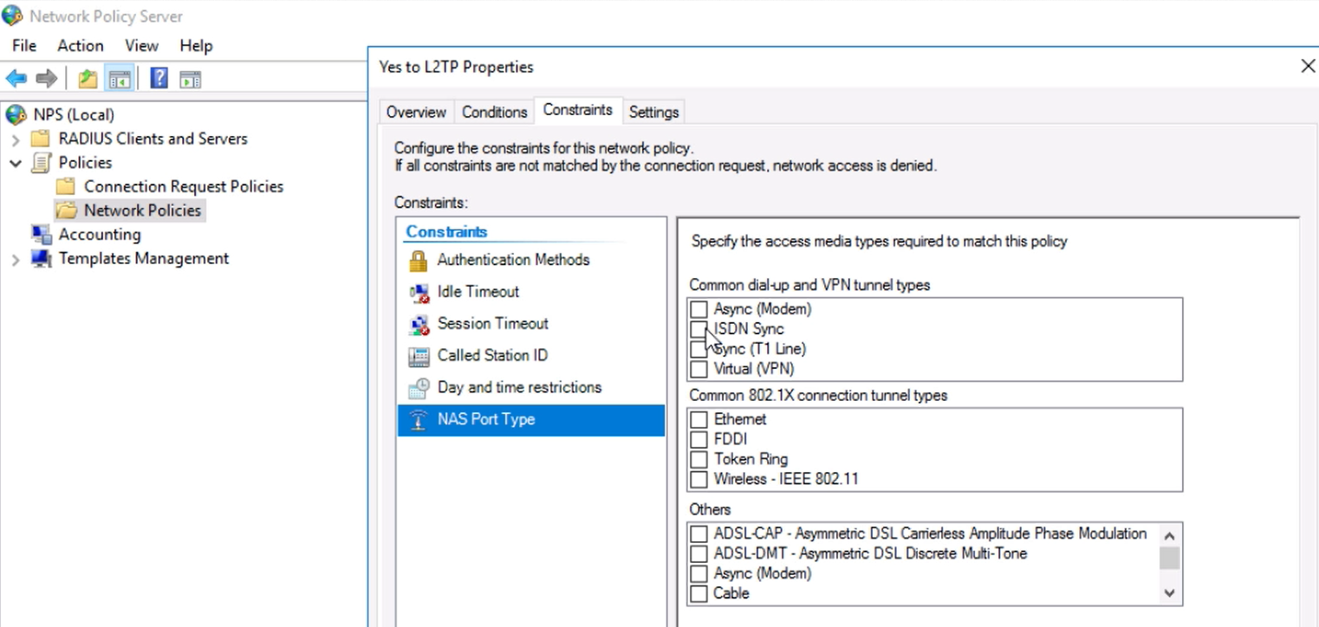

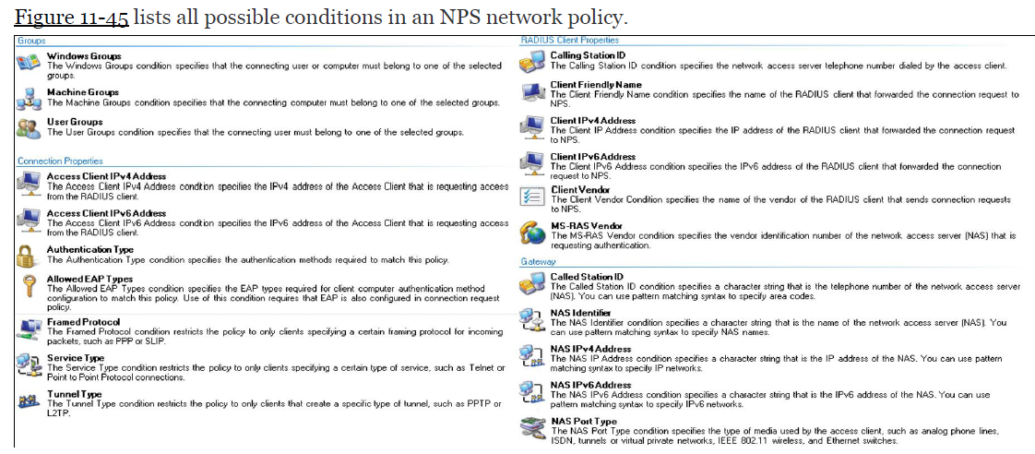

**Import and export NPS policies**

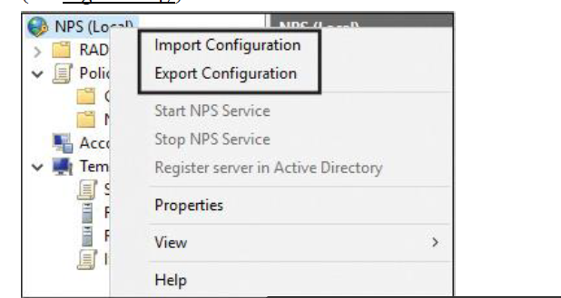

.xml oluşturur

**Import-NpsConfiguration** and **Export-NpsConfiguration**

**POWERSHELL**

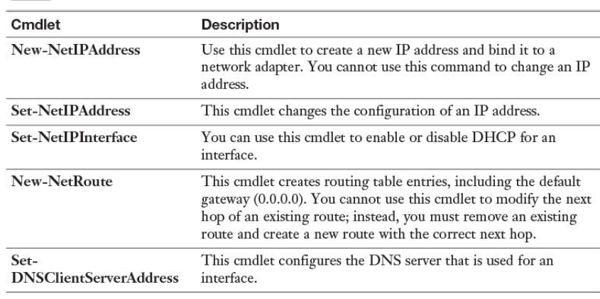

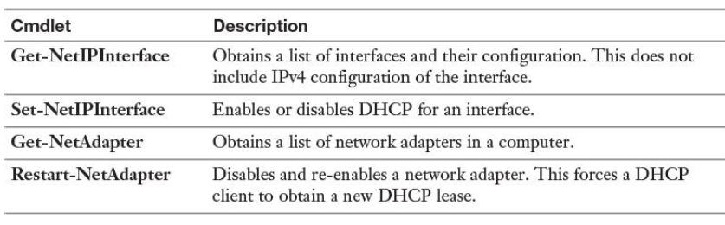

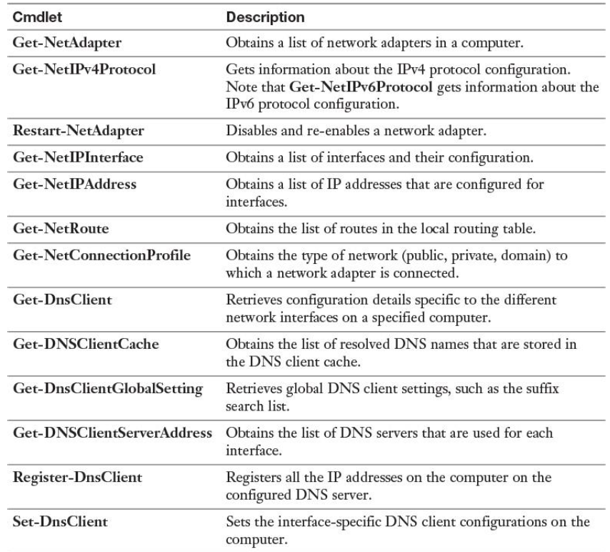

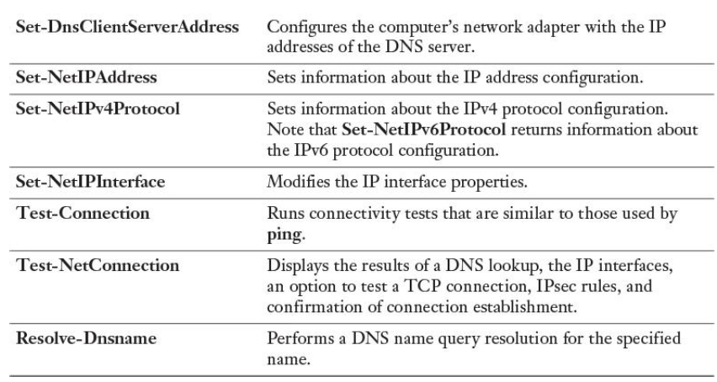

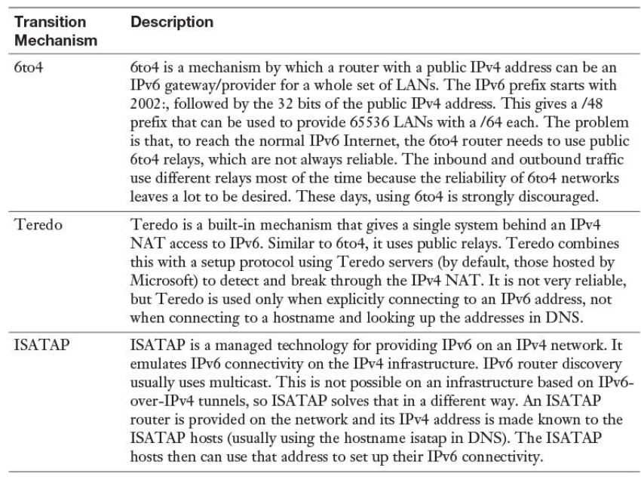

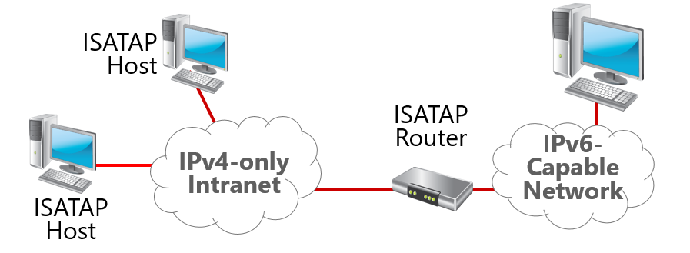

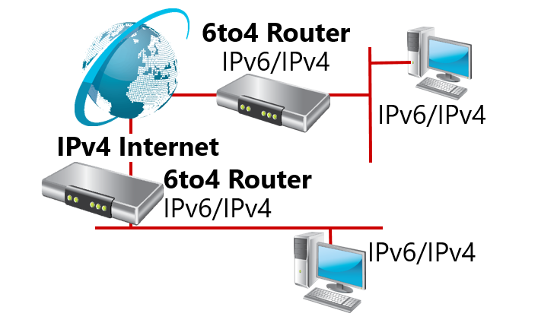

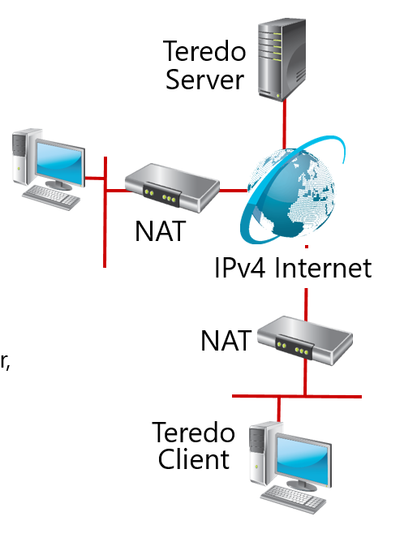

**NETWORK CONTROLLER**

